Contents

March 2022 5

March 11, 2022 Friday 5

March 10, 2022 Thursday 6

March 9, 2022 Wednesday 6

March 8, 2022 Tuesday 6

March 7, 2022 Monday 6

Update Mar 4, 2022 Friday 6

Update Mar 3, 2022 Thursday 6

Update Mar 2, 2022 Wednesday 6

Update Mar 1, 2022 Tuesday 6

February 2022 7

Update Feb 28, 2022 Monday 7

Update Feb 25, 2022 Friday 7

Update Feb 24, 2022 Thursday 7

Update Feb 23, 2022 Wednesday 7

Update Feb 22, 2022 Tuesday 7

Update Feb 18, 2022 Friday 7

Update Feb 17, 2022 Thursday 8

Update Feb 16, 2022 Wednesday 8

Update Feb 15, 2022 Tuesday 8

Update Feb 14, 2022 Monday 8

Update Feb 11, 2022 Friday 8

Update Feb 10, 2022 Thursday 9

Update Feb 9, 2022 Wednesday 9

Update Feb 8, 2022 Tuesday 9

Update Feb 7, 2022 Monday 9

Update Feb 4, 2022 Friday 9

Update Feb 3, 2022 Thursday 9

Update Feb 2, 2022 Wednesday 9

Update Feb 1, 2022 Tuesday 9

January 2022 10

Update Jan 31, 2022 Monday 10

Update Jan 30, 2022 Sunday 10

Update Jan 28, 2022 Friday 10

Update Jan 27, 2022 Thursday 10

Update Jan 26, 2022 Wednesday 10

Update Jan 25, 2022 Tuesday 11

Update Jan 24, 2022 Monday 11

Update Jan 21, 2022 Friday 11

Update Jan 20, 2022 Thursday 11

Update Jan 19, 2022 Wednesday 12

Update Jan 18, 2022 Tuesday 13

Update Jan 14, 2022 Friday 13

Update Jan 13, 2022 Thursday 13

Update Jan 12, 2022 13

Update Jan 11, 2022 13

Update Jan 10, 2022 13

Update Jan 7, 2021 Friday 13

Update Jan 6, 2021 Thursday 14

Update Jan 5, 2021 Wednesday 14

Update Jan 4, 2021 Tuesday 14

December 2021 14

Update Dec 29, 2021 Thursday 14

Update Dec 28, 2021 Wednesday 15

Update Dec 28, 2021 Tuesday 15

Update Dec 27, 2021 Monday 15

Update Dec 26, 2021 Sunday 16

Update Dec 25, 2021 Saturday 16

Update Dec 24, 2021 Friday 16

Update Dec 23, 2021 Thursday 16

Update Dec 22, 2021 Wednesday 17

Update Dec 21, 2021 Tuesday 17

Update Dec 20, 2021 Monday 18

Update Dec 17, 2021 Friday 18

Update Dec 16, Thursday 18

Update Dec 15, Wednesday 19

Update Dec 14, Tuesday 19

Update Dec 13, Monday 20

Update Dec 10, 2021 Friday 20

Update Dec 9, 2021 Thursday 21

Update Dec 8, 2021 Wednesday 21

Update Dec 7, 2021 Tuesday 21

Update Dec 6, 2021 Monday 21

Update Dec 4, 2021 Friday 21

Update Dec 3, 2021 Thursday 22

Update Dec 1, 2021 Wednesday 22

November 2021 23

Update Nov 30, 2021 Tuesday 23

Update Nov 29, 2021 Monday 23

Update Nov 24, 2021 Wednesday 23

Update Nov 23, 2021 Tuesday 24

Update Nov 22, 2021 Monday 24

Update Nov 19, 2021 Friday 25

Update Nov 18, 2021 Thursday 25

Update for Wednesday Nov 17, 2021 25

Update for Tuesday Nov 16, 2021 26

Update for Nov 15, 2021 Monday 28

Nov 12 to Nov 14 Friday to Sunday Weekend update. 28

RTB Updates for Nov 14, 2021 Sunday 29

Update for Nov 13, 2021 Saturday 29

Update for Nov 12, 2021 Friday 29

Update for Nov 11, 2021 Thursday 30

Update for Nov 10, 2021 Wednesday 31

Update for Nov 9, 2021 Tuesday 31

Update for Nov 8, 2021 Monday 31

Update for Nov 5, 2021 Friday 32

Update for Nov 4, 2021 Thursday 32

Update for Nov 3, 2021 Wednesday 32

Update for Nov 2, 2021 Tuesday 33

Update for Nov 1, 2021 Monday 33

October 2021 33

Update for Oct 29, 2021 Friday 34

Update for Oct 28, 2021 Thursday 34

Update for Oct 27, 2021 Wednesday 34

Update for Oct 26, 2021 Tuesday 34

Update for Oct 25, 2021 Monday 34

Update for Oct 25, 2021 Monday 35

Update for Oct 22, 2021 Friday 35

Update for Oct 21, 2021 Thursday 35

Update for Oct 19, 2021 Tuesday 36

September 2021 36

20210921 Day 31 Task - 285 Sync EP snow ticket 36

20210920 Day 30 Task - 285 Sync EP snow ticket 36

20210917 Day 29 Task - 285 Sync EP snow ticket 37

20210916 Day 28 Task - 285 Sync EP snow ticket 37

20210915 Day 27 Task - 285 Sync EP snow ticket 37

20210914 Day 26 Task - 285 Sync EP snow ticket 37

20210913 Day 25 Task - 285 Sync EP snow ticket 37

20210910 Day 24 Task - 285 Sync EP snow ticket 37

20210909 Day 23 Task - 285 Sync EP snow ticket – touchstone APIs 37

20210908 Day 22 Task - 285 Sync EP snow ticket – logic discussion on servicenow and touchstone APIs 37

20210907 Day 21 Task - 285 Sync EP snow ticket – logic: servicenow and touchstone APIs 38

20210903 Day 20 Task - 285 Sync EP snow ticket – review codebase 38

20210902 Day 19 Task 285 - Sync EP snw ticket – new comments in ticket 38

20210901 Day 18 Knowledge Transfer adssrejob 38

August 2021 39

20210831 Day 17 Add GitHub Repo URL – issue fixed and working 39

20210830 Day 16 Add GitHub Repo URL – fix issue AND Reporting Code Introduction 39

20210827 Day 15 Add GitHub Repo URL – code merged to main 40

20210826 Day 14 Add GitHub Repo URL – logic completed 40

20210825 Day 13 Add GitHub Repo URL – sample hard-coded json 42

20210824 Day 12 Add GitHub Repo URL – refactor current variable names 47

20210823 Day 11 Add GitHub Repo URL – debug and check variable contents 48

20210820 Day 10 Add GitHub Repo URL – logic confirmation 54

20210819 Day 9 Add GitHub Repo URL – test and hypothesis 55

20210818 Day 8 Control Center Demo 57

20210817 Day 7 GitHub Repo URL and EP Change 77

20210816 Day 6 Pool metrics, Clickhouse, and Tabix 77

20210813 Day 5 Adssrejob Control Center, Spring Batch 86

20210812 Day 4 Meetings, Setups, and Knowledge Transfer of RaptorBatch 106

20210811 Day 3 Documentation, More Setups and Access, Tess.io 123

20210810 Day 2 Online Trainings, New Hire Docs 134

20210809 Day 1 Start Date, Welcome, and Laptop 134

# June 2022

## June 17, 2022 Friday

done [SHEPHERD-1179] ​​[adsinfra-common] add tests in adsmetadata service

## June 16, 2022 Thursday

done [SHEPHERD-1178] [adsinfrajob] fix dual write to changeinfo v2

done [SHEPHERD-1186] ​​[adsmetdatasvc] add target, BU, site to query API

done [SHEPHERD-1212] [adsmetadatasvc] use common lib for epoch convert

## June 15, 2022 Wednesday

done [SHEPHERD-1187] ​​fix dual ES write on zonedatetime conversation

done [SHEPHERD-1198] ​​[adsinfra-common] enhance _source field

done [SHEPHERD-1199] ​​missed CR for change in servedTraffic after data collection

done [SHEPHERD-1210] ​​[adsinfra-common] add default value for source

done [SHEPHERD-1211] ​​[adsinfra-common] remove local url and add preprod url

## June 13, 2022 Monday

done [SHEPHERD-1176] add changeinfo id as parameter

## June 10, 2022 Friday

done [SHEPHERD-1082] change job write to ES via adsmetadatasvc

* duplicate data insert to

done [ SHEPHERD-1165] add adsmetadatasvc client in common lib

done [ SHEPHERD-1166] ​​add unique ES doc id and upsert doc in ES

done [ SHEPHERD-1172] ​​​​refactor response-request obj create change info

done [ SHEPHERD-1175] ​​​​refactor to use request obj instead of payload

change_info_v2_metadata

## June 3, 2022 Friday

done [SHEPHERD-1121] add multiple values in type param for GET query API

done [SHEPHERD-1120] add term query in es service

done [SHEPHERD-1147] ​​use must instead of filter for timeRange

done [SHEPHERD-1148] fix curr head datetime string parsing

## June 3, 2022 Thursday

done [SHEPHERD-1122] fix time range query

## June 1, 2022 Tuesday

done [SHEPHERD-1123] ​​verify adssrejob split repo

# May 2022

## May 30, 2022 Monday

done [SHEPHERD-1095] fix changes data structure and tooltips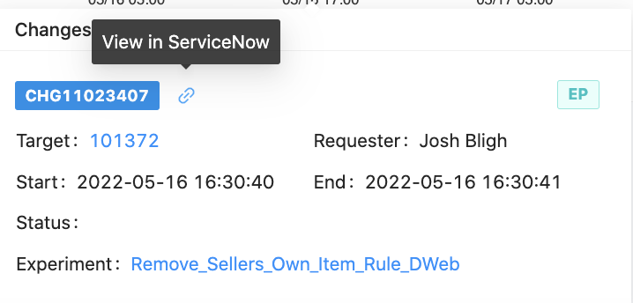

## May 27, 2022 Friday

done [SHEPHERD-1115] refactor GET API query

done [SHEPHERD-1117] refactor ads-infra common for GET API changeinfo

done [SHEPHERD-1118] refactor GET API to align to UI

## May 25, 2022 Wednesday

done [SHEPHERD-1102] Raptor Upgrade for adsmetadatasvc

## May 23, 2022 Monday

done [SHEPHERD-1096] flatten EP change data structure

* placementIds (duplicate of info.placementIds)
* jiraTicketUrl (duplicate of approvalDoc)
* experimentStatus (add back)

## May 19, 2022 Thursday

done [SHEPHERD-1081] refactor code for changes page

​- Also, I found the schema of backend is a bit changed for the Change interface defined in UI code. Maybe @cjasonbautista you can update the UI code later (and also the changes metadata page if needed).

## May 18, 2022 Wednesday

done [SHEPHERD-1081] add back more EP fields

done [SHEPHERD-1077] remove audit logs and add BU ids

## May 17, 2022 Tuesday

done [SHEPHERD-1078] remove auditLogs in ES

done [SHEPHERD-1076] add back mfe config info

## May 16, 2022 Monday

done [SHEPHERD-1071] follow contract - change dss to DSS

done [SHEPHERD-1065] fix jira url extract on DSS

done [SHEPHERD-1064] show DSS change tickets

done [SHEPHERD-1052] refactor ChangeInfo svc find missing fields

done [SHEPHERD-1043] SOP for plp_valid_uncharged_clicks_main

## 

## May 13, 2022 Friday

done [SHEPHERD-1049] fix search filters in changes metadata

done [SHEPHERD-1014] scrape DSS change tickets

## May 11, 2022 Wednesday

done [SHEPHERD-1044] investigate rule group owner mismatch

## May 10, 2022 Tuesday

done [SHEPHERD-1041] add my email to Control Center Alerting Rules Daily Report

done [SHEPHERD-975] implement EP API in adsmetadatasvc

## May 9, 2022 Monday

done [SHEPHERD-1047] fix EP info fields missing

done [SHEPHERD-1042] KB fix auto shortening of imports in java

done [SHEPHERD-1040] SOP for job failed due to service account

done [SHEPHERD-1027] refactor and retrieve hostname for requester - adsmetadatasvc

done [SHEPHERD-1026] [tracking] missed CR generation from EP team

The CRs of experiment 101504 are failed to be created, cause by requesting mmi failed.

We will do the enhancement for this situation to ensure successful creation.

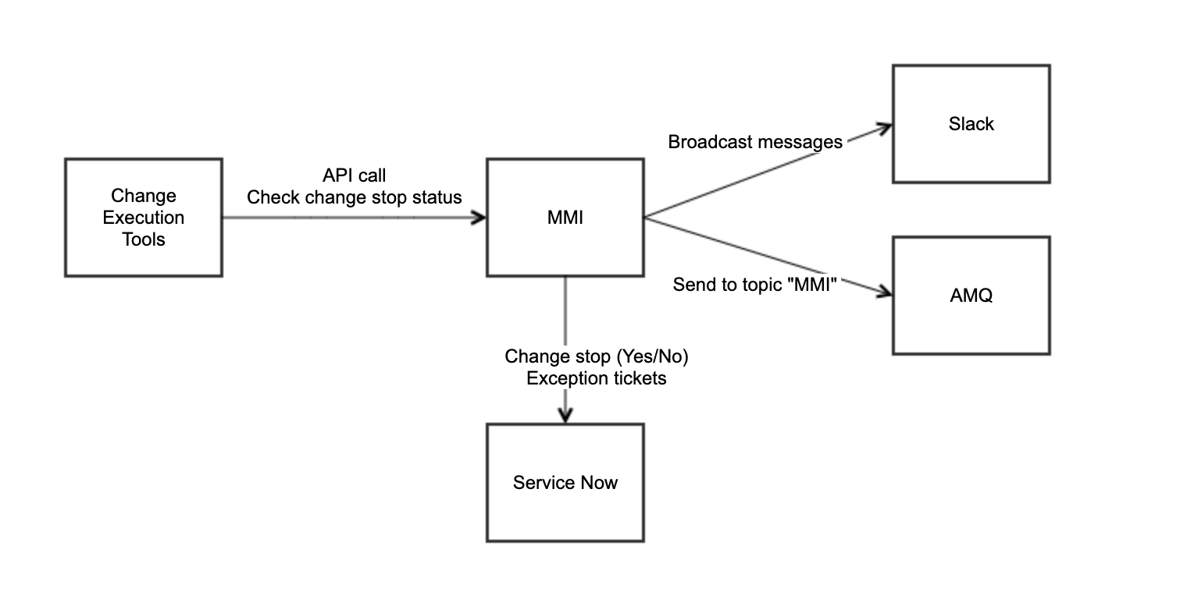

## May 6, 2022 Thursday

done [SHEPHERD-974] add unit tests for adsmetadatasvc

done [SHEPHERD-997] [SOP] EP Change

## May 4, 2022 Tuesday

done [SHEPHERD-976] implement write to ES for adsmetatadatasvc

## May 3, 2022 Monday

done [SHEPHERD-1019] deploy adsmetadatasvc to prod

# April 2022

## April 29, 2022 Friday

:done:[SHEPHERD-995] investigate missing EP CR job after repo refactor

:done:[SHEPHERD-996] fix intelliJ configuration for monorepo infrarepo

:done: [SOP] EP change doc - initial draft : reassigned to Freecia

## April 28, 2022 Thursday

:done: [SHEPHERD-973] EP API doc for adsmetadasvc

2.5 hour meeting - ads QE&infra, KT with Tim, ep enhancement weekly, keystone bi-weekly, ads QE biweekly

## April 27, 2022 Wednesday

:done:[SHEPHERD-988] investigate auto build jenkins for infrarepo

:done::rocket: [SHEPHERD-972] add error handling for initial POST API for adsmetadatasvc

## April 26, 2022 Tuesday

in progress [SHEPHERD-972] add error handling for initial POST API for adsmetadatasvc

## April 25, 2022 Monday

in progress [SHEPHERD-988] investigate auto build jenkins for infrarepo

2 hour meeting - ads eng design review, ads infra US weekly

email - DSS change johnny hatch - we get 50 tickets for now. maybe need to filter by table name for impact

## April 22, 2022 Friday

:git_merge: :rocket: [SHEPHERD 915] add backend service for ads metadata

:done: [SHEPHERD 918] [tracking] tested new app pool creation

## April 21, 2022 Thursday

:git_merge: :rocket: [adssrejob SHEPHERD 958] move adssrejob from root to new folder

in progress [SHEPHERD 915] add backend service for ads metadata

## April 20, 2022 Wednesday

in progress [adssrejob SHEPHERD 958] move adssrejob from root to new folder

2 hr and 30 min meeting - git work session, mock server KT, ads infra all weekly

## April 19, 2022 Tuesday

:git_merge: :rocket: [adssrejob SHEPHERD 952] fix ep history extraction

:done: [SHEPHERD 953] investigate missing CR EP

## April 18, 2022 Monday

:git_merge: :rocket: [adssrejob SHEPHERD 939] fix start time ep effect

in progress [adssrejob SHEPHERD 952] fix ep history extraction

in progress [SHEPHERD 953] investigate missing CR EP

## April 15, 2022 Friday

[in progress SHEPHERD-915] add backend service for ads metadata - created adsmetadatasvc pool.

## April 14, 2022 Thursday

[adssrejob :git_merge: :rocket: SHEPHERD-932] add action type for ep history

3 hour meeting, ads QE&I, ads biweekly, ep sync for ep work, ep enhancement project, keystone project

## April 13, 2022 Wednesday

[adssrejob :git_merge: :rocket: SHEPHERD-920] create historical servedTraffic for EP

[:done: SHEPHERD-584] As a user, I can view audit logs of EP in Metadata > Changes

[adssrejob :git_merge: :rocket: SHEPHERD-925] flatten data structure for ep histories

## April 12, 2022 Tuesday

[adssrejob :git_merge: :rocket: SHEPHERD-916] add default values for plane and channel

Run raptor IO service hello world with ads2canarytest

## April 11, 2022 Monday

[in progress] investigate DSS changes

[in progress] Run raptor IO service hello world with ads2canarytest

[adssrejob - in progress SHEPHERD-916] add default values for plane and channel

3 hour meeting: ads sprint review - demo

:done:Clark's OKR

## April 8, 2022 Friday

:white_check_mark: Install new work laptop and returned old broken work laptop

[adssrejob :git_merge: :rocket:SHEPHERD-585] reduce API calls to touchstone

:white_check_mark: back filled missing EP data

## April 7, 2022 Thursday

Install new work laptop and returned old broken work laptop

[adssrejob in progress SHEPHERD-585] reduce API calls to touchstone

## April 6, 2022 Wednesday

:white_check_mark: SHEPHERD-886 Investigate touchstone API code 429

[adssrejob :git_merge: :rocket: SHEPHERD-892] enhance EP id extraction logic

## April 5, 2022 Wednesday

[adssrejob in progress SHEPHERD-892] enhance EP id extraction logic

## April 4, 2022 Monday

missing EP data

[adssrejob :git_merge: :rocket: SHEPHERD-761] refactor raw data field for changes metadata

[adssrejob :git_merge: :rocket: SHEPHERD-585] batch job audit logs

2 hour meeting: sync on QE&I, ads infra US, ads domain review

oncall log comments. and url

Arize - test in staging

Resolve capacity issue in dimension framework

Existing and incoming events - its not merging. They are replacing it.

¡`œa

Preeti sql statement

Lots of alerts come from anomaly detection.

On-call - Site GMV for UK - check. Check daily.

PageId - is the parent page. Its the view item merch pageid. Aka client page id. Not placement id - page id

Project release and expected drop. It should be valid + expected.

By if its because by a bug, then it should be valid + bug.

incident management category and subcategory

incident management categorization model

https://docs.servicenow.com/bundle/sandiego-it-service-management/page/product/incident-management/reference/r_CategorizingIncidents.html

Analytics and QE team has issue.

Provide JIRA as incident in incident management page

Maybe people want to take a look at the list.

Email means more awareness though

Ads daily incident report - opt-in / unsubscribe model instead?

(Clark) Changes

To onboard DSS changes

Policy change in effect: multiple CRs for EP ramp up/down

https://psohub.vip.qa.ebay.com/release/roadmap?initiative=Customer%20Centric%20Advertising&releaseType=Big+Bet,Key+Launch&detaillayers=status,lifecycle,demand

https://jirap.corp.ebay.com/browse/RELEASE-98079

Track timeline for EP project

Doc and table for Q1 and Q2 plan

User stories

EP metadata index - kibana links

We need praj

- EP real-time. With need real-time info, like NRT.

Algo target

et

- if placement is executed by ep,

Et is not reliable, for tracking the result.

Whenever you apply page opt, it is not targeted to specific placement.

Hancheng - leverage Shao, Jing’s NRTs. Handle Xt tag. To provide real-time data for page optimization.

Sample PageOpt

https://touchstone.vip.ebay.com/experiment/view?experimentId=100913

For PageOpt,

Merch EP types??

And ALGO.Override

What is algo targeting?

Praj:

PO factor name will always have PAGE.OPTIMIZATION and algo targeting have ALGO.OVERRIDE or plmt-

Define

Algo targeting

Page opt

Sites search

We are noticed a decline in PLA Revenue starting on 2/27/2022, it could’ve been as early as Feb 23, 2022.

Here are our findings:

- Week on week, hourly PLA Revenue decreased by more than 15% during peak traffic hours. However, revenue was stronger than projection last week.

- Non-mWeb

- No change found (CODE-ROLL / EP / MFE_CONFIG)

Uk is higher?

Autos is going down?

PLS Revenue Offebay 101288

Last 7 days

Last 14 days

There’s a drop in clickhouse

Which data source can we trust?

Placement owner, migrate from

Mfetool to write to our ES

Email

101288 google drop

101392 bing doing fine

Ping Yueting

- any changes in marketing?

Spending data???

Ep information parsing in a backend server - then have it maintain by Xiaoyue etc

Batch job to call server for parsing

Backend - shepherd or new one

export JAVA_HOME=/Library/Java/JavaVirtualMachines/1.8.242_mac

export PATH=$JAVA_HOME/bin:$PATH

export PATH="$PATH:/Applications/Visual Studio Code.app/Contents/Resources/app/bin"

export M2_HOME=/Applications/ride-5.2.3-mac64/apache-maven-3.1.1

export PATH=$PATH:$M2_HOME/bin

export PATH=$PATH:/Applications/tess

alias tess='/Applications/tess'

alias tk='tess kubectl'

export PATH="$HOME/.yarn/bin:$HOME/.config/yarn/global/node_modules/.bin:$PATH"

export PATH="~/.pyenv/versions/3.8.5/bin:$PATH"

/Users/cjasonbautista/.m2/raptor2/com/sun/activation

## April 1, 2022 Friday

[waiting for review SHEPHERD-761] refactor raw data field for changes metadata

[waiting for review SHEPHERD-585] batch job audit logs

# March 2022

## March 31, 2022 Thursday

prepared EP metadata change project Q1 Q2 report

## March 30, 2022 Wednesday

Created ticket. found minor issue SHEPHERD-873 standardized offset days format for rule dashboard links and core metrics page

2 hour meetings: ads QE&I, keystone, EP metadata, ads QE biweekly

EP before and after servedTraffic

Ads annotation. Attend velocity demo feature flag

At eBay Cloud Platform, create a new application

At step 5, Ebay standard release strategy (unselect this).

Reason for opting-out: internal pool

If its Site Pool, then there’s more checks.

If its Internal Pool, then there’s less check

Have alerts in metrics in NRT

NRT is limited to BU:Merch and Algo-targeting (does not include Page Opt)

Check if it supports customized query (MADCDL)

Index data structure for those UIs

owner and migrate from. add this to index ads_infra_placement_info. instead of refactoring mfetool

## March 29, 2022 Tuesday

combine two JIRA tickets in 1 PR

[in progress SHEPHERD-761] refactor raw data field for changes metadata

[in progress SHEPHERD-585] batch job audit logs

## March 28, 2022 Monday

[in progress SHEPHERD-761] refactor raw data field for changes metadata

## March 25, 2022 Friday

Team Lunch/Activity

## March 24, 2022 Thursday

shepherd-ui :rocket: SHEPHERD-467 Add sort functionality in Metadata

shepherd-ui :rocket: SHEPHERD-832 enhance id search and default page size

shepherd-ui :rocket: SHEPHERD-847 add total pool count

shepherd-ui :rocket: SHEPHERD-823 declutter info column for EP

shepherd-ui/adssrejob :rocket: SHEPHERD-724 Standardized Site Names in Core Metrics and Metadata

[in progress] refactor raw data field for changes metadata

## March 23, 2022 Wednesday

shepherd-ui :git_merge: SHEPHERD-847 add total pool count

shepherd-ui :git_merge: SHEPHERD-823 declutter info column for EP

## March 22, 2022 Tuesday

shepherd-ui [in progress] SHEPHERD-823 declutter info column for EP

## March 21, 2022 Monday

shepherd-ui :git_merge: SHEPHERD-832 enhance id search and default page size

## March 18, 2022 Friday

shepherd-ui [merged] SHEPHERD-467 Add sort functionality in Metadata

multiple CRs for EP ramp up and down now released to prod

shepherd-ui [merged] SHEPHERD-832 enhance id search and default page size

## March 17, 2022 Thursday

[in progress - CC] SHEPHERD-467 Add sort functionality in Metadata

investigate missing CR for EP ramp-down - talked with Wenjun

2 hour meeting: ads QE infra framework, ads QE biweekly, keystone update, ep metadata project

## March 16, 2022 Wednesday

[in progress - CC] SHEPHERD-467 Add sort functionality in Metadata

2 hour and 30 min meeting: ads infra US, mfe tool, ads infra whole

## March 15, 2022 Tuesday

shepherd-ui [merged] Standarized Site Names in Core Metrics and Metadata SHEPHERD-724

## March 14, 2022 Monday

shepherd-ui [in progress] Standarized Site Names in Core Metrics and Metadata SHEPHERD-724

3 hour meeting: ads spring review - demo

## March 11, 2022 Friday

adssrejob [done] use raptor site enums in EP SHEPHERD-808

shepherd-ui [in progress] Standarized Site Names in Core Metrics and Metadata SHEPHERD-724

Meeting with Josh B

transfer ownership of mfetools to adsinfra GitHub organization - to centralize tooling for ads infra team

Placement cloning is ambiguous. It can either be:

migration of one placement id to another

used as a template

## March 10, 2022 Thursday

adssrejob [done] fix algo pattern when empty SHEPHERD-802

shepherd-ui [done] [feature] add data lag predict for PLA SHEPHERD-780

2 hour meeting: ads QE infra framework, ads QE tech talk, ep metadata project

## March 9, 2022 Wednesday

adssrejob [done] Write algo pattern in ES SHEPHERD-540

## March 8, 2022 Tuesday

adssrejob [in progress] Write algo pattern in ES SHEPHERD-540

## March 7, 2022 Monday

[done] Investigate algo family with Xiaoyue Zhang SHEPHERD-776

## Update Mar 4, 2022 Friday

[done] investigate algo

[in progress] implement algo pattern in adssrejob

## Update Mar 3, 2022 Thursday

7 hour meetings: all hands, ads qe&infra, developer learning: marko, PLS rev AU CA site, algo sync up, keystone, core product, ads qe biweekly, EP NRT.

## Update Mar 2, 2022 Wednesday

4 hour meetings: RCG decision, Ads Infra Weekly, RCA no merch on top

RTB

* PLS Revenue Drop for CA site on 3/2. 30% drop

## Update Mar 1, 2022 Tuesday

[in progress] SHEPHERD-780 [feature] add data lag predict for PLA

2 hour meetings: 1-on-1, RCG interview Yazhi Wang, review PLA daily drop DE site

RTB

* PLS Revenue Drop for AU site on 2/26 - 3/1. 10% drop

# February 2022

## Update Feb 28, 2022 Monday

[reviewed and merged] SHEPHERD-754 Support query changes from core metrics page from hanxiao

RTB

* 2/28 pageId 2065864 avg PL impressions drops -28.652%
* 2/27 pageId 2065864 avg PL impressions drops -34.135%

## Update Feb 25, 2022 Friday

[deployed] SHEPHERD-759 resourceId of some pools don’t populate

## Update Feb 24, 2022 Thursday

[deployed] SHEPHERD-723 adssrejob: prevent initialization of metadata pool list if job doesn’t require it

## Update Feb 23, 2022 Wednesday

Meetings - Q4 Earnings Call, Ads Infra Team Weekly

[in progress] SHEPHERD-723 adssrejob: prevent initialization of metadata pool list if job doesn’t require it

## Update Feb 22, 2022 Tuesday

[reviewed and merged] SHEPHERD-755 support placement filter for mfe config from hanxiao

[review] SHEPHERD-754 Support query changes from core metrics page from hanxiao

## Update Feb 18, 2022 Friday

[in progress] SHEPHERD-512 Scrape Algo Pattern for EPs in touchstone

* 510 records as of Feb 18, 2022 1:20 PM PST.
* Xiaoyue will assist.

[updated ticket description] SHEPHERD-704 placement metadata

* in Pronto - <https://esadsquality-kibanaslc.vip.ebay.com/app/kibana#/discover?_g=(refreshInterval:(pause:!t,value:0),time:(from:now-90d,to:now))&_a=>(columns:!(_index,type,info.placementIds),index:'23f94d00-214a-11ec-9a71-19eb6bfa8bcd',interval:auto,query:(language:kuery,query:'type.keyword%20:%20%22MFE_CONFIG%22%20or%20type.keyword%20:%22EP%22'),sort:!(!(createAt,desc)))
  + index: change_info_metadata_2022
  + type: EP or MFE_CONFIG
  + info.placementIds
* owner - CC > Metadata > Changes > Links (link to https://reco.pp.stratus.ebay.com/service/v0/plmt/101093/plmtCfg)
* migrate to - CC > Metadata > Changes > [+] (expanded row) > info.implementationPlan

## Update Feb 17, 2022 Thursday

[deployed] SHEPHERD-720 add montage link in custom links in UI

[deployed] SHEPHERD-695 add link to placement ids urls in metadata

[done] SHEPHERD-750 As a user, I can click montage link from custom links of a pool name

2 hour meetings: sync up for ads QE, Ads&QE Infra, Ads&QE bi-weekly

## Update Feb 16, 2022 Wednesday

[deployed] SHEPHERD-749 add montageLabel info for pools in ES

ads QE bi-weekly meeting prep

## Update Feb 15, 2022 Tuesday

[in progress] add link to placement ids urls in metadata SHEPHERD-695

[done] added pools for pulse/cc: adsnotification, adsnotificationsvc, plbestofferconsumer

## Update Feb 14, 2022 Monday

[ticket created] SHEPHERD-723 adssrejob: prevent initialization of metadata pool list if job doesn’t require it

[ticket created] SHEPHERD-724 Standardized Site Names in Core Metrics and Metadata

4 hours meeting: ads infra team US, ads sprint demo

## Update Feb 11, 2022 Friday

[resolved] adssrejob - ep time series. will wait for CR policy within 1 month for CR per EP ramp up/down

deployed shepherd UI in Prod. update release notes in github wiki and in #shepherd-dev

[deployed] Set filter resets when changing time range in metadata changes SHEPHERD-630

[deployed] Add search for “sites” and full text for EP in Metadata > Changes SHEPHERD-609

Updated OneNote for ES/Pronto index management and document management in Dev Tools Index Management / Document Management (Web view)

## Update Feb 10, 2022 Thursday

[in progress - testing in dev] adssrejob - ep time series

## Update Feb 9, 2022 Wednesday

[in progress] adssrejob - ep time series

## Update Feb 8, 2022 Tuesday

[merged] Set filter resets when changing time range in metadata changes SHEPHERD-630

[merged] Add search for “sites” and full text for EP in Metadata > Changes SHEPHERD-609

## Update Feb 7, 2022 Monday

[in progress] adssrejob - ep time series

## Update Feb 4, 2022 Friday

[in progress] adssrejob - ep time series

RTB - updated OneNote 20220204 Unable to Restart VM for homesplice4 (Web view)

< 2 Meeting - metadata placement with Rustin Holmes, ep enhancement project MFE Config migration issue (Web view)

## Update Feb 3, 2022 Thursday

[in progress] adssrejob - ep time series

## Update Feb 2, 2022 Wednesday

[waiting for review] Add search for “sites” and full text for EP in Metadata > Changes SHEPHERD-609

## Update Feb 1, 2022 Tuesday

[waiting for review] Set filter resets when changing time range in metadata changes SHEPHERD-630

# January 2022

## Update Jan 31, 2022 Monday

Tried deploying Shepherd UI

r1pita8 instead of r1pita for calpoolname

[resolved] lost access due to password change requirement

[code review - shepherd ui] hancheng - ep filter

[code review - adssrejob] yichao - email pulse/cc

## Update Jan 30, 2022 Sunday

[fixed - with deployment of new manifest] adssrejob FAIL:

188org.elasticsearch.ElasticsearchException: java.util.concurrent.ExecutionException: javax.net.ssl.SSLHandshakeException: PKIX path building failed: sun.security.provider.certpath.SunCertPathBuilderException: unable to find valid certification path to requested target

## Update Jan 28, 2022 Friday

< 2 hour meetings: EP enhancement sync up, global sre plan, release shepherd UI

## Update Jan 27, 2022 Thursday

[done - merged in UI] adssrejob: scrape MFE current id, previous id, dbConfigDiffUrl

[update] Check 101018 - Core Metrics with Laskshmi Chimmineni in Slack and Email (​​RE: PL GMV drop for some placement id in page family SRP compared with last 14 days)

## Update Jan 26, 2022 Wednesday

[in progress - checking API] EP time series data

[in progress] adssrejob: scrape MFE current id, previous id, dbConfigDiffUrl

[RTB] investigated Nous 101113 - why and how do we know its organic with Prajakta More, Zhangyu Liu

* https://www.reco.pp.stratus.ebay.com/service/v0/plmt/101113/plmtCfg
* https://homesplice.vip.ebay.com/api/v1/catalog

## Update Jan 25, 2022 Tuesday

[in progress] find algo pattern for treatments/factors in EP

[in progress] MFE Config change upgrade

[in progress] EP time series data

synced up with Amit Joshi - MFE Config Change

## Update Jan 24, 2022 Monday

< 2 hour meetings: ads infra us weekly, ads domain review

[in progress] find algo pattern for treatments/factors in EP

[in progress] MFE Config change upgrade

[in progress] EP time series data

[updated in Pronto but not found in CC] Pulse/CC update for r1pita

## Update Jan 21, 2022 Friday

< 2 hour meetings: Operation Policy, EP Enhancement

[in progress] find algo pattern for treatements/factors in EP

[in progress] MFE Config change upgrade

[in progress] EP time series data

[updated in Pronto but not found in CC] Pulse/CC update for r1pita

## Update Jan 20, 2022 Thursday

< 2 hour meetings: Future (Publisher Network) MFE with Amit Joshi, Ads Quality Infra Framework, Ads QE biweekly

[in progress] find algo pattern for treatments/factors in EP

[INFO/DISCUSSION] Impressions/clicks of pageId 2065864 including placements 101482 and 101481 drops a lot since 2022-1-17 00:00:00 MST. Don’t find EP or MFE changes related to these placements and pageID.

:questionblock:. :questionblock:. :questionblock:

[Question] what is the product using these placement ids?

* ans: Future (Publisher Network) Pilot
* logic:
* we deliver the eBay product listing ads to the publisher (i.e. NYTimes) as iframe.
  + Meaning, the publisher loads eBay ads in their platform
  + Meaning, publisher has own ad server that loads our tag/iframe in the ad slot.
* publisher gets paid cost per click
* eBay gets final product fee and final listing fee
* when user clicks the eBay listing, it will redirect them to view item page of eBay.
* placement ids are used/create for these iframe (also called tags)

[Question] what are “tests”? and there was “testing” involved, why wasn’t there any EP?

* ans: test means they do all the configuration to prepare for test period that consist of 2 phases. 1st phase - pay publisher to check if everything is working correctly. 2nd phase - same as 1st phase with bigger budget to spend.
* Note: Whitelisting of partner domain in our services, then partner can start testing.

[Question] so how do we impressions/clicks info for these?

* ans: there’s a dashboard and right now is a manual process with zeta query. Also, Sherlock by placement id.

[Resources]

Video with Amit explaning

[INFO] Operation Policy for CRs filed on EPs to align with SEC policy

:dart: Goal: drive the discussion for TDO/Problem Management team to create operation policy for CRs filed on EPs

* CRs filed for EP ramp up/down
* general idea is that any event/traffic changes that has an impact should have a CR for us to track it

Current state:

* no operation policy
* 1 CR filed for 1 EP only
* why no multiple CR? they implemented before and had 40k changes per day and they stopped it. It was most likely a bug that caused the 40k. Now, with the number EP changes data we have, we estimate to have 30 changes per day only.

Benefit: Adds visibility to Ads Infra team as we can impact policy changes

:memo: Other notes: once operation policy is implemented, EP team will follow.

## Update Jan 19, 2022 Wednesday

< 2 hour meeting RCG discussion, Ads Infra US sync up

[in progress] find algo pattern for treatments/factors in EP

## Update Jan 18, 2022 Tuesday

Update MFE in OneNote

< 2 hour meetings: 2 RCG interviews, sync up with hancheng and honghao

## Update Jan 14, 2022 Friday

RCG interview - Revanth Krishna

EP enhancement project meeting and planning for next demo/sprint.

## Update Jan 13, 2022 Thursday

[done] Job should return success even with 500 status code from other API endpoint

## Update Jan 12, 2022

[in progress] Job should return success even with 500 status code from other API endpoint https://jirap.corp.ebay.com/browse/SHEPHERD-633

Interview - RCG

## Update Jan 11, 2022

[done - deployed] remove unused dependency injection in adssrejob https://jirap.corp.ebay.com/browse/SHEPHERD-639

[done - deployed] MFE Config Changes - add filter for scrape to NOT grab testing records https://jirap.corp.ebay.com/browse/SHEPHERD-627

## Update Jan 10, 2022

[in progress] remove unused dependency injection in adssrejob https://jirap.corp.ebay.com/browse/SHEPHERD-639

[in progress] MFE Config Changes - add filter for scrape to NOT grab testing records https://jirap.corp.ebay.com/browse/SHEPHERD-627

Meeting - Ads Sprint Review Demo

## Update Jan 7, 2021 Friday

[done - deployed] add duration to EP SHEPHERD-594

Meeting - EP enhancement project

Meeting - RCG

## Update Jan 6, 2021 Thursday

[waiting for review] add duration to EP SHEPHERD-594

Meeting - Ads QE biweekly team meeting (CCOE friendly time)

## Update Jan 5, 2021 Wednesday

Updated OneNote MFE Config

Updated Shepherd deployment docs https://wiki.vip.corp.ebay.com/display/AdsInfra/Shepherd+Deployment

[in progress] add duration to EP SHEPHERD-594

Meeting - ads infra US weekly

## Update Jan 4, 2021 Tuesday

[done - deployed] adssrejob: fix duplicate ep in es SHEPHERD-617

[done - deployed] adssrejob: fix names for multiple business units in EP SHEPHERD-618

[in progress] add duration to EP SHEPHERD-594

[done - deployed] As a user, I can view MFEConfig in Metadata > Changes

Meeting - ep and mfe config

# December 2021

## Update Dec 29, 2021 Thursday

[done. UI also done] adssrejob: scrape MFE Config Changes in SNOW https://jirap.corp.ebay.com/browse/SHEPHERD-572

[in progress] adssrejob: EP duration https://jirap.corp.ebay.com/browse/SHEPHERD-594

## Update Dec 28, 2021 Wednesday

[in progress] adssrejob: scrape MFE Config Changes in SNOW https://jirap.corp.ebay.com/browse/SHEPHERD-572

[in progress] adssrejob: EP duration https://jirap.corp.ebay.com/browse/SHEPHERD-594

Meeting - Ads Infra All Weekly

## Update Dec 28, 2021 Tuesday

[in progress] adssrejob: scrape MFE Config Changes in SNOW https://jirap.corp.ebay.com/browse/SHEPHERD-572

[in progress] adssrejob: EP duration https://jirap.corp.ebay.com/browse/SHEPHERD-594

RTB

* CPC_ATTR_CLICK_ATTRIBUTION
  + From: sum(rate(attribution_counter{_namespace_="plcps",attribution_type="CLICK_ATTRIBUTION",status="charged"}[2h] offset 1d)) / sum(rate(attribution_counter{_namespace_="plcps",attribution_type="CLICK_ATTRIBUTION",status="charged"}[2h])) > 2
  + To: sum(rr:charging_counter:sum_rate_30m{_namespace_="plcps", status = "CHARGED"}) / sum(rr:charging_counter:sum_rate_30m{_namespace_="plcps", status = "CHARGED"} offset 1w) < 0.5
* P2 - pl_revenue_drop_by_site_WoW
* alerted 20 times
* P2 - pla_GMV_drop_by_site_WoW
* alerted 24 times

## Update Dec 27, 2021 Monday

RTB

* #pageopt-alerts [FIRING:4 for SIMPLEX_HS_CASSINI_ENRICHER_ERROR_SLC]
  + Xin Yin - there was a transient data loss on the Rheos side which caused some metrics to spike briefly. all these metrics went back to normal later

KT

* uploaded migration of placement ids and MFE Config Demo

[in progress] adssrejob: scrape MFE Config Changes in SNOW https://jirap.corp.ebay.com/browse/SHEPHERD-572

## Update Dec 26, 2021 Sunday

RTB

* same alerts with Thursday plus tora low item count
* Rebooted homesplice VM
* #pl_bigmoney_alerts [FIRING:1 for CPC_DUAL_LISTING_MODE_DIST]

## Update Dec 25, 2021 Saturday

RTB

* same alerts with Thursday
* #pl_bigmoney_alerts [FIRING:1 for SELLERADC_SIGNIN_SUCCESS] downward trend

## Update Dec 24, 2021 Friday

[deployed] Add “raw” column in Metadata > Changes https://jirap.corp.ebay.com/browse/SHEPHERD-502

[in progress] adssrejob: scrape MFE Config Changes in SNOW https://jirap.corp.ebay.com/browse/SHEPHERD-572

[deployed] [Frontend] show experiment name in Changes > Metadata https://jirap.corp.ebay.com/browse/SHEPHERD-583

RTB

* same alerts with Thursday plus tora low item count
* #pl_bigmoney_alerts [FIRING:1 for SELLERADC_SIGNIN_SUCCESS] downward trend
* rebooted homesplice VM

## Update Dec 23, 2021 Thursday

[UI - waiting for deployment] Add “raw” column in Metadata > Changes https://jirap.corp.ebay.com/browse/SHEPHERD-502

[in progress] adssrejob: scrape MFE Config Changes in SNOW https://jirap.corp.ebay.com/browse/SHEPHERD-572

[UI - waiting for deployment] [Frontend] show experiment name in Changes > Metadata https://jirap.corp.ebay.com/browse/SHEPHERD-583

ep project updates

* Xiaoyue
  + Dong introduced a new api from TS to onboard the metrics, we can prolly switch the query to the api , I can share more info in the next meeting
* Hancheng
  + time series ep - in progress
  + there is another endpoint to show all the active prod plmts https://reco.ebay.com/service/v0/plmt?cfg=all

RTB

* P1 - pl_mWeb_GMV_drop_WoW
  + 1 day: 20% drop at 11 AM PST
* P1 - pl_global_revenue_drop_WoW
  + 1 day: 10% drop
* P2 - PL_IMPS_RATE_PAGE_7D
  + 7 day : 25% - 38% drop
* P2 - PL_CLICK_RATE_PLMT_7D
  + 7 day : 32% - 38% drop. 100% drop in 9 AM to 10 AM incl. PST
* P2 - lca_1m_pl_revenue_drop
  + 4m - 6m drop
* #ads-cpc-ui-alerts [FIRING:1 for r1feadsplp_CREATE_error]
  + Jiaohao - UI messed up the request body for addListing call, which failed the deserializer and validator from XS.

## Update Dec 22, 2021 Wednesday

[UI - waiting for deployment] Add “raw” column in Metadata > Changes https://jirap.corp.ebay.com/browse/SHEPHERD-502

[in progress] adssrejob: scrape MFE Config Changes in SNOW https://jirap.corp.ebay.com/browse/SHEPHERD-572

[UI - waiting for deployment] [Frontend] show experiment name in Changes > Metadata https://jirap.corp.ebay.com/browse/SHEPHERD-583

[done] Add sites to Metadata > Changes for EP https://jirap.corp.ebay.com/browse/SHEPHERD-589

Meeting - Ads Infra US Weekly

## Update Dec 21, 2021 Tuesday

[UI - waiting for review] Add “raw” column in Metadata > Changes https://jirap.corp.ebay.com/browse/SHEPHERD-502

[in progress] adssrejob: scrape MFE Config Changes in SNOW https://jirap.corp.ebay.com/browse/SHEPHERD-572

Meeting - Team Holiday Celebration Event (online group game - December)

[waiting for Ankita Jain’s response] email to Paul Baria. RE: operation policy for EP changes

Message - RE: drill down migration of placement ids - How does the migration of old to new placement id happens? Does it come to the PM? and for sure there’s automation involve on redirecting traffic from old to new. any idea on this?

* Praj’s response: Yes product owners are usually aware of the migrations as they lead the efforts. Migration happens rarely. There is no automation its more of like code level changes from frontend calling placement and backend support. There is no direct way to trace it but ask PM questions if you are seeing traffic shift.

## Update Dec 20, 2021 Monday

[UI - in progress, batch job - merged and deployed] Add “raw” column in Metadata > Changes https://jirap.corp.ebay.com/browse/SHEPHERD-502

[in progress] adssrejob: scrape MFE Config Changes in SNOW https://jirap.corp.ebay.com/browse/SHEPHERD-572

Meeting - Ads Infra US weekly

Meeting - Ads Infra CCOE weekly

Meeting - migration of placement ids with Dong Liu- analytics

Event - Ads P&E Team Event: Magician

## Update Dec 17, 2021 Friday

[UI - in progress, batch job - merged and deployed] Add “raw” column in Metadata > Changes https://jirap.corp.ebay.com/browse/SHEPHERD-502

Sent email to Paul Baria. RE: operation policy for EP changes

Sent message to Prajakta More with Freecia. RE: drill down migration of placement ids

Meeting - ep enhancement project

## Update Dec 16, Thursday

Ticket created: Add sites to Metadata > Changes https://jirap.corp.ebay.com/browse/SHEPHERD-589

[in progress] Add “raw” column in Metadata > Changes https://jirap.corp.ebay.com/browse/SHEPHERD-502

[done - merged and deployed] fix search placement ids in treatments only https://jirap.corp.ebay.com/browse/SHEPHERD-588

Meeting - Q4 All Hands

Quick-sync up. Adssrejob with Hancheng.

## Update Dec 15, Wednesday

epchange: initial EP Setup fields -merged and deployed. https://jirap.corp.ebay.com/browse/SHEPHERD-519

Add “raw” column in Metadata > Changes - in progress https://jirap.corp.ebay.com/browse/SHEPHERD-502

Message to Paul - in progress

Meeting - Ads Infra US Weekly

Ads Infra All Meeting - Wednesday 12/15/2021

Stand Up Doc

* Discussions
  + Given, Thanksgiving season affecting our alerts, do we do the same for after christmas sales? To suppress them? From what date to what date?
  + Idea: compare with the same season last year adding a growth multiplier? (exception during the pandemic)
* RTB
  + P2 - pla_GMV_drop_by_site_WoWRHEOS outage - ongoing
  + P2 - pl_revenue_drop_by_site_WoW AU - ongoing - seems to be legit
    - continue monitoring
  + EP to add sites
  + PLX missing data <https://ebay-eng.slack.com/archives/C02N6K7QCLD/p1639597260024400>
    - might be related to exchange rate from existing Oracle table
* JIRA Control Center
  + data validation configuration SHEPHERD-580
    - share doc once completed. to check for more requirements from other teams.
* Fun Updates
  + Welcome back Huayi
  + RE: Huayi and Jason’s babies. Crying every 2 hours :babyhead: . As ads infra team, we must know the following:
    - Knowing which cry is a P1, P2, or P3 alert :mt-confused: :questionblock:
    - Managing on-call baby rotation lol. :pager:
    - How to suppress alerts (crying) :thinking_face:
    - Share best practices and SOPs as well :thumbsupparrot:

## Update Dec 14, Tuesday

epchange: EP Setup fields - in progress - almost done. https://jirap.corp.ebay.com/browse/SHEPHERD-519

Message to Paul - in progress

## Update Dec 13, Monday

Created ticket - [Frontend] show experiment name in Changes > Metadata https://jirap.corp.ebay.com/browse/SHEPHERD-583

Created ticket - As a user, I can view audit logs of EP in Metadata > Changes https://jirap.corp.ebay.com/browse/SHEPHERD-584

epchange: EP Setup fields - in progress - refactoring. https://jirap.corp.ebay.com/browse/SHEPHERD-519

Meeting - Ads Sprint Review - Demo Only

Meeting - Ads Sprint Review - Demo Only (CCOE Session)

Meeting - Ads Infra Sync Mon CCOE Only

Ads Infra CCOE Meeting

* Stand Up Doc
  + RTB
    - P2 - pla_GMV_drop_by_site_WoWRHEOS outage
  + DevOps
    - Canary Rules migration - There’s still 1 more team to remind/inform
* Li, Jingshan
  + [RTB] Alerting rule completion of CCOE teams (SOP) - 90% done
  + clickhouse #ch-dq-monitor alert check points - Es expression type - completing UT
* Shao, Bingcheng
  + Migrate Sherlock io rule to V4 - to confirm end of December
  + [Backend]Drill down for business metrics (by site or placement) - ready for review
* Yu, Chong
  + Sherlock alert rule V4 - frontend adjustment - to confirm with Sherlock team
  + Core Metrics: eBay Site GMV metrics investigation - validating transactions in Oracle
* Wang, Yixin
  + Add batch accounts to control center tool - still blocked

To answer your question, 圣诞节 (christmas) holiday break US side Dec 24 (Christmas Eve) and Dec 25 (Christmas Day). :slightly_smiling_face:

## Update Dec 10, 2021 Friday

adssrejob: fix security vulnerability log4j - merged and deployed.

epchange: EP Setup fields - in progress - refactoring. https://jirap.corp.ebay.com/browse/SHEPHERD-519

Meeting - EP Enhancement project

Meeting - MFE Config changes

## Update Dec 9, 2021 Thursday

Pulse/CC adscanarytest2 and adstrackingpayloadgen has now been added in Control Center. All batch job ran successfully

epchange: EP Setup fields - in progress - refactoring. https://jirap.corp.ebay.com/browse/SHEPHERD-519

Meeting - Ads QE biweekly team meeting (CCOE friendly time)

## Update Dec 8, 2021 Wednesday

epchange - shepherd-ui: As a user, I can view all business units and filter in Metadata > Changes - deployed.

epchange - shepherd-ui: add rule to validate slack name without # - deployed

epchange: EP Setup fields - in progress https://jirap.corp.ebay.com/browse/SHEPHERD-519

Meeting - Ads Infra US Weekly

## Update Dec 7, 2021 Tuesday

epchange - shepherd-ui: As a user, I can view all business units and filter in Metadata > Changes - merged.

epchange - shepherd-ui: add rule to validate slack name without # - merged

epchange: EP Setup fields - in progress https://jirap.corp.ebay.com/browse/SHEPHERD-519

## Update Dec 6, 2021 Monday

epchange As a user, I can view all business units and filter in Metadata > Changes. adssrejob - merged and deployed. shepherd-ui - pending review.

epchange: EP Setup fields - in progress https://jirap.corp.ebay.com/browse/SHEPHERD-519

Meeting - ads infra US weekly team

## Update Dec 4, 2021 Friday

epchange: As a user, I can view all business units and filter in Metadata > Changes - in progress https://jirap.corp.ebay.com/browse/SHEPHERD-558

epchange: EP Setup fields - in progress https://jirap.corp.ebay.com/browse/SHEPHERD-519

Meeting - 1 on 1 with Pavel

## Update Dec 3, 2021 Thursday

Pulse/CC janus has now been added in Control Center. All batch job ran successfully

Ticket created: As a user, I can view all business units and filter in Metadata > Changes https://jirap.corp.ebay.com/browse/SHEPHERD-558

epchange: EP Setup fields - in progress https://jirap.corp.ebay.com/browse/SHEPHERD-519

epchange: Add JIRA ticket link (approvalDoc) for EP changes in UI - deployed https://jirap.corp.ebay.com/browse/SHEPHERD-518

epchange: Add Touchstone link for EP changes in UI - deployed https://jirap.corp.ebay.com/browse/SHEPHERD-533

Meeting - Ads quality infrastructure framework

## Update Dec 1, 2021 Wednesday

Prep for Ads quality infrastructure framework meeting (Thursday)

Pulse/CC adsreporting has now been added in Control Center. All batch job ran successfully

Meeting - quick sync on EP on Control Center implementation

Meeting - ads infra sync up wed whole team

Minutes of the meeting - ads infra sync up wed whole team - Dec 1, 2021

* Parking Lot - RTB
  + _ad_pl_gmv_drill_down_by_placementId
    - still in trial stage and muted. forwarded to the #ads-infra-honest-shepherd channel.
  + Recotls issue
    - still no permission to do remediation.
  + ad_PLAttributionRatio_realtime_by_site
    - strangely, there was a missing datapoint for this hour.
    - Next time check with clickcube, nucolumnar, etc.
* Parking Lot - CPC overcharge issue
  + Invalid CPC Bid Counter
    - the fix requires additional fixing. has a ticket being tracked for this issue.
* 2021- 12-01 RTB
  + initial pipes are done for adscanarytest2
    - Srujan will follow up with Pavel for additional requirements
  + P1 - PL_CLICK_RATE_PLMT_7D
    - SOP updated
* JIRA - Control Center
  + Core Metrics: Site GMV metrics investigation - SHEPHERD 499
    - Collection code merged to preprod and validating.
* Suggested by Jason: comparing current and last week without using something other than control center
  + ticket to be created.

# November 2021

## Update Nov 30, 2021 Tuesday

Updated mapping (index) unindexed fields on ES dev and ES prod for app_service_info_pools_metadata

epchange: EP Setup fields - in progress https://jirap.corp.ebay.com/browse/SHEPHERD-519

epchange: Add JIRA ticket link (approvalDoc) for EP changes in UI - merged https://jirap.corp.ebay.com/browse/SHEPHERD-518

epchange: Add Touchstone link for EP changes in UI - merged https://jirap.corp.ebay.com/browse/SHEPHERD-533

epchange: Change BU number to name - merged and deployed. https://jirap.corp.ebay.com/browse/SHEPHERD-527

## Update Nov 29, 2021 Monday

epchange: EP Setup fields - in progress https://jirap.corp.ebay.com/browse/SHEPHERD-519

epchange: Add JIRA ticket link (approvalDoc) for EP changes in UI - merged https://jirap.corp.ebay.com/browse/SHEPHERD-518

epchange: Add Touchstone link for EP changes in UI - merged https://jirap.corp.ebay.com/browse/SHEPHERD-533

epchange: Change BU number to name - merged and deployed. https://jirap.corp.ebay.com/browse/SHEPHERD-527

Control Center admin role for cjasonbautista - merged and deployed.

Updated mapping (index) unindexed fields on ES dev shepherd_metadata_change_info and ES prod change_info_metadata - done

Scoping for algo pattern extraction https://jirap.corp.ebay.com/browse/SHEPHERD-512

Meeting - Ads Infra US weekly

## Update Nov 24, 2021 Wednesday

epchange: EP Setup fields - in progress https://jirap.corp.ebay.com/browse/SHEPHERD-519

epchange: Add JIRA ticket link (approvalDoc) for EP changes in UI - in progress

Created ticket: Add Touchstone link for EP changes in UI https://jirap.corp.ebay.com/browse/SHEPHERD-533

epchange: Add Touchstone link for EP changes in UI - in progress

## Update Nov 23, 2021 Tuesday

Added r1moonshine and r1hydroraptio to ES dev and ES prod. Ran batch jobs.

epchange: EP Setup fields - in progress https://jirap.corp.ebay.com/browse/SHEPHERD-519

epchange: Add JIRA ticket link (approvalDoc) for EP changes in UI - in progress

Cleaned up JIRA tickets assigned to me for this sprint

Created ticket: Change business units from numbers to string values https://jirap.corp.ebay.com/browse/SHEPHERD-527

Created ticket: Run batch job given time range using job parameters https://jirap.corp.ebay.com/browse/SHEPHERD-526

## Update Nov 22, 2021 Monday

epchange: EP Setup fields - in progress https://jirap.corp.ebay.com/browse/SHEPHERD-519

epchange: Add JIRA ticket link (approvalDoc) for EP changes in UI - in progress https://jirap.corp.ebay.com/browse/SHEPHERD-518

#ch-dq-monitor added to on-call checklist

#ads-infra-honest-shepherd - to forward alerts that needed to be fine tuned

fix: adssrejob failing due to empty pool list: merged and deployed

fix: ES error in app_service_pools_info_metadata_2021 The length of [field_21] field of [82213] doc of [jobs] index has exceeded [10000] - maximum allowed to be analyzed for highlighting. changed index.highlight.max_analyzed_offset from 1000000 to 10000000.

Meeting - ads infra US weekly

Ads Infra US Weekly Nov 22, 2021 Meeting notes

* all other updates: check Ads SRE/DevOps Standup 2021
* #ch-dq-monitor added to on-call checklist
* Noisy alerts should be forwarded to a different channel to keep track. As well as slow alerts, etc.
* Action: new channels will be part of the on-call checklist.
* How-to: forward an alert to a new channel, “share” the alert to another channel.
* mWeb has been dropping since nov 12. Fix is external. They are not looking in mWeb. non-mWeb is increasing. So not a real issue. mWeb decreasing is expected, this is okay as long as global revenue is increasing. We should be fine.
* Action: srujan to resolve mWeb alerts.
* Best practices/process improvement::
  + Problem: too many alerts and hard to keep track of a human conversation thread.
    - Solution: slack > search > more filters > bots…
  + Problem: too many alerts (non-critical) very noisy, difficult to check all.
    - Solution: wait for more time i.e. 3 hours and check them all. Find the trend or root cause. Then resolve everything
* fun Black Friday updates:
* Slickdeals.com
* Yichao: cool projectors
* Jason: Dyson vacuum brand alternative - Roidmi
* Srujan: Where to buy cheap GPUs
* Freecia: doing alerts for personal shopping
* Clark: no plans to buy anything hopefully, bought a 65-inch OLED with sound bar last year.

## Update Nov 19, 2021 Friday

epchange: EP Setup fields - in progress https://jirap.corp.ebay.com/browse/SHEPHERD-519

epchange: Add JIRA ticket link (approvalDoc) for EP changes in UI - in progress https://jirap.corp.ebay.com/browse/SHEPHERD-518

Meeting - ads-business-data-alerts and slack-test-hy with Srujan

## Update Nov 18, 2021 Thursday

adssrejob fix: update dependencies to fix vulnerabilities - merged

epchange: EP Setup fields - in progress https://jirap.corp.ebay.com/browse/SHEPHERD-519

epchange: Add JIRA ticket link (approvalDoc) for EP changes in UI - in progress https://jirap.corp.ebay.com/browse/SHEPHERD-518

Meeting - ep change project

## Update for Wednesday Nov 17, 2021

Shepherd UI - Search by id and type in metadata > changes. status: MERGED.

Created ticket SHEPHERD-518: Add JIRA ticket link (approvalDoc) for EP changes in UI

Created ticket SHEPHERD-517: Each alert should create a thread in slack for each day

Created ticket SHEPHERD-516: Ack of an alert in Control Center must update alert status in Slack

EP Team: no business unit #15 - we should remove this in adssrejob.

EP project: from EP Team: change frequency depends on EP’s owner. metric ids and names mapping does not change.

EP project: from EP Team: list of creators - adanesh jbligh jingshao mgearhart mkhan7 pramore whairan wilau xiaoyuezhang - need to figure out which team they are from

EP project: Followed up on xiaoyue and hancheng. no blockers for them.

Meeting - ads infra us weekly whole team

RTB Update Nov 17, 2021 Wednesday

* Alert count for #ads_business_data_alert 20+
* Alert count for slack-test-hy 135+
* Alert count for #ch-dq-monitor < 10
* Alert count for #pl_bigmoney_alerts 1 [FIRING:1 for PLA_DAILY_REVENUE_DROP]
* P1 - pl_mWeb_revenue_drop_WoW. from 1 AM to 4 AM drop most likely due to US - Merch - mWeb. from 6 AM to 11 AM drop most likely due to UK - Merch & SRP - mWeb
* P2 - pla_mWeb_GMV_drop_WoW drop most likely due to US - SRP - mWeb. over 5 days. There is a drop from 4 AM to 5 AM.
* P2 - pl_au_GMV_drop_WoW. over 5 days. There is a drop from 2 AM to 5 AM. Maybe off-peak?
* P2 - pla_it_GMV_drop_WoW. over 5 days. Normal trend
* P1 - pl_mWeb_GMV_drop_WoW. Findings: biggest gap with AU site

## Update for Tuesday Nov 16, 2021

Developer Learning Session: Micro-Frontend

RTB dealt with a lot of revenue alerts (Issue: 0 revenues in ClickHouse trigger all revenue alerts from 2 AM PST to 12 PM PST.)

Initial RCA report to ads infra team - still waiting for RCA report from PL team with hanswu

RTB Update Nov 16, 2021 Tuesday

* P1 - pl_global_revenue_drop_WoW alert at 6 AM PST - UK > SRP > Others
* No data in clickhouse after 2 AM PST onwards. Root cause: Root caused, the issue is in organicrealtimeingest3 latest manifest. Not in plsales. We’re inserting records with eventWeek=0, which caused an issue for the query. Notes: reminder to check metadata changes Control Center to help with RCA. https://ebay-eng.slack.com/archives/G01RH2Y6L5Q/p1637113385206900

RTB Update Nov 16, 2021 Tuesday.

Issue: 0 revenues in ClickHouse trigger all revenue alerts from 2 AM PST to 12 PM PST.

RCA: This was due to CODE_ROLL of pool r1organicrealtimeingest3 from ads nucolumnar team before 2 AM PST and affected clickhouse data from 2 AM PST to 12 PM PST Nov 16 .

Action taken: called on-call personnel from ads nucolumnar team - 1893 - Promoted Listings - Ads NuColumnar. while clickhouse was down, we snoozed the alerts for 12 hours.

Current status: r1organicrealtimeingest3 has been roll-backed and data is catching up. There would be a backfill for data between 2 AM to 12 PM.

Lessons learned: use Control Center > Show Changes or Metadata > Changes to speed up RCA as there was a CODE_ROLL before the issue happened.

Alerts triggered: by r1organicrealtimeingest3 CODE_ROLL:

#ads_business_data_alert

* P1 - pl_global_revenue_drop_WoW
* P1 - pl_mWeb_revenue_drop_WoW
* P2 - lca_1m_pl_revenue_drop

slack-test-hy

* P1 - pl_dWeb_GMV_drop_WoW
* P1 - pl_merch_GMV_drop_WoW
* P1 - pl_srp_GMV_drop_WoW
* P1 - pl_IOS_ANDROID_OTHERS_GMV_drop_WoW
* P2 - pl_au_GMV_drop_WoW
* P2 - pl_ca_GMV_drop_WoW
* P2 - pl_de_GMV_drop_WoW
* P2 - pl_es_GMV_drop_WoW
* P2 - pl_fr_GMV_drop_WoW
* P2 - pl_it_GMV_drop_WoW
* P2 - pl_us_GMV_drop_WoW
* P2 - pl_uk_GMV_drop_WoW
* P2 - pl_au_revenue_drop_WoW
* P2 - pl_ca_revenue_drop_WoW
* P2 - pl_de_revenue_drop_WoW
* P2 - pl_es_revenue_drop_WoW
* P2 - pl_fr_revenue_drop_WoW
* P2 - pl_it_revenue_drop_WoW
* P2 - pl_uk_revenue_drop_WoW
* P2 - pl_us_revenue_drop_WoW
* P2 - pl_merch_revenue_drop_WoW
* P2 - pl_srp_revenue_drop_WoW

#ch-dq-monitor

* P2 - v2_sales_ch_realtime_vs_WoW
* P2 - v2_sales_eventType_PLS_rt_hourly_vs_wow
* P2 - v2_sales_eventType_PLPS_rt_hourly_vs_wow
* P2 - v2_sales_eventType_OPLS_rt_hourly_vs_wow
* P3 - eventtype_PLXC_clickhouse_vs_history_realtime

## 

RTB Update Nov 16, 2021 Tuesday

P1 - pl_global_revenue_drop_WoW alert at 6 AM PST - UK > SRP > Others

No data in clickhouse after 2 AM PST onwards. Root cause: Root caused, the issue is in organicrealtimeingest3 latest manifest. Not in plsales. We’re inserting records with eventWeek=0, which caused an issue for the query. Notes: reminder to check metadata changes Control Center to help with RCA.

## Update for Nov 15, 2021 Monday

* Pending - access rights to change rules in Control Center - followed up with Vincent
* Updated stand-up doc for Ack Slack issue, timezone issue daylight savings time
* Updated wiki with how to get a historical state of Control Center https://wiki.vip.corp.ebay.com/pages/viewpage.action?pageId=913968096
* Updated wiki SOP for ads business data alert : pl_mWeb_GMV_drop_WoW https://wiki.vip.corp.ebay.com/display/AdsInfra/SRE+DevOps+SOP
* Meeting - quick sync up on RTB and resolving alerts in Slack and CC with Pavel
* Meeting - EP Structure Info with Honghao and Pavel

RTB Updates for Nov 15, 2021 Monday

* Rebooted slchomesplice-g8wcl-tess0125
* Moved P1 - pl_mWeb_GMV_drop_WoW from test channel to #ads_business_data_alert by Pavel
* P2 - pla_it_GMV_drop_WoW - can’t match the numbers https://ebay-eng.slack.com/archives/G01AREHJK7A/p1637024402486000
* P2 - pla_es_GMV_drop_WoW - can’t match the numbers https://ebay-eng.slack.com/archives/G01AREHJK7A/p1637025301487600
* [FIRING:1 for r1pldomain_MarkDown_Events] nothing return from link.

## Nov 12 to Nov 14 Friday to Sunday Weekend update.

Update for Nov 12, 2021 Friday

Ticket for Improve UX: view changes graph data results in table

on-call - buyer look up trending down. homesplice cassini timeouts count is down at 9 to 10 ET.

Meeting - ep change enhancements

RTB updates Nov 12, 2021 5 PM PST

* Pending: updated rule in sherlock but not updating in Control Center? - Change rule for PLCPS_BUYER_LOOKUP [20, 80] to [400, 1300]
* Big drop in errors for pools at 6-7 PM PST due to sherlock.io data outage.
* Changed rule for PLA_DAILY_REVENUE_DROP to + … and on() hour() == 21 and every 1 PM
* P2 Service Client 5xx Alert - emailed Taylor Kim and Manohara Shankar

Update for Nov 13, 2021 Saturday

* Requested access to Zeta cluster

RTB Updates for Nov 13, 2021 Saturday

* P1 - pl_global_revenue_drop_WoW alert at 10 AM PST and 10:30 AM PST - big chunk comes from US - SRP - Others
* P3 - pl_spark_file_timeliness alert at 10 AM PST - checked in zeta but have error running query.
* [ REBALANCE RUNNING 53.17%. ] on MerchKeyStoreTessCELVS - no action taken

RTB Updates for Nov 14, 2021 Sunday

* P2 - PL_CLICK_RATE_PLMT_7D alert - AU site is biggest contributor to spike 7 days ago.
* [FIRING:1 for ads_sre_hosthealth_cpuusage] firing from 10 AM to 12 PM PST - stable now
* [FIRING:1 for PLCPS_BUYER_LOOKUP] alerted 12:46 PM PST - trending downwards now within 400 to 1300 range.

## RTB Updates for Nov 14, 2021 Sunday

P2 - PL_CLICK_RATE_PLMT_7D alert - AU site is biggest contributor to spike 7 days ago.

[FIRING:1 for ads_sre_hosthealth_cpuusage] firing from 10 AM to 12 PM PST - stable now

[FIRING:1 for PLCPS_BUYER_LOOKUP] alerted 12:46 PM PST - trending downwards now within 400 to 1300 range.

## Update for Nov 13, 2021 Saturday

Requested access to Zeta cluster access https://wiki.vip.corp.ebay.com/display/ND/Zeta+-+Interface+Walkthrough

RTB Updates for Nov 13, 2021 Saturday

* P1 - pl_global_revenue_drop_WoW alert at 10 AM PST and 10:30 AM PST - big chunk comes from US - SRP - Others
* P3 - pl_spark_file_timeliness alert at 10 AM PST - checked in zeta but have error running query.
* [ REBALANCE RUNNING 53.17%. ] on MerchKeyStoreTessCELVS - no action taken

## Update for Nov 12, 2021 Friday

Ticket for Improve UX: view changes graph data results in table https://jirap.corp.ebay.com/browse/SHEPHERD-513

on-call - buyer look up trending down. homesplice cassini timeouts count is down at 9 to 10 ET.

Meeting - ep change enhancements

RTB updates Nov 12, 2021 5 PM PST

* Pending: updated rule in sherlock but not updating in Control Center? - Change rule for PLCPS_BUYER_LOOKUP [20, 80] to [400, 1300]
* Big drop in errors for pools at 6-7 PM PST due to sherlock.io data outage. https://ebay-eng.slack.com/archives/C02APCKDLAU/p1636742054104800
* Changed rule for PLA_DAILY_REVENUE_DROP to + … and on() hour() == 21 and every 1 PM https://ebay-eng.slack.com/archives/CN2HZV607/p1636395016044100
* P2 Service Client 5xx Alert - emailed Taylor Kim and Manohara Shankar as Kyle Leung (on-call) is not with ebay anymore https://ebay-eng.slack.com/archives/C025ZFTH5RV/p1636730442056800 https://cloud.ebay.com/rule-groups/rg/PLA_DAILY_REVENUE_DROP?env=production
  + email: Taking a look at the alert, the alert happened around 7:00 AM to 7:30 AM. The errors are for r1PLBES pool where it received 500 server error from PLBoost, which was mainly due read timeout errors from sdf pool. Some of the logs are here:
  + http://appmon.vip.ebay.com/logviewui/environment/prod/pool/r1plboost11/machine/lvsplboost11-xwhmg-tess0057/eventDetail?datetime=2021/11/12%2008:12&thread=477&evt=1636729972800
  + http://appmon.vip.ebay.com/logviewui/environment/prod/pool/r1plboost11/machine/lvsplboost11-zptdq-tess0038/eventDetail?datetime=2021/11/12%2008:12&thread=484&evt=1636729971160
  + From PLBES side, these events are retried and the items are eventually synced correctly. The issue is no longer there. We have a ticket to analyze timeouts and change/adjust configurations if required for PLBES/ PLBoost.
  + Logs:
  + https://srestar.vip.ebay.com/d/m_PRP7IMk/ex-2-error-detail?orgId=1&var-name=com.ebay.aero.hystrix.plugins.executionhook.AeroExecutionHook.logOnError_RuntimeException&var-status=RuntimeException&var-type=Error&var-pool=r1plboost11&from=1636729051000&to=1636732831000

## Update for Nov 11, 2021 Thursday

Added new pool in dev ES - inscpcb, insightscpcbes

Removed QA pools in dev ES

Ticket for scrape algo pattern https://jirap.corp.ebay.com/browse/SHEPHERD-512

on-call - observed pl revenue drop. rebooted r1homesplice4 pool

Meeting - RCA PL Revenue Drop - Freecia, honghao, pavel

Meeting - pulse CC and ep change - pavel

Followed up on ep change with Xiaoyue and Hancheng

## Update for Nov 10, 2021 Wednesday

Added new pool in ES - inscpcb, insightscpcbes

Removed QA pools in ES

Update JIRA tickets scope and days - in progress

“CR creation for EP traffic related actions?...” https://ebay-eng.slack.com/archives/CPH9BKS0G/p1635890482223200 - in progress

Add “info” data column https://jirap.corp.ebay.com/browse/SHEPHERD-466 - approved not yet merged.

Add sort functionality in Metadata > Changes - in progress

Meeting - ads infra sync up wed whole team

## Update for Nov 9, 2021 Tuesday

Update JIRA tickets scope and days - in progress - added Epic Link and days to tickets

“CR creation for EP traffic related actions?...” https://ebay-eng.slack.com/archives/CPH9BKS0G/p1635890482223200 - in progress

Add “info” data column https://jirap.corp.ebay.com/browse/SHEPHERD-466 - approved not yet merged.

Add sort functionality in Metadata > Changes - in progress

Checked our Ads Infra Wiki - planning to Improve Ads Infra documentation

## Update for Nov 8, 2021 Monday

Update JIRA tickets scope and days - in progress

Researching on “CR creation for EP traffic related actions?...” https://ebay-eng.slack.com/archives/CPH9BKS0G/p1635890482223200

EP ServiceNow CR filing principal - https://jirap.corp.ebay.com/browse/TSDEV-5306 - per investigation experiment clone is not a cause of multiple CRs or missing changes

Created ticket for “raw” data column in control center https://jirap.corp.ebay.com/browse/SHEPHERD-502

Add “info” data column https://jirap.corp.ebay.com/browse/SHEPHERD-466 - approved not yet merged.

Meeting - EP change data structure with Honghao Wang and Pavel Liu

Meeting - ads infra sync mon

## Update for Nov 5, 2021 Friday

Shepherd UI: info column with placements ids, info expanded row, and search : created pull request. https://jirap.corp.ebay.com/browse/SHEPHERD-466

Resolved: EP Start time: https://jirap.corp.ebay.com/browse/SHEPHERD-486

Meeting - EP start time, scope follow up with Pavel Liu

Meeting - EP scope data definition with Xiaoyue Zhang and Pavel Liu

Meeting - EP change enhancements - Dawei, Pavel, Xiaoyue, Xiaocheng

Meeting - Clark 1 on 1

## Update for Nov 4, 2021 Thursday

EP Project Scoping

EP Start time https://jirap.corp.ebay.com/browse/SHEPHERD-486 - started. will discuss in today's meeting

Change placement ids structure in shepherd UI - ready for review. will discuss in today's meeting

Add sort functionality in Metadata > Changes - in progress

Setting up shepherd API locally. - in progress.

Emailed Guna Kamaraj for montage API endpoint use case.

Tried to help Jason Chan with python attribution charging or phantom repo. Asked him to reach out to group chat instead.

Sent more Shepherd API setup info to Hancheng Xiao

## Update for Nov 3, 2021 Wednesday

EP Start time https://jirap.corp.ebay.com/browse/SHEPHERD-486 - started. Huayi said to discuss with you.

Change placement ids structure in adssrejob - in progress - DONE merged and deployed. structure is info.placementIds

Change placement ids structure in shepherd UI - ready for review.

Add sort functionality in Metadata > Changes - in progress

Setting up shepherd API locally. - in progress.

Meeting Ads Infra Sync Up Wed Whole Team

## Update for Nov 2, 2021 Tuesday

EP Start time https://jirap.corp.ebay.com/browse/SHEPHERD-486 - started. Huayi said to discuss with you.

Change placement ids structure in adssrejob - in progress - ready for code review.

Change placement ids structure in shepherd UI - in progress

Add sort functionality in Metadata > Changes - in progress

Setting up shepherd API locally. - in progress.

## Update for Nov 1, 2021 Monday

EP Start time https://jirap.corp.ebay.com/browse/SHEPHERD-486 - started. no response with Huayi yet.

Updated touchstone endpoints for Data Collection for EP Flow Dashboard - https://docs.google.com/spreadsheets/d/1L5zOjK4ZJYBAZb3me51ujIpBAL5vgixsw6RXAcLUxvw/edit#gid=0

Updated data in ES for Ads EP Dashboard on ControlCenter (WIP) -https://docs.google.com/document/d/170IJO6VHVQFNRO9gSAeqlQNojnj6tMktT63tsnl_35k/edit

Explored different endpoints used in touchstone UI:

* https://touchstone-api.vip.ebay.com:8080/api/v1/tsexperiments/99642
* https://touchstone-api.vip.ebay.com:8080/api/v1/exptlifecycle/99642
* https://touchstone-api.vip.ebay.com:8080/api/v1/analyticalreports/99642?
* https://touchstone-api.vip.ebay.com:8080/api/v1/exptactivehistory/99642?

Last Friday EP Meeting scope. I think there was no defined requirements for that meeting. here are the important parts i have taken notes

* Aside from hovering to each in the graph, maybe have a button to show all in another page.
* Add domain filter in dashboard.
* More granularity for dashboard.
* If EP, apply placement to filter.
* Alerting rule for specific metadata.
* Create Data Structure first. - already have a ticket for this.

Shepherd UI - Search by id and type in metadata > changes - DONE - in prod.

Change placement ids structure - in progress.

Add sort functionality in Metadata > Changes - in progress

Setting up shepherd API locally. - in progress.

Meeting Ads Infra US Weekly

# October 2021

## Update for Oct 29, 2021 Friday

Shepherd UI - Search by id and type in metadata > changes - merged.

Change placement ids structure - in progress. - I researched and found that I could no longer use data field as it was previously mapped with type text instead of type object. the only way to rename/change the type is to reindex which I don't plan to do. I would use a different name for data instead to include the placement Ids.

Add sort functionality in Metadata > Changes - in progress

Setting up shepherd API locally. - in progress.

EP Change Meeting.

Completed Cybersecurity Phish Alert Button Training - 2021

## Update for Oct 28, 2021 Thursday

Shepherd UI - Search by id and type in metadata > changes - done. waiting for code review/merge.

Change placement ids structure - in progress

Add sort functionality in Metadata > Changes - in progress

## Update for Oct 27, 2021 Wednesday

Updated Metadata video in OneNote

Fix data in Pronto Prod for placement ids - done. Placement ids were fixed for Experiment ids: 99539, 99566, 99633, 99634, 99656, tickets spanning from Oct 11 to Oct 22.

Change placement ids structure - in progress

Add sort functionality in Metadata > Changes - in progress

Meeting - Ads Infra US Weekly

## Update for Oct 26, 2021 Tuesday

Change placement ids structure - in progress. figuring out correct way to use XContentBuilder array.

Fix data in Pronto Prod for placement ids - in progress

## Update for Oct 25, 2021 Monday

Postman Setup - done

Ads Infra US weekly team meeting

Reviewing SRE DevOps 2021 RCA and Post Mortems https://wiki.vip.corp.ebay.com/display/AdsInfra/2021+RCA+and+Post+Mortems

Updated on-call checklist on how to RCA for PL Global Revenue

Fix data in Pronto Prod for placement ids - in progress

Change placement ids structure - in progress

## Update for Oct 25, 2021 Monday

Postman Setup - done

Ads Infra US weekly team meeting

Reviewing SRE DevOps 2021 RCA and Post Mortems https://wiki.vip.corp.ebay.com/display/AdsInfra/2021+RCA+and+Post+Mortems

Updated on-call checklist on how to RCA for PL Global Revenue

Fix data in Pronto Prod for placement ids - in progress

Change placement ids structure - in progress

## Update for Oct 22, 2021 Friday

Fix data in Pronto Prod for placement ids - in progress

Update UI with prometheus and git url - in progress

Change placement ids structure - in progress

## Update for Oct 21, 2021 Thursday

adssrejob - fix NPE on /components/entity/ApplicationService/ endpoint

adsrejob - fix regex pattern for placement id. it wrongly captured the sequence from other ids and date. also added tests for this regex.

adsrejob - deployed new manifest for adssrejob. important fix for some jobs failing and incorrect data for placement id.

shepherd ui - show pre-prod es data. used yarn and endpoint https://shepherd-api-adsshepherd-preprod.vip.ebay.com

deleted index pattern epchange_info_metadata* in Kibana

findings - https://touchstone-api.vip.ebay.com:8080/api/v1/tsexperiments/99539 Placement Ids are 100936,100941 but 100941 in not located in https://docs.google.com/spreadsheets/d/1zCFQ183pBFRJkAIWR2XYVX9GtjkBsX3pHR7QGGdqHqs/edit#gid=25495363 is there a site to check placement ids?

## Update for Oct 19, 2021 Tuesday

Finished logic for pool info scrubber 1) bulk data from /CACHE_APP_SERVICE 2) single data from applicationService 3) read existing data from ES. 4) add owner and description information.

Updated Tora alerts SOP docs - contact slack channel if < 5 item count.

Updated OneNote for on-call checklist (slack channels and SOPs).

Shared "how to" resolve an homesplice error count from mad_snap_team_alerts channel.

Meeting with Freecia - RCAs. Sherlock console.

Meeting with Pavel - discussed resolving RTBs. more communication, visibility on deployments.

# September 2021

## 20210921 Day 31 Task - 285 Sync EP snow ticket

Meeting

* P&E Onboarding Part 1

## 

## 20210920 Day 30 Task - 285 Sync EP snow ticket

EP Change

* Read from JSON file
* Refactor getFromFile function
* Need to add placement id, ChangeType to CODE_RELEASE and EXPERIMENT

Meeting

* Alerts Monitoring: SOP for alerts in ads-infra-alerts with Srujan Tata
* Alerts: ch-dq-monitor Clickhouse with Srujan Tata and Pavel Liu

## 

## 20210917 Day 29 Task - 285 Sync EP snow ticket

Team Building

* Virtual Escape Room

## 20210916 Day 28 Task - 285 Sync EP snow ticket

## 20210915 Day 27 Task - 285 Sync EP snow ticket

Meeting

* Ads Infra US Weekly

## 20210914 Day 26 Task - 285 Sync EP snow ticket

## 20210913 Day 25 Task - 285 Sync EP snow ticket

Meeting

* Ads Infra US Weekly

## 20210910 Day 24 Task - 285 Sync EP snow ticket

Task - 285 Sync EP snow ticket

* Tested Touchstone API if reachable on prod using tess.
* Added mock JSON response from touchstone

Tess

* Now have access to Tess
* Srujan Tata completed on adding python to pod but not added to path yet. https://jirap.corp.ebay.com/browse/SHEPHERD-369

## 20210909 Day 23 Task - 285 Sync EP snow ticket – touchstone APIs

Task - 285 Sync EP snow ticket

* Worked on Touchstone API request.

## 20210908 Day 22 Task - 285 Sync EP snow ticket – logic discussion on servicenow and touchstone APIs

Logic

Task - 285 Sync EP snow ticket

Code:

* Extracted experiment ids and attempting to hit the touchstone endpoint and retrieve touchstone experiments

Meeting

* Ads Infra US weekly

## 20210907 Day 21 Task - 285 Sync EP snow ticket – logic: servicenow and touchstone APIs

Task - 285 Sync EP snow ticket

* Extend ServiceNow code to obtain ExperimentId with ServiceNow API filter by category: experiment
* Obtain Experiment Info with ExperimentId with touchstone API
* Filter by Ads and Merchandising

Meeting

* EP Change ticket with Pavel Liu and Yichao Huang

## 20210903 Day 20 Task - 285 Sync EP snow ticket – review codebase

Task - 285 Sync EP snow ticket

1. Validate current head (start date) - check with ES

2. Get list of experiments. Hit endpoint https://touchstone-api.vip.ebay.com:8080/api/v1/tsexperiments/98877 3. Filter experiments with ids 1 and 21. hit endpoint: https://touchstone-api.vip.ebay.com:8080/api/v1/businessunits)

4. Build the Experiment Object

5. Write/insert to ES

Read

* Self-service experimentation: https://docs.google.com/presentation/d/1NTTYcahMvyYNIV9tJKD_Q9u_NhbTKt3Ha9UlhWSfLXc/edit#slide=id.g7c145ce6be_3_20

## 20210902 Day 19 Task 285 - Sync EP snw ticket – new comments in ticket

Task - 285 Sync EP snow ticket

* Doing logic
* Yichao added comments to define start date, end date, effect start, effect end https://jirap.corp.ebay.com/browse/SHEPHERD-285

Meetings

* Ads P&E Event

## 20210901 Day 18 Knowledge Transfer adssrejob

Task - 285 Sync EP snow ticket

* Reviewed the task to start it again

Meetings

* Ads infra sync up whole team

Knowledge Transfer for Adssrejob with Jason Chan

# August 2021

## 20210831 Day 17 Add GitHub Repo URL – issue fixed and working

Task - 307 Add GitHub Repo URL to Pronto as a new field

* Fix issue on git url extraction
* https://esadsquality-kibanaslc.vip.ebay.com/app/kibana#/discover?_g=(refreshInterval:(pause:!t,value[…]anguage:kuery,query:''),sort:!(!(time,desc)))

Training

* eBay Release excellence

Review

* Reporting Code Introduction by Huayi Tang

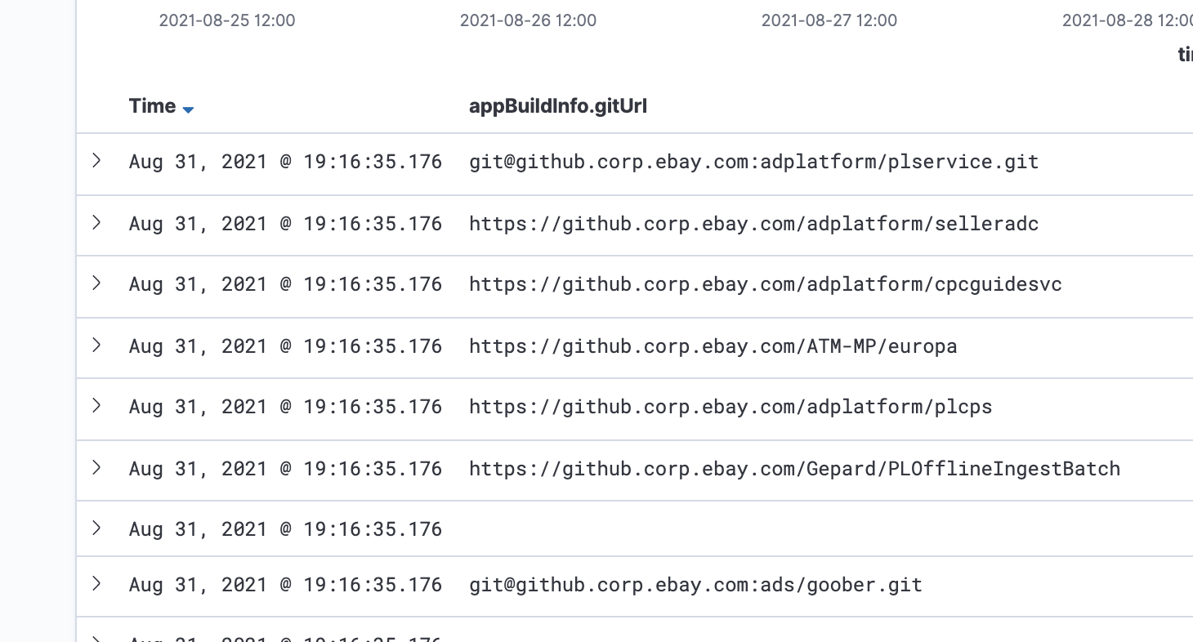

## 20210830 Day 16 Add GitHub Repo URL – fix issue AND Reporting Code Introduction

Task - 307 Add GitHub Repo URL to Pronto as a new field

* Fix issue on git url extraction

Meeting

* Deploy Batch in Pre-prod with Jenkins, eBay Cloud Platform, and Kibana (ES).
* Ads Infra US weekly
* Collab with Jason Chan
* Reporting Code Introduction with Huayi Tang
* Slide: https://docs.google.com/presentation/d/1mZ4h00Ocd6RJyWQC9CiU3NKuITRBbHuVR3qB-wRZpKI/edit#slide=id.g91f2c439fc_0_670
* https://ebay.zoom.us/rec/share/1Sqazb14f6KnCYGJ64isa-8hSZIoPqEUFKdf_cUmAeVgtSnt__279AWqvldgWdGU.A1-AlJSxR9WBmKoD Passcode: =v6#*0lq

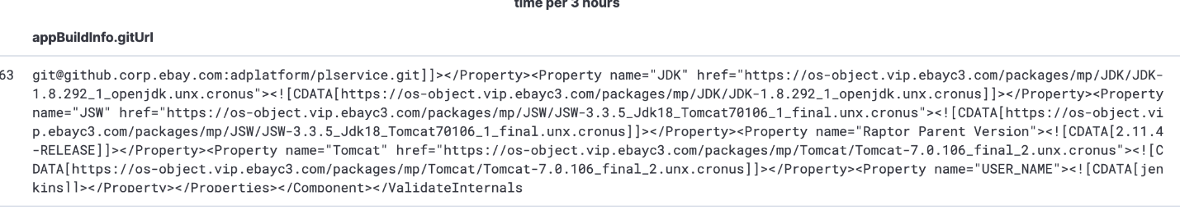

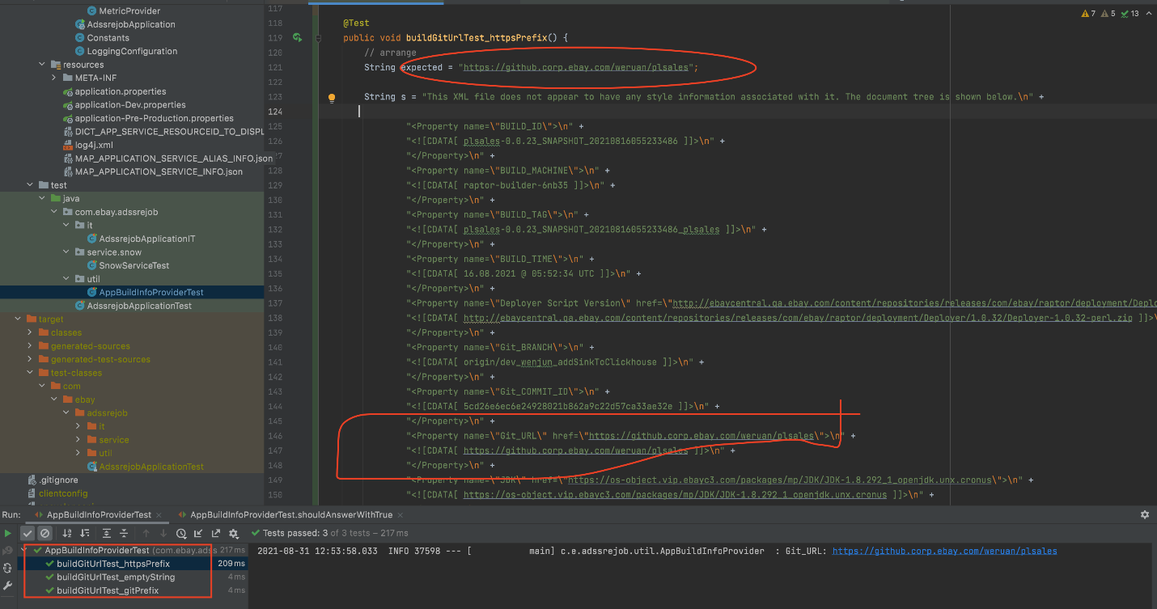

## 20210827 Day 15 Add GitHub Repo URL – code merged to main

Task - 307 Add GitHub Repo URL to Pronto as a new field

* Code merged to main branch original repo
* Checked on testing

Meeting

* Q3'21 Ads All Hands - Session 2
* Meeting with Jason Chan

## 20210826 Day 14 Add GitHub Repo URL – logic completed

Task - 307 Add GitHub Repo URL to Pronto as a new field

* Done with logic. Please check updates here: https://github.corp.ebay.com/adssre/adssrejob/pull/33
* Not done - end-to-end testing.

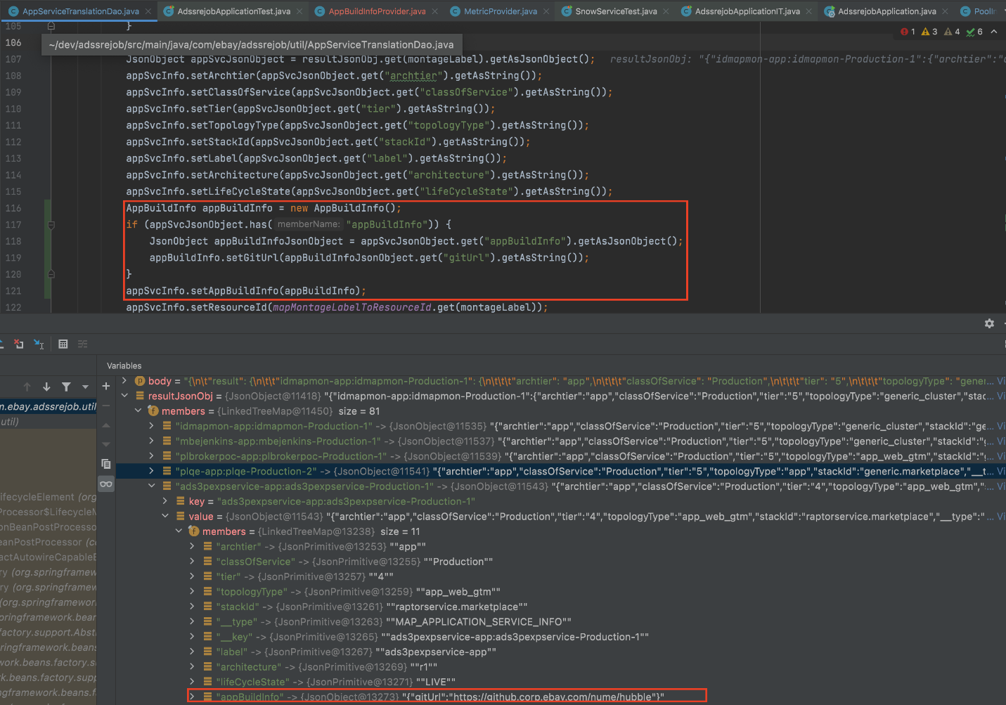

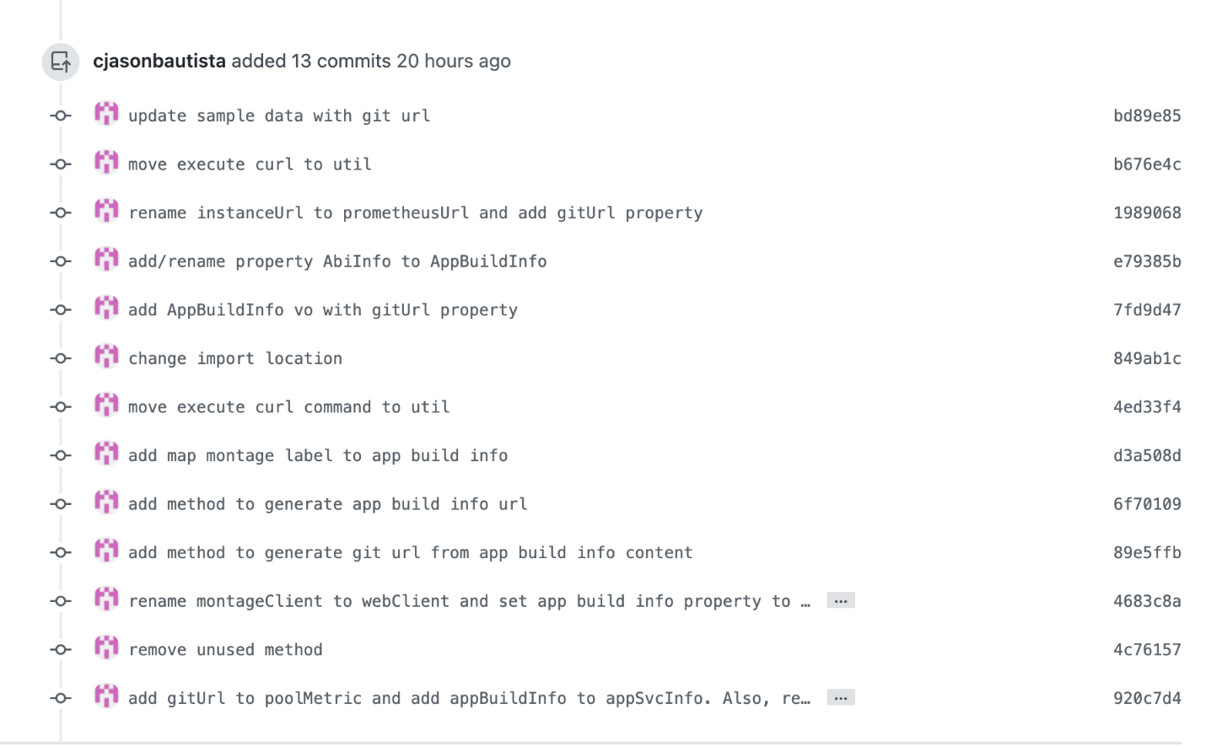

## 20210825 Day 13 Add GitHub Repo URL – sample hard-coded json

Task - 307 Add GitHub Repo URL to Pronto as a new field

* Completing hard-coded json response. (will continue working on it)
* Completing logic to read from hard-coded json response (will continue working on it)
* Here's a sample hard-coded json. Added a property appBuildInfo and nested property of gitUrl

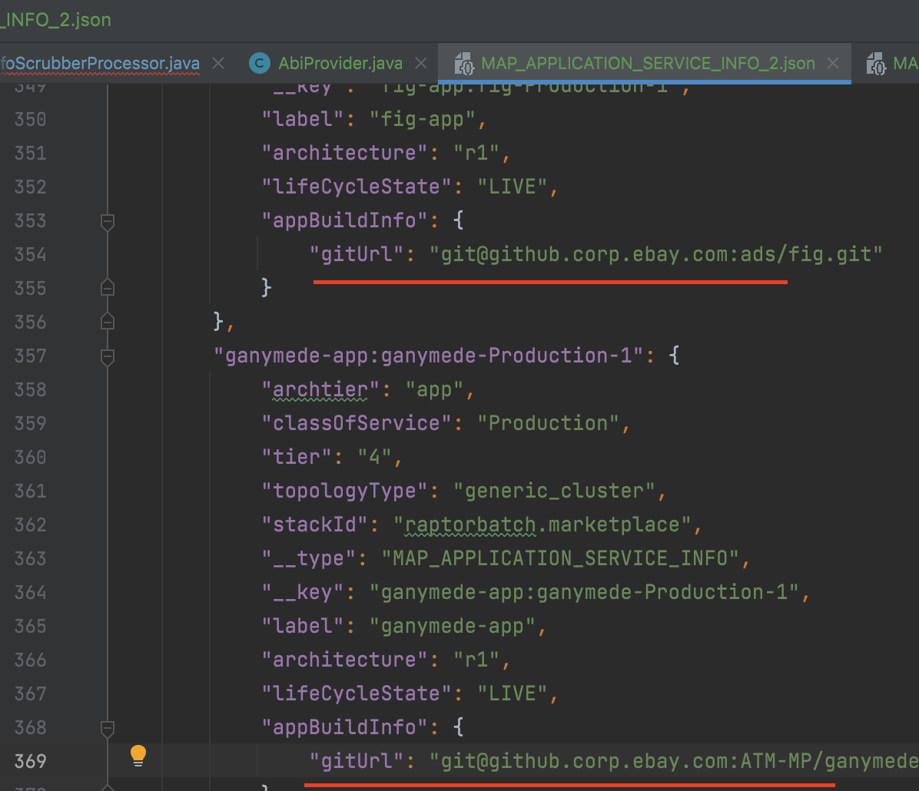

Ads Domain Review

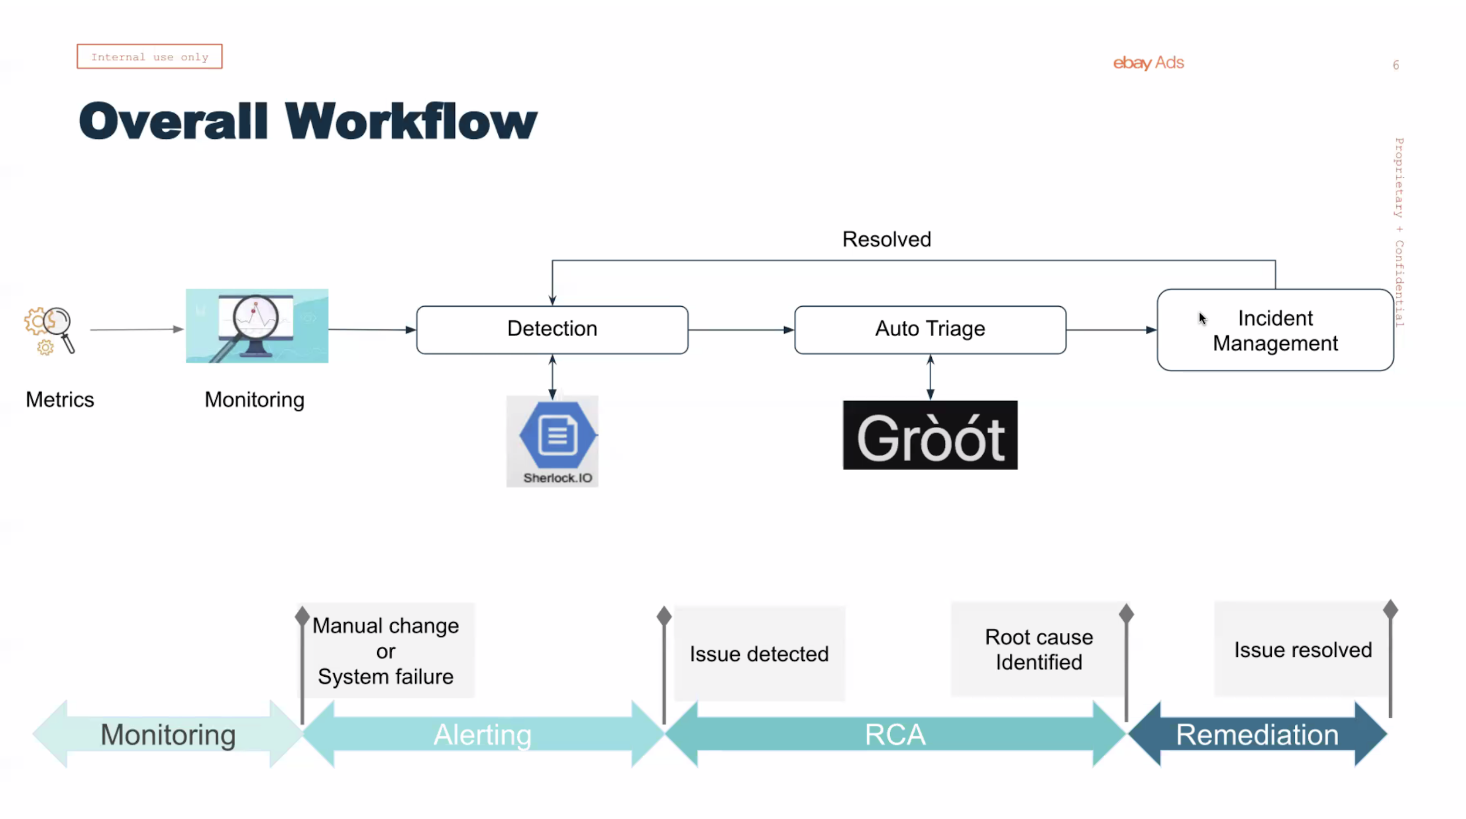

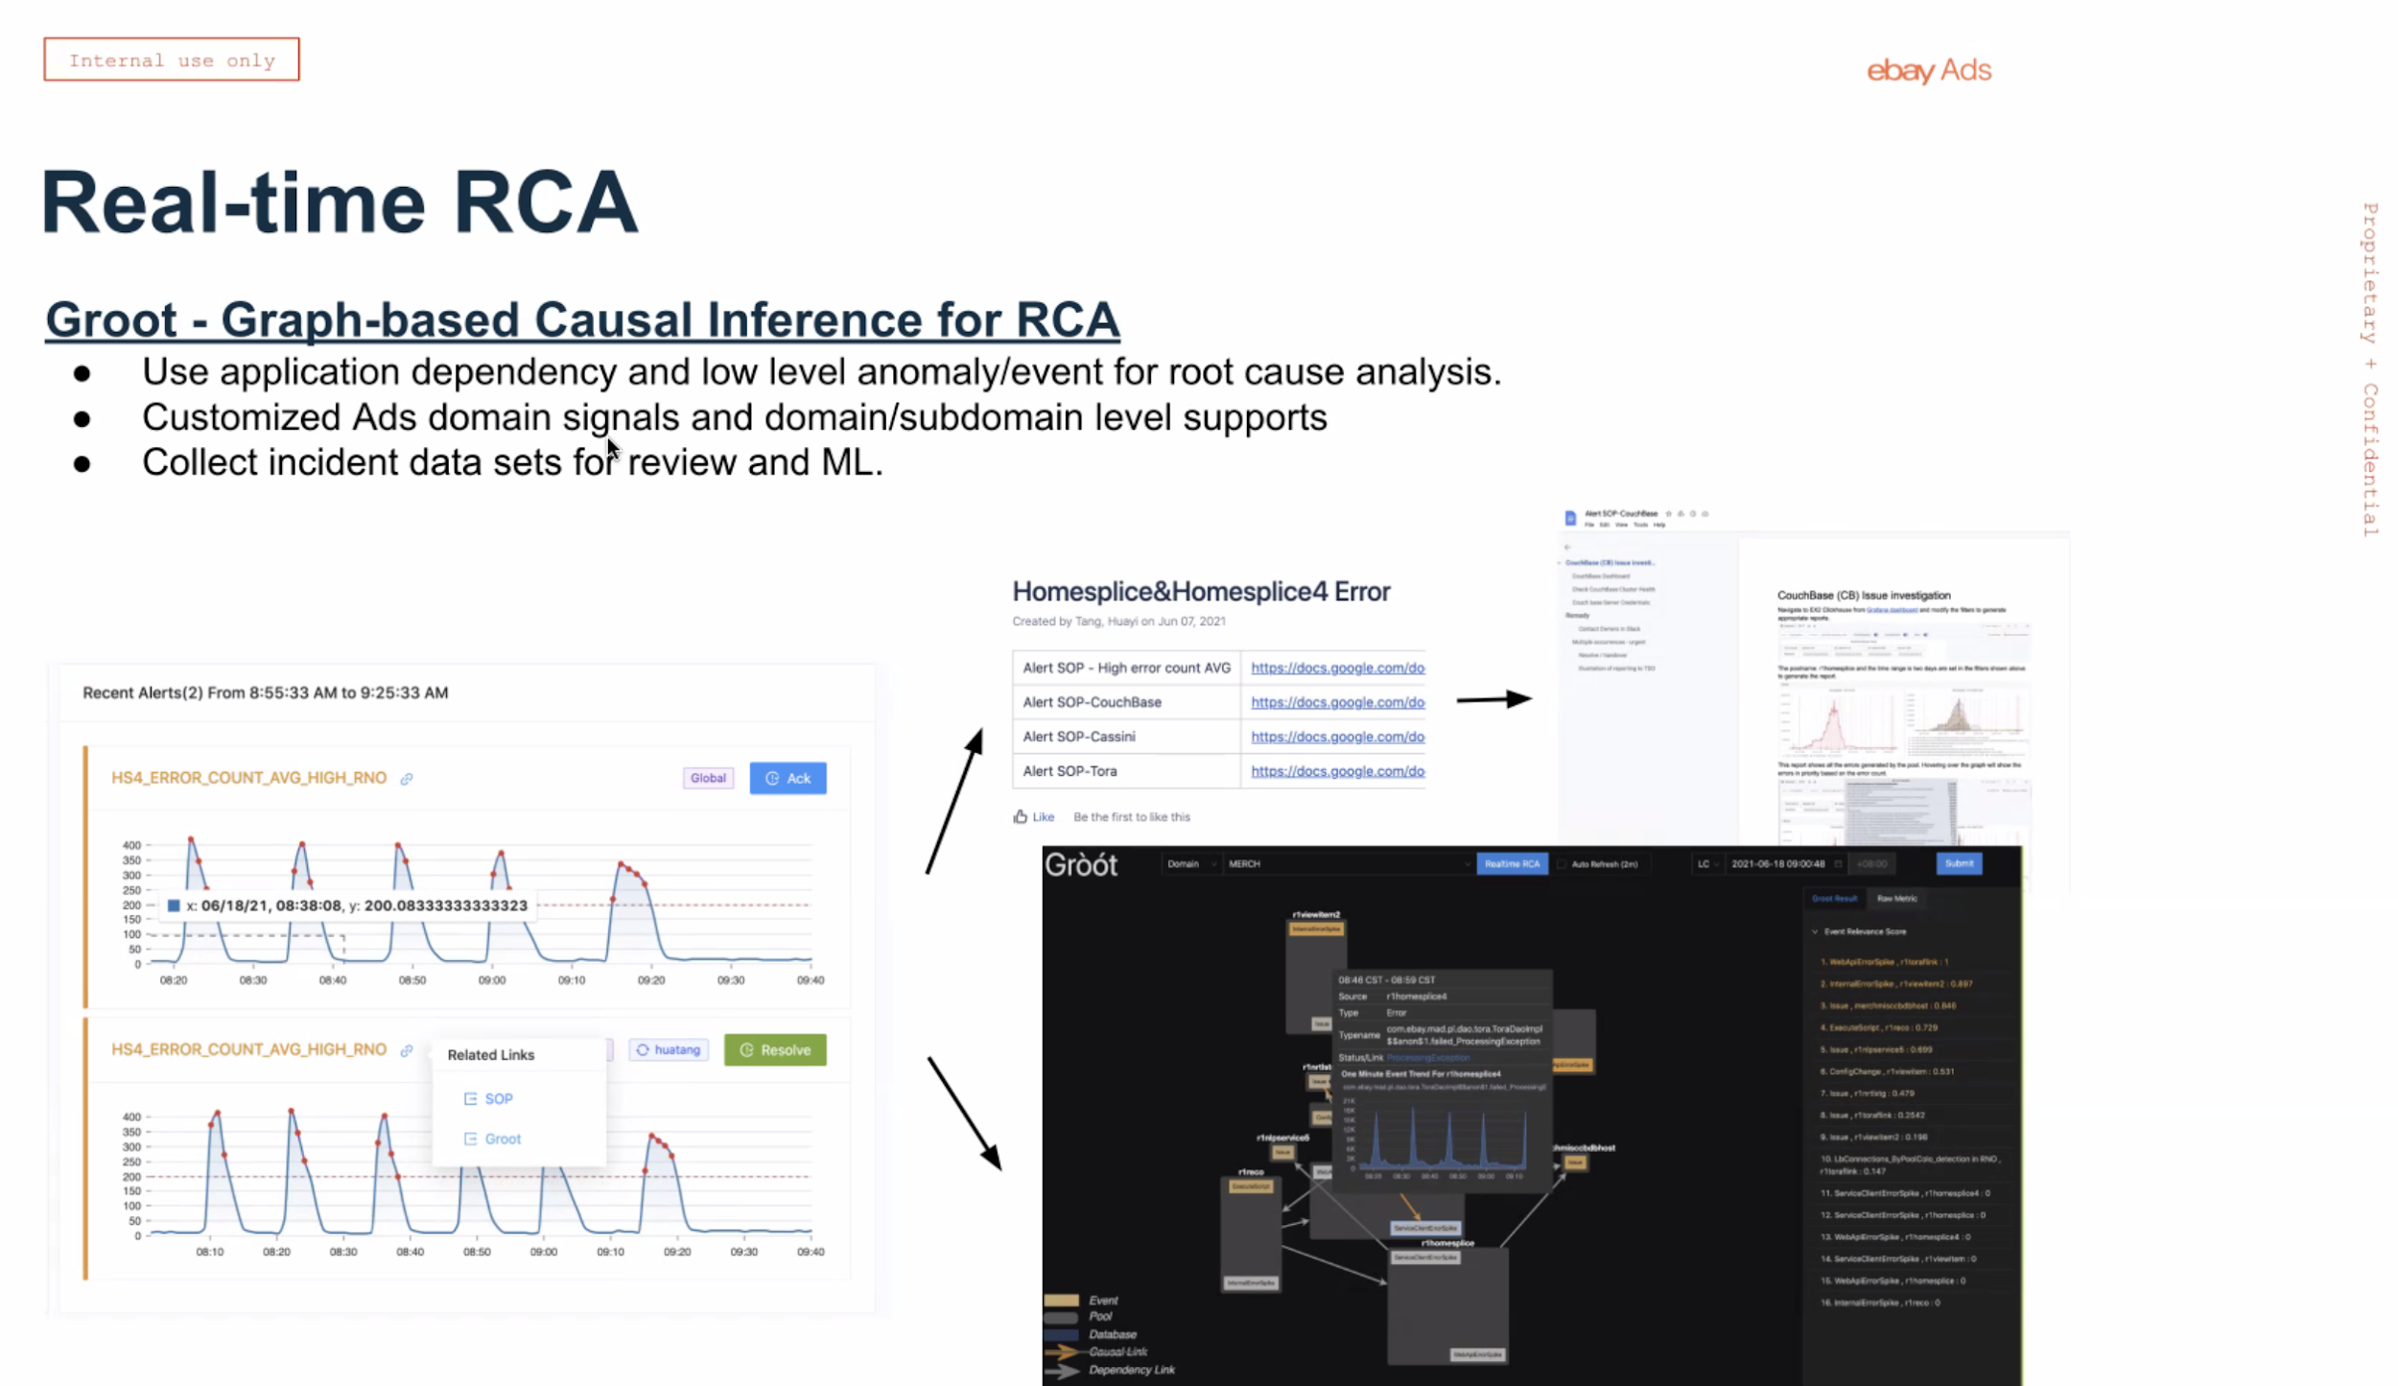

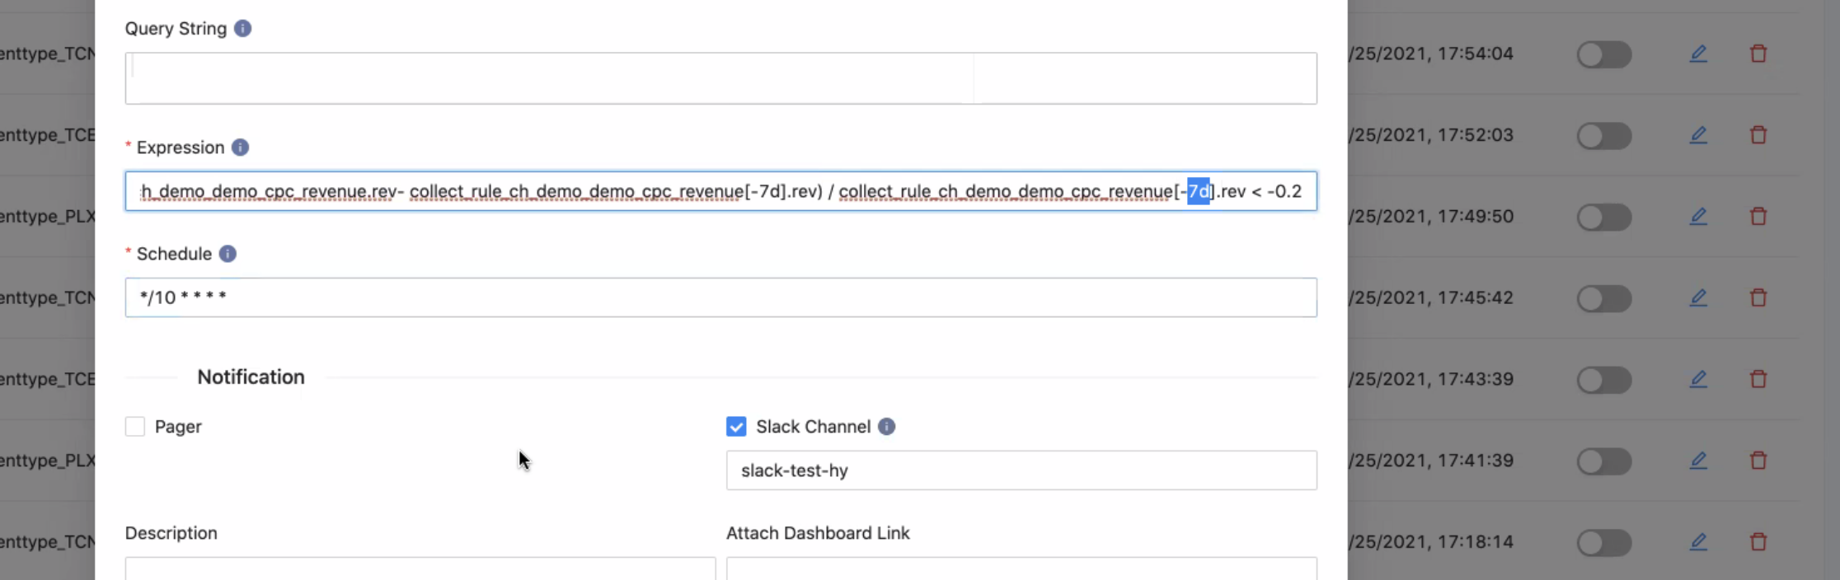

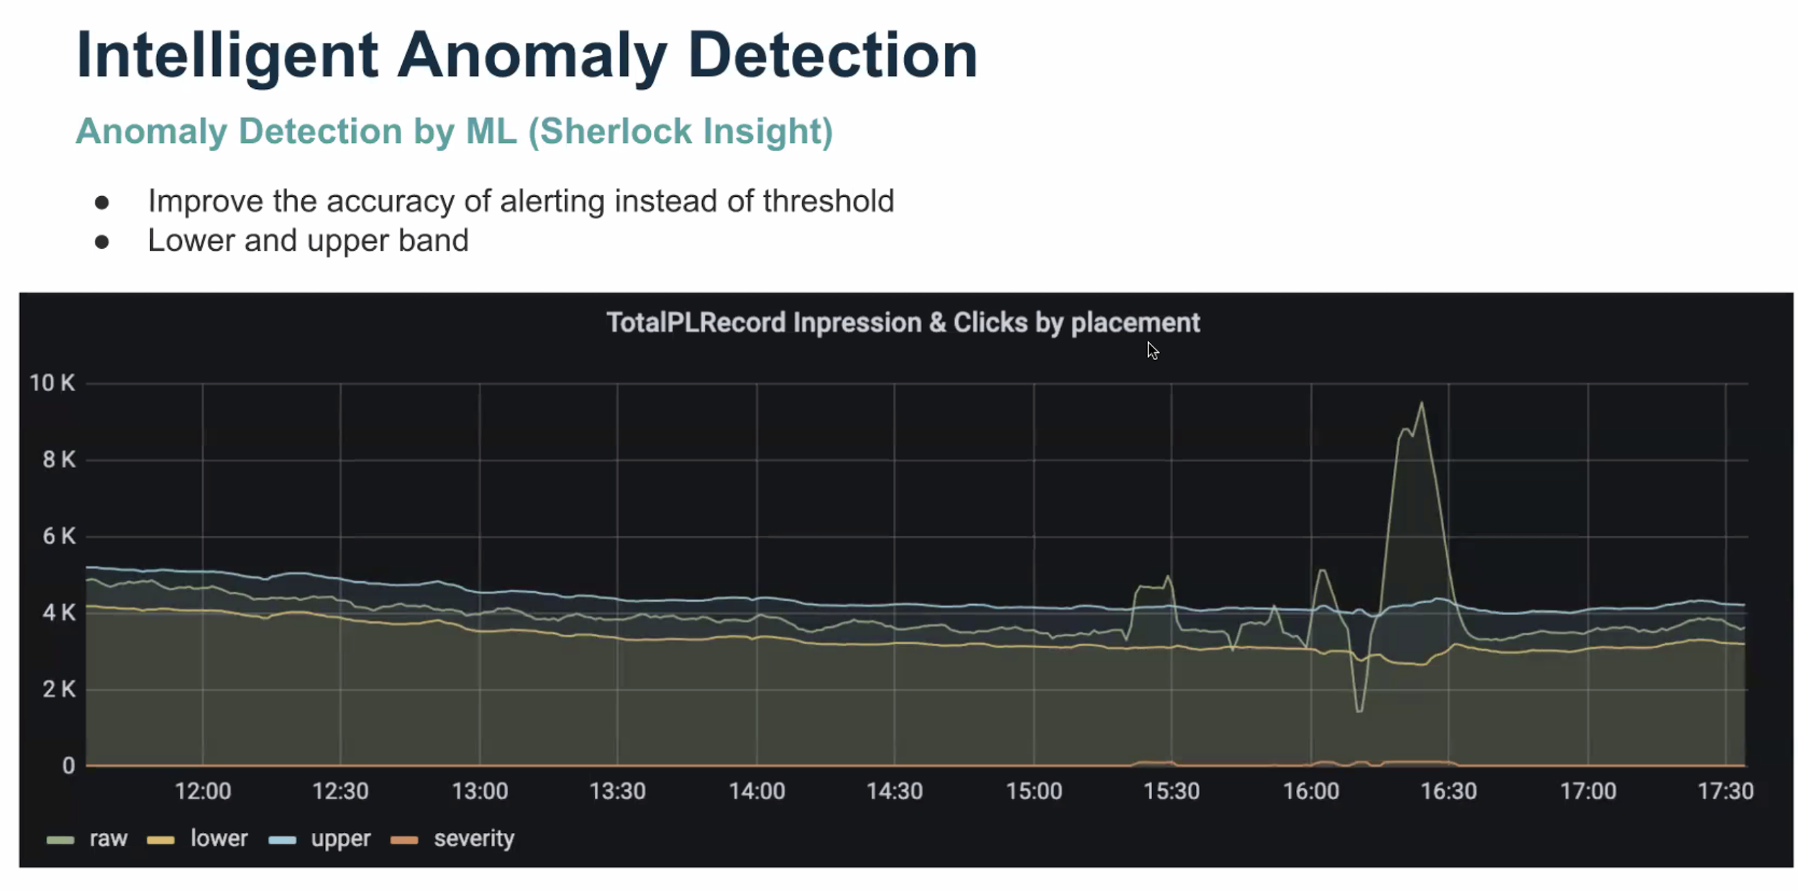

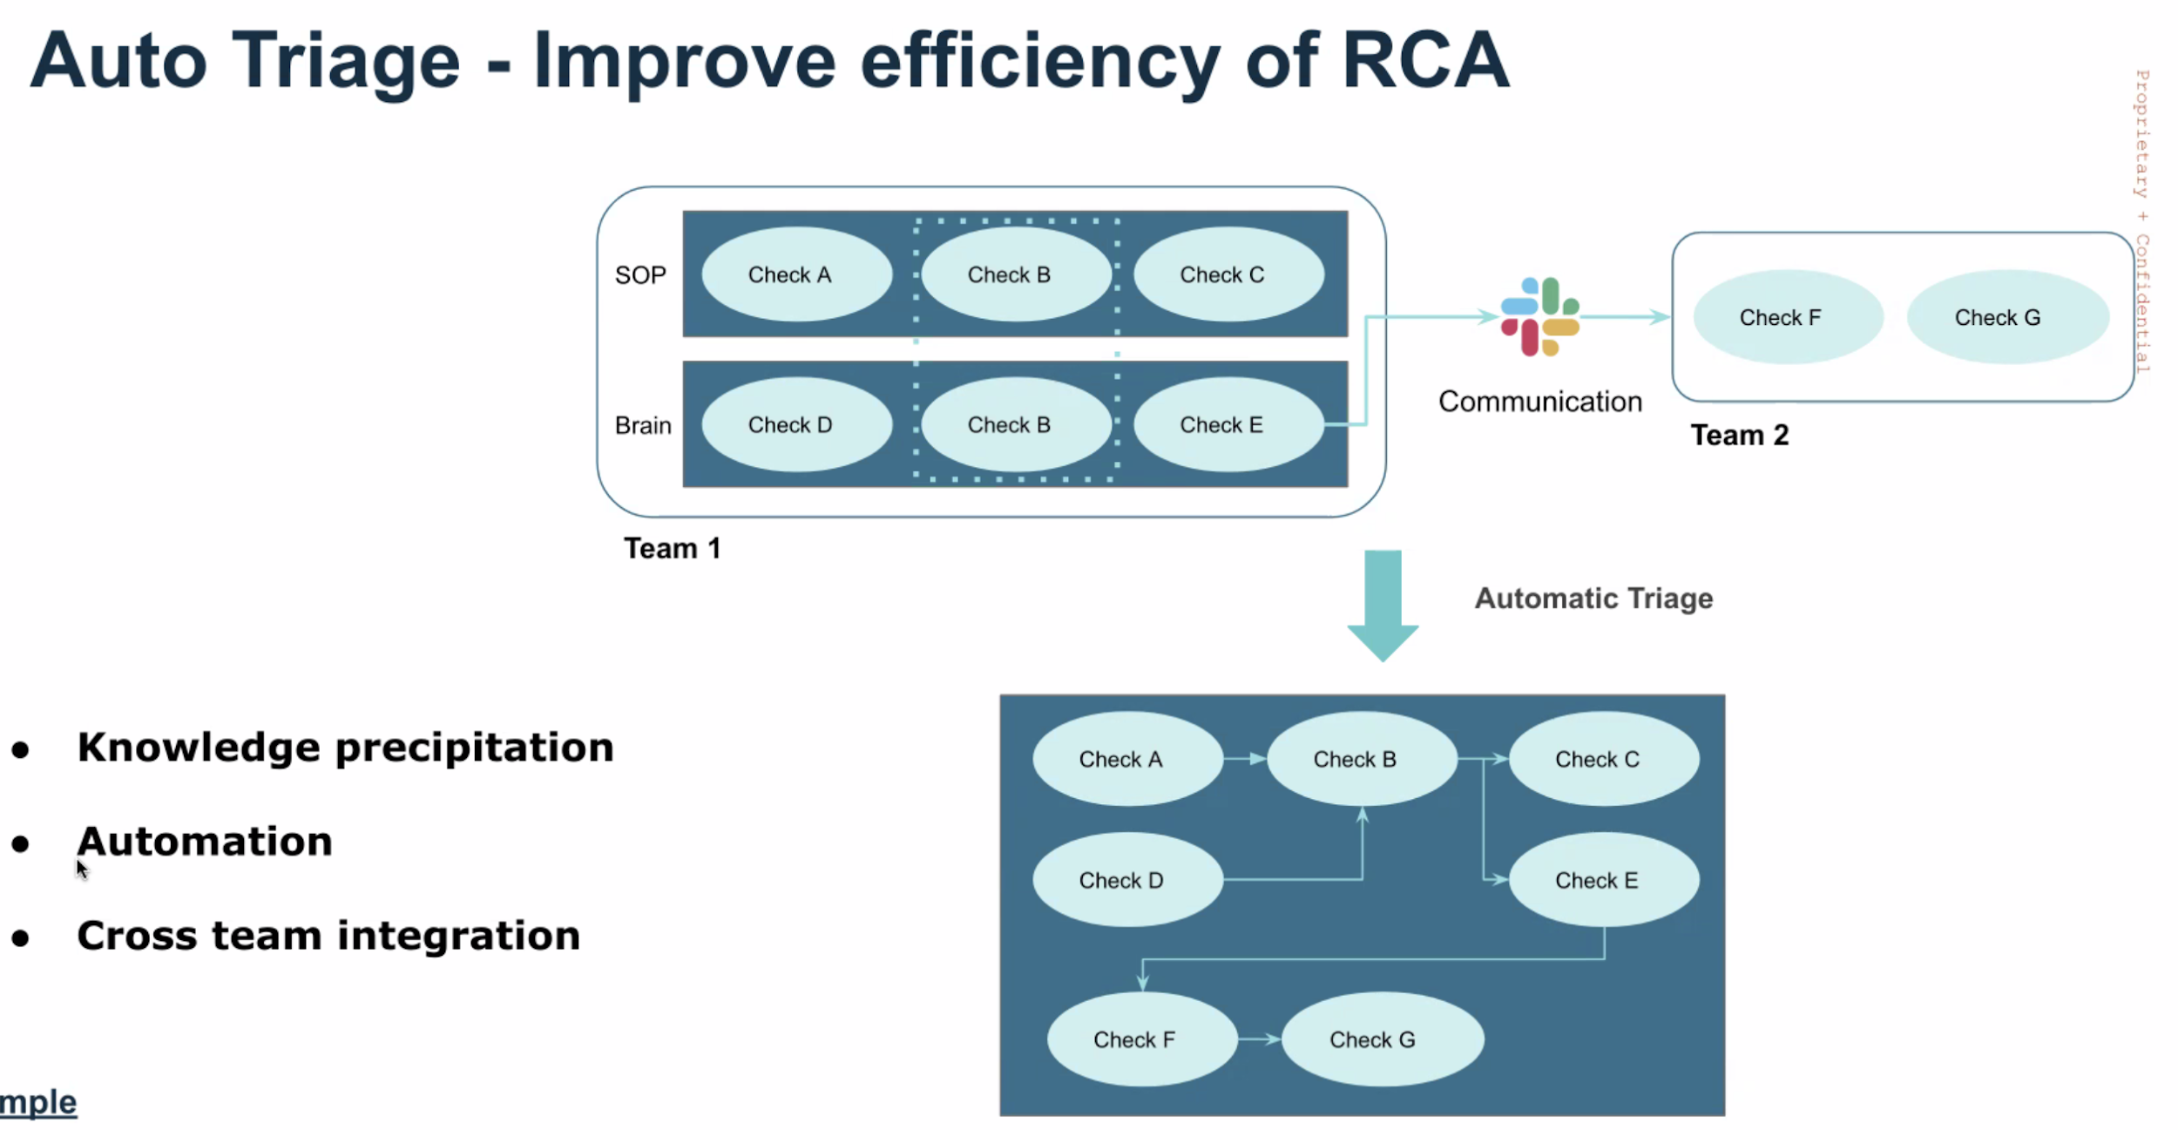

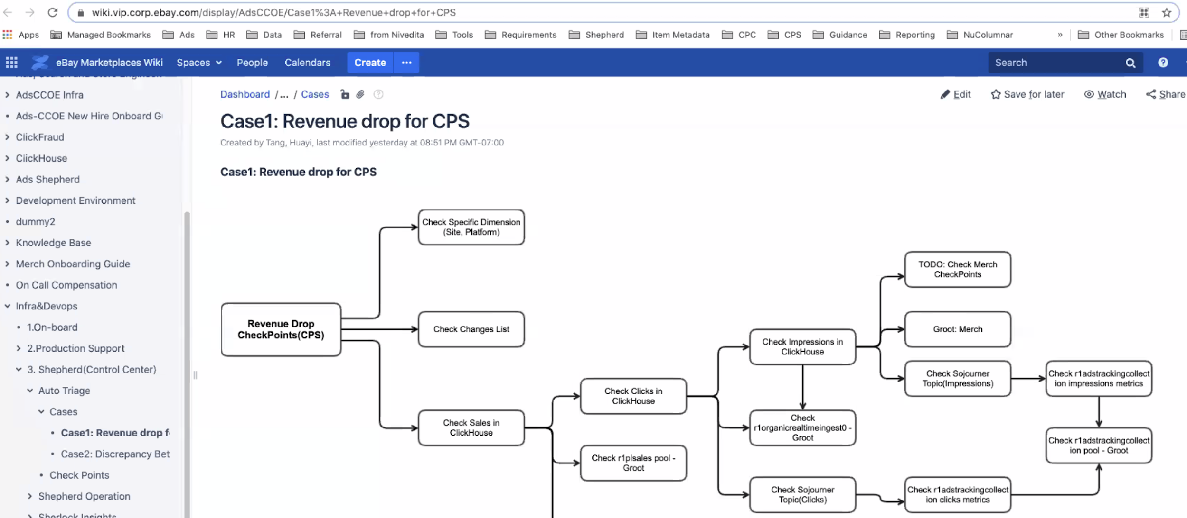

Ads sre sync up

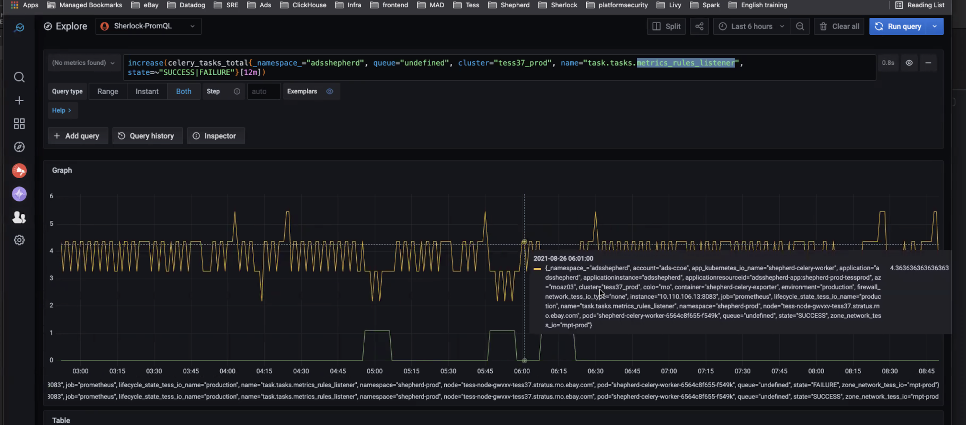

## 20210824 Day 12 Add GitHub Repo URL – refactor current variable names

Task - 307 Add GitHub Repo URL to Pronto as a new field

* Refactor - naming aliases, prometheus URL,
* Refactor - execCurl method to utils "console"
* Added - AbiInfo, abiUrl, gitUrl
* Added - AbiProvider - getAbiUrls, getGitInfoUrl

Meeting

* Meeting with Clark/Pavel X2

// Use RE to get the pool instance urls

String pattern = "\"service_hostName\":\".*\\.stratus\\.[a-z][a-z][a-z]\\.ebay\\.com";

Pattern r = Pattern.compile(pattern);

[11:38 AM] Map<String, String> mapMontageLabelToAbiUrl = abiProvider.getInstanceUrls(montageUrls, mapInstanceUrlToMontageUrl, mapMontageUrlToMontageLabel);

[11:39 AM] inside of loop

[11:39 AM] String abiUrl = mapMontageLabelToAbiUrl.get(montageLabel);

[11:40 AM] cmd = {"curl", abiUrl};

lines = metricProvider.execCurl(cmd);

// Analyze the content of the curl response and store the data

abiProvider.analyzeContent(descriptions, abiInfo, metricUnit, lines, name, namespace,token,montageLabel);

## 20210823 Day 11 Add GitHub Repo URL – debug and check variable contents

Task - 307 Add GitHub Repo URL to Pronto as a new field

* We read from ES or local
* MetadataProvider
* With default pool list
* poolList is: [r1sspbridge13, r1gshake, genericplzkpoc, r1gdpr4, r1homesplice, r1adstxt, r1plofinbat, r1adstrackingservice, r1advertisingaudience25, r1idmap, r1nori, r1sushi, r1gum]
* It gets assigned to names in AppServiceTranslationDao

AppSvcInfo

- has no instanceUrl etc

processDict

* Body - resourceId and label
* montageLabel = label. idmapmon-app:idmapmon-Production-1

mapResourceIdToMontageLabel

* Key: resourceId
* value: montageLabel

mapMontageLabelToResourceId

* key:montageLabel
* value: resourceId
* processAlias

mapAliasToMontageLabel

* Key: alias idmapmon-app:idmapmon
* value: montageLabel

AppSvcInfo

- architecture as montageLabel

- calPoolName as alias

mapMontageLabelToAppSvcInfo

* key: Montage Label
* Value: AppSvcInfo object

Meeting

* Meeting with Pavel
* Ads Infra US Weekly

We read from ES or local

MetadataProvider

With default pool list

poolList is: [r1sspbridge13, r1gshake, genericplzkpoc, r1gdpr4, r1homesplice, r1adstxt, r1plofinbat, r1adstrackingservice, r1advertisingaudience25, r1idmap, r1nori, r1sushi, r1gum]

It gets assigned to names in AppServiceTranslationDao

AppSvcInfo

- has no instanceUrl etc

processDict

Body - resourceId and label

montageLabel = label. idmapmon-app:idmapmon-Production-1

mapResourceIdToMontageLabel

Key: resourceId

value: montageLabel

mapMontageLabelToResourceId

key:montageLabel

value: resourceId

processAlias

mapAliasToMontageLabel

Key: alias idmapmon-app:idmapmon

value: montageLabel

AppSvcInfo

- architecture as montageLabel

- calPoolName as alias

mapMontageLabelToAppSvcInfo

key: Montage Label

Value: AppSvcInfo object

Hit 3 times

In poolinfoscrubberprocessor

Add another prometheusurl map

Remame instance url to prometheus url

If too long, refactor to a method

Create analyzeContent with xml and abiInfo

Hard code in execCurl

Either return line or xml

Instead of lines. Use xml, or

Get list of aliases

From an alias, get montageLabel

Build montageUrl with url + montageLabel

Some service instance (1st one) is down and 2nd one is up

Right now PagerDuty oncall is manually added as ads-sre-onshift on Slack

We will integrate this next time.

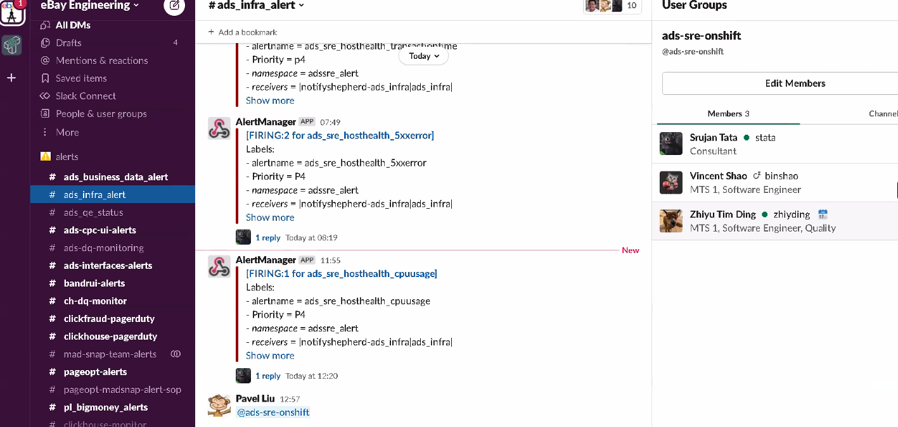Ads Infra alert

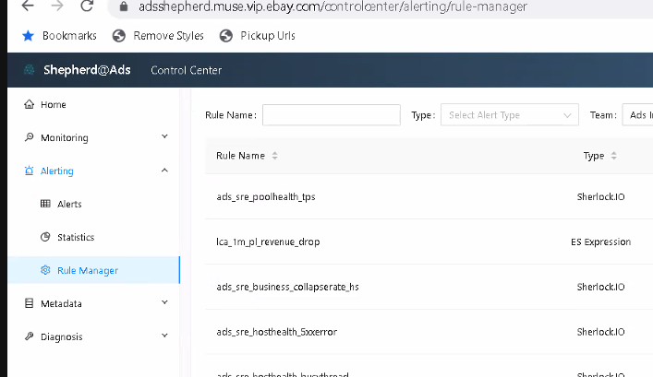

ads_sre_hosthealth_cpuusage

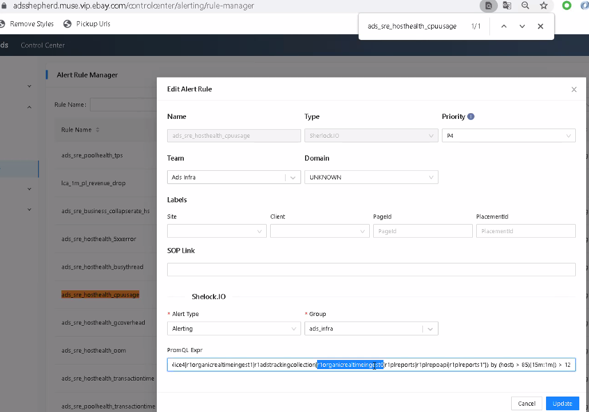

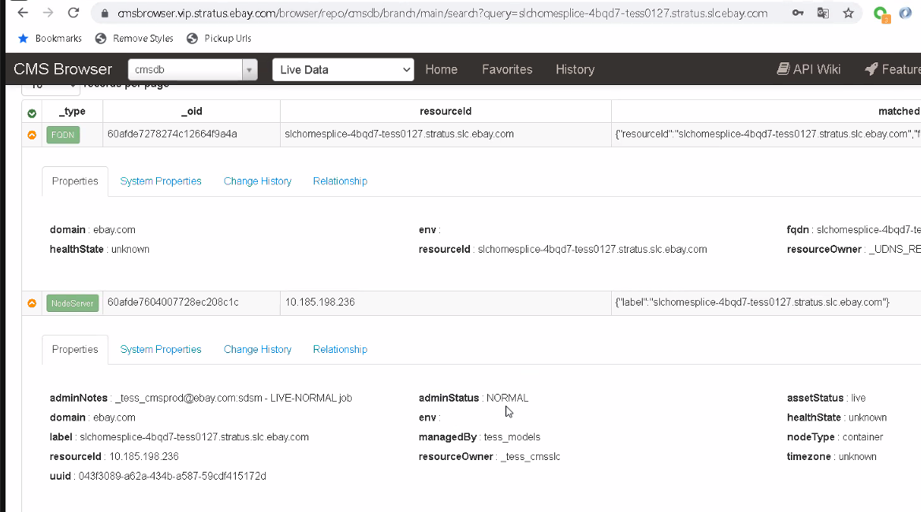

Instead of CMS, better to check montage. You can use the URL

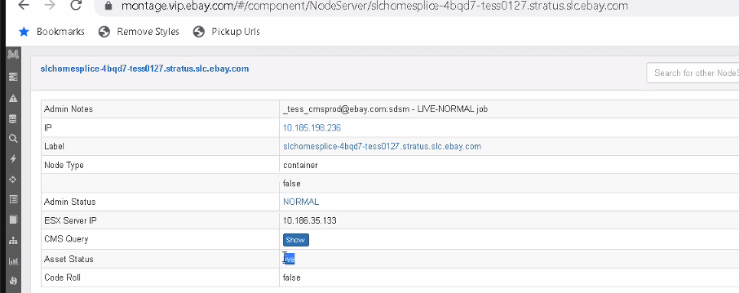

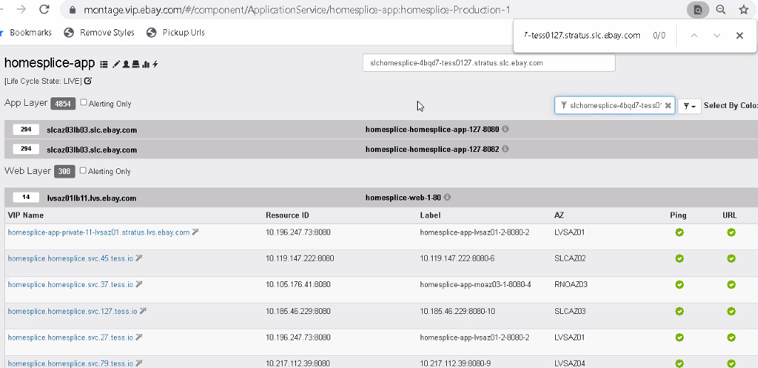

Check if enabled

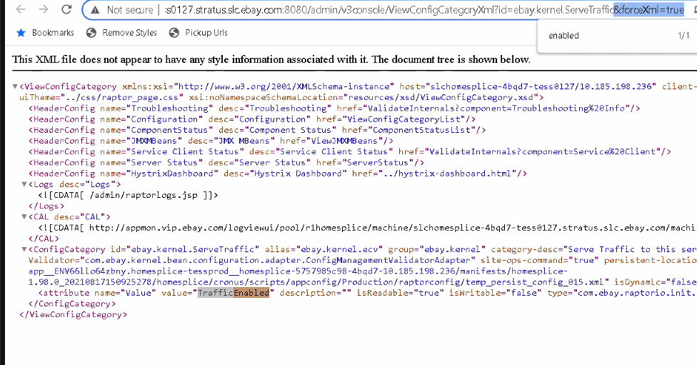

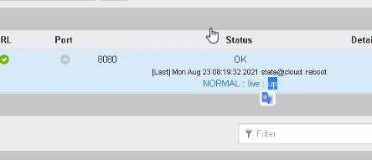

Suppress

Down

https://github.ebay.com/huyu/PLMetrics

## 20210820 Day 10 Add GitHub Repo URL – logic confirmation

Task - 307 Add GitHub Repo URL to Pronto as a new field

* Created an XML file (i.e. http://lvsplsales-5j97r-tess0075.lvs02.dev.ebayc3.com:8083/admin/v3console/ValidateInternals?componen[…]ication%20Build%20Information&forceXml=true)
* Read XML as String and grabbed git URL and CommitID
* Confirmation on association of contents to a service: git Url and Commit Id belongs to a service instance. a service instance belongs to a service (name).
* Confirmation on look up logic to get associated resource Id: validate internals xml has service instance with git url and git commit. I can map service instance to service name in couchbaseCache/get/MAP_APPSERVICE_TO_SERVICE:<service_name>. then map service name to resourceId in DICT_APP_SERVICE_RESOURCEID.
* Confirmation on where to add Git Url and Git Commit Id content. in DICT_APP_SERVICE_RESOURCEID?

Read

* Montage Wiki

Meeting

* Meeting with Pavel

## 20210819 Day 9 Add GitHub Repo URL – test and hypothesis

Task - 307 Add GitHub Repo URL to Pronto as a new field

* Empty instanceUrls for all MontageUrl
* Sample: https://montageapi.vip.ebay.com/components/dependency/ApplicationServiceDetail/fig-app:fig-Production-1 - http://lvsfig-6k4sx-tess0057.stratus.lvs.ebay.com
* Test/Debug 1: curl with valid URL + /admin/prometheus - no lines returned
* Test/Debug 2: curl with valid URL + /admin/v3console/ValidateInternals - no lines returned
* Test/Debug 3: curl with www.google.com OR https://baconipsum.com/api/?type=all-meat&paras=3&start-with-lorem=1&format=html- lines were returned
* Hypothesis: logic is working. maybe I just don't have access to Endpoint with curl on batch job. Batch Job curl cmd might require additional options to connect to eBay endpoints?

Meeting

* Meeting with Pavel
* Ads QE team biweekly meeting

http://lvsfig-6k4sx-tess0057.stratus.lvs.ebay.com

Meeting with Pavel

Fork the repo

Commit and push

So I save to the cloud

Use GUI - smartgit - check on Wiki

GitHub stuff is not metric

URL

Commit ID

Content Provider

OR Metric Info and Build Info

Yixin??

Keep debugging

Ads QE team biweekly meeting

OOSLA

Use automation and canary rollout

Ads is not doing well compared with other domains

LucidX

BugBash request

SoCal: Service Overview CAL with Deep Call Tracing

https://hubtv.corp.ebay.com/video/141840.aspx

## 20210818 Day 8 Control Center Demo

Meetings

* Join the eBay on Campus team for an innovation sharing session
* Velocity Demo Part II: Using Pact to Enforce Consumer Driven Contract Testing
* Control center demo for QE team
* Ads infra sync up Wed whole team

Task - 285 Sync EP snow ticket

* Confirmed to capture any data in touchstone API and change it afterwards

Learning

* Studying Spring Batch in Udemy
* eCommerce 101 on eBay

Setup

* PagerDuty

Control center demo for QE team

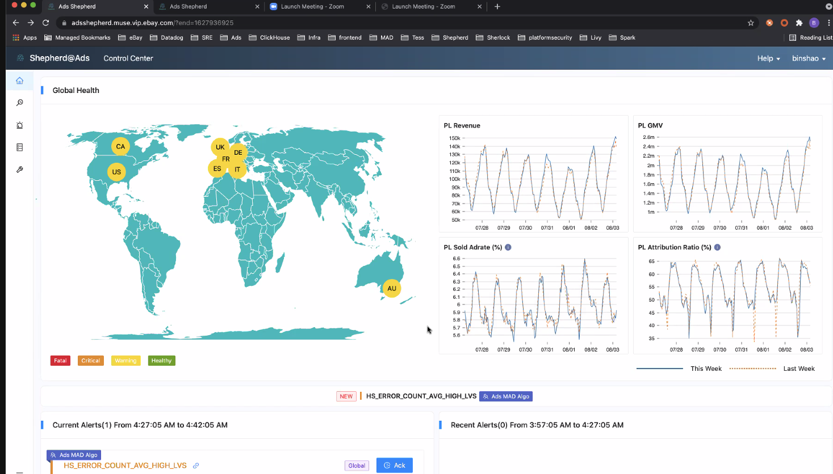

Four main parts

(Upperleft) Geomap for health states on 8 locations

* Fatal, Critical, Warning, Healthy
* Alerts are shown below the geomap

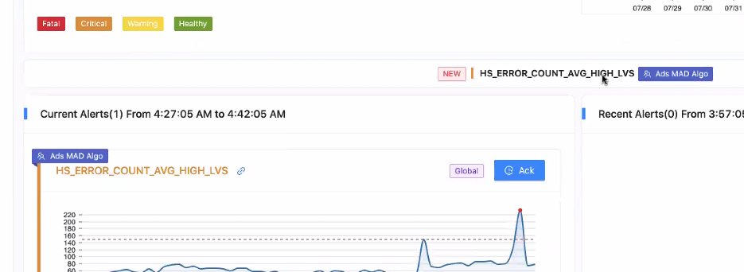

Shows which team is responsible. i.e. Ads MAD Algo

Current alert was for 5 minutes

They will also send a message to a Slack channel

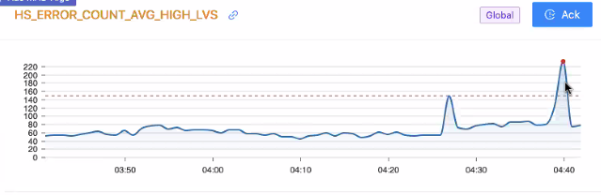

Metrics above the dotted line will trigger the alert

It also has a label “Global”

How to triage it? Click the related links

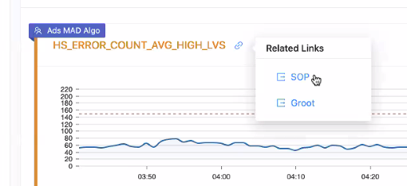

SOP directs you to the wiki

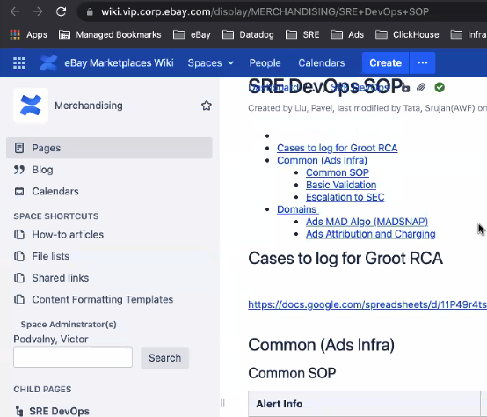

Then you can submit a ticket to the SRE team

For Groot

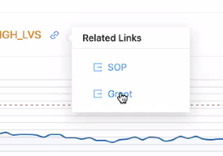

Groot will automatically run a procedure if there is any upstream or downstream relationship with the error.

Weiyu suggested to put the recipients so people would know.

If you want to take the alert

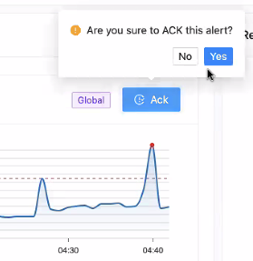

Once done, you can click resolve

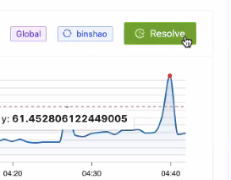

Then the Global Site health will turn green

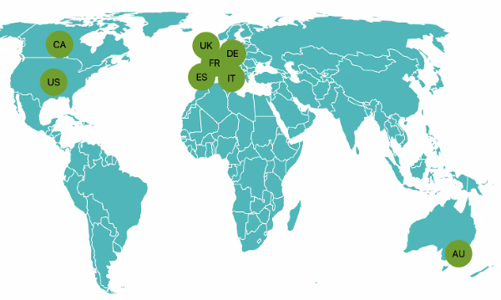

Currently the alert list is in the Control Center

Monitoring dashboard

Performance and Business tabs

Time range to explore the metrics

Campaign Type – PL, PLX, etc.

Metrics – Impression, Clicks

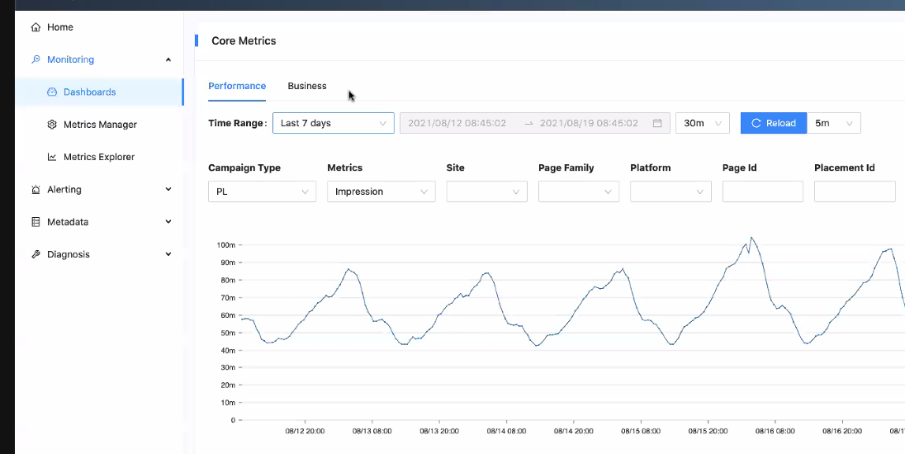

Business tabs

Campaign Type – PL, PLA

Metrics - GMV, PL Sold Ad rate, etc

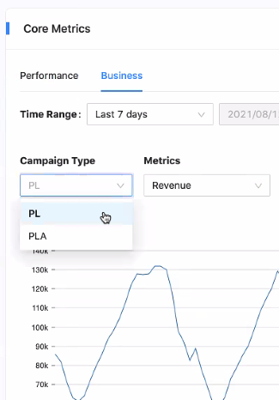

Compare History switcher with Compare With i.e. 14 days ago

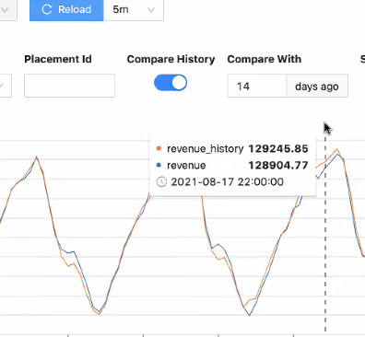

You can filter Alert Priority

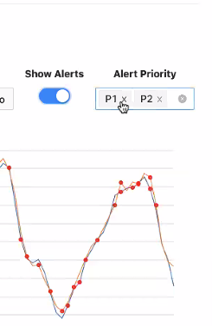

Monitoring > Dashboards

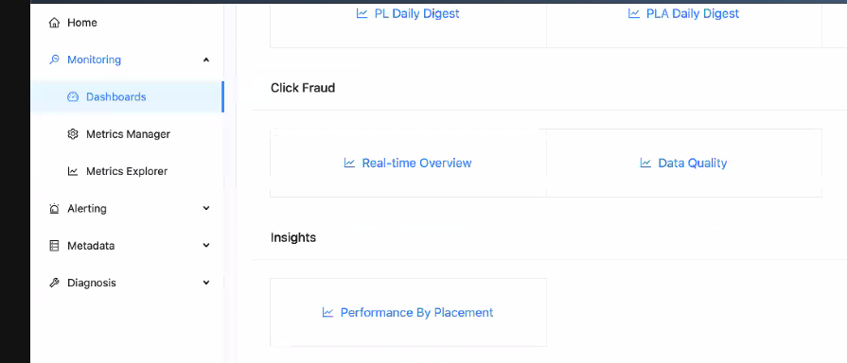

Creating Metrics Rule

Data Source: Spark SQL, ClickHouse SQL

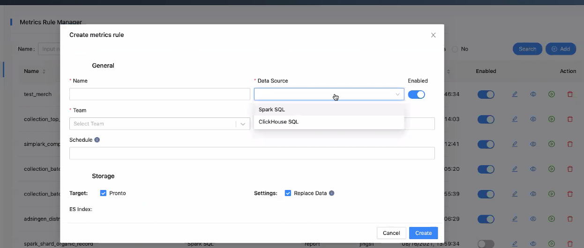

Backfill Time – collect data that would last for X number of days

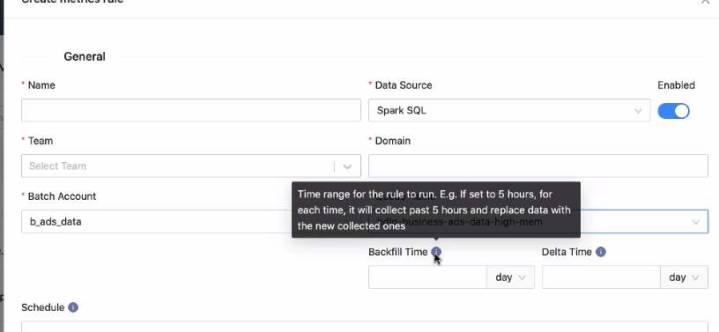

6 days ago to 1 day ago

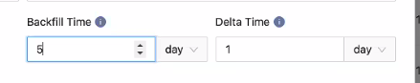

Search for Spark

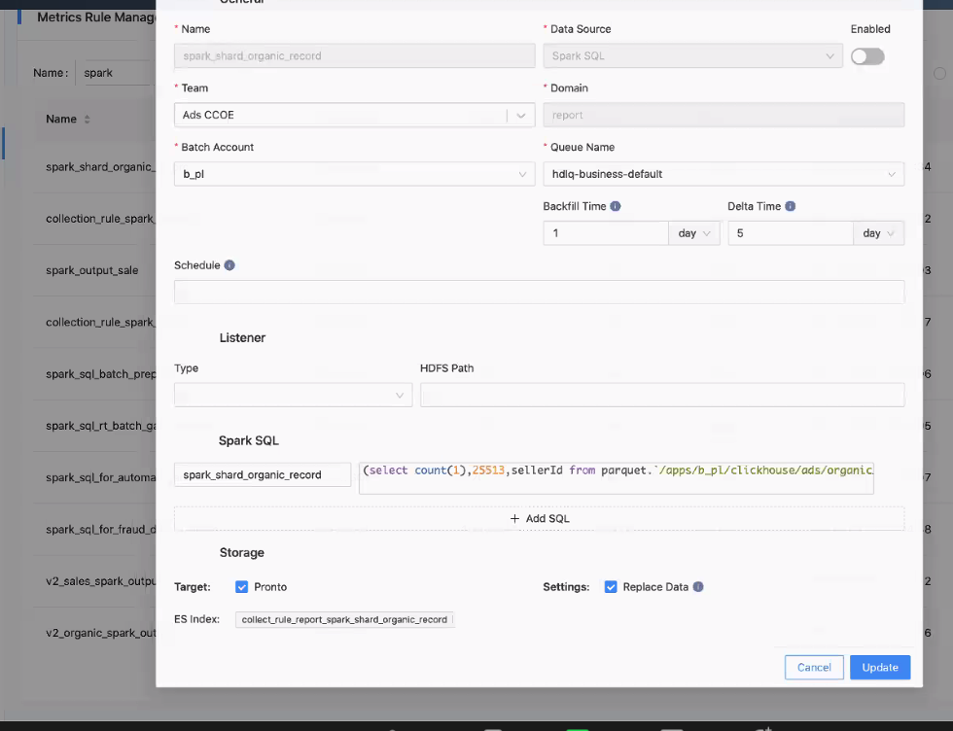

HDFS Path – has format of the date

User can add Spark SQL to get data from cluster

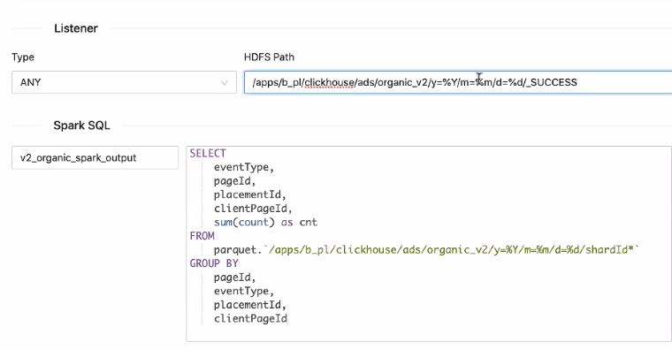

Target – Pronto

Replace Data if same

ES Index is automatically generated from Spark SQL name and rule name

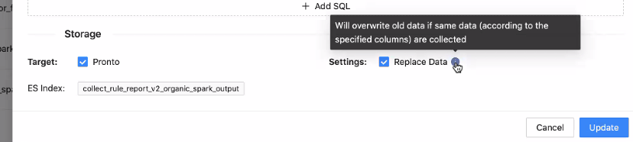

Preview icon

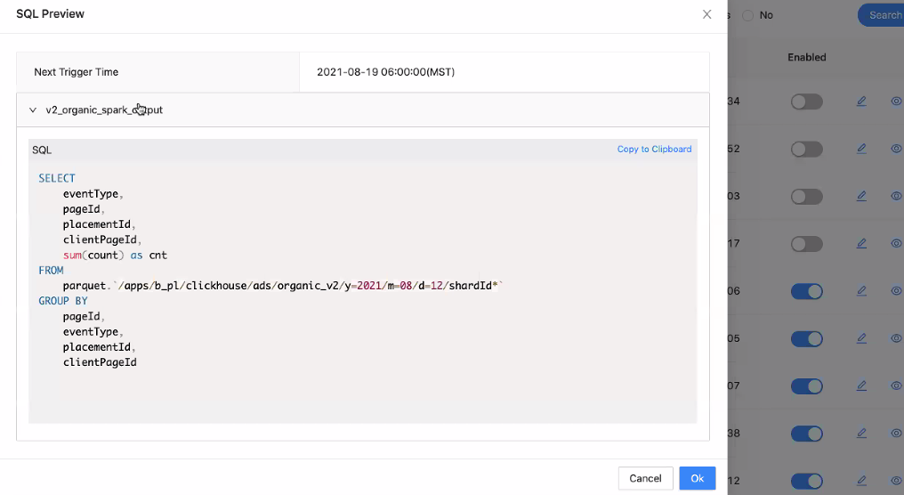

Metrics run button

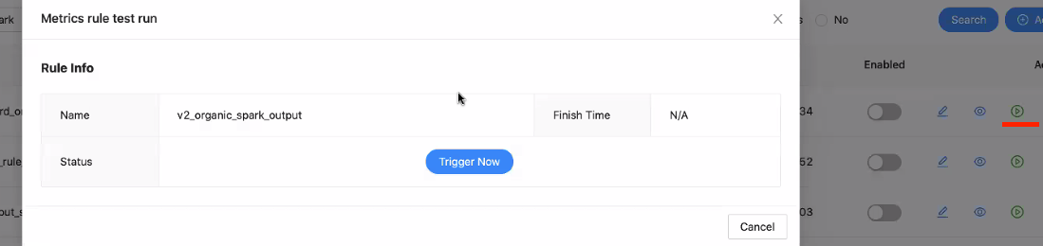

If metrics rule successfully run, we can explore with Metrics Explorer

Will automatically give you the index

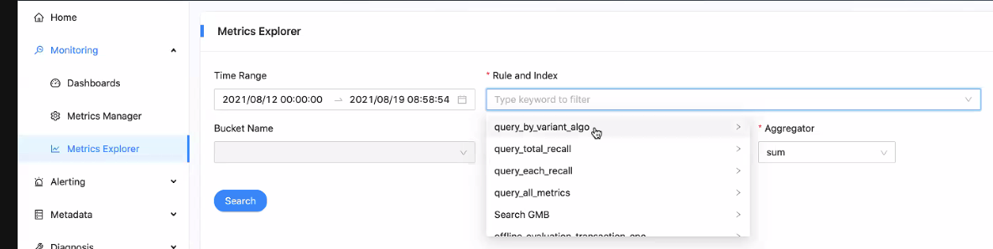

Currently supported aggregation

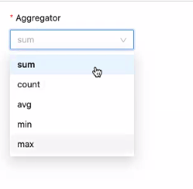

Core Metrics are predefined

Core Metrics are real-time

In pre-prod, will provide offline data in the future

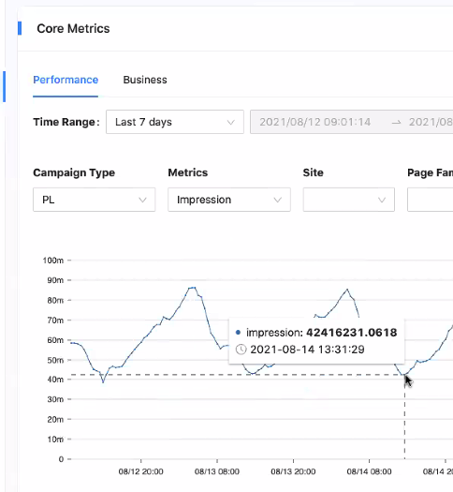

Metrics Rule are custom metrics

Ads SRE weekly meeting

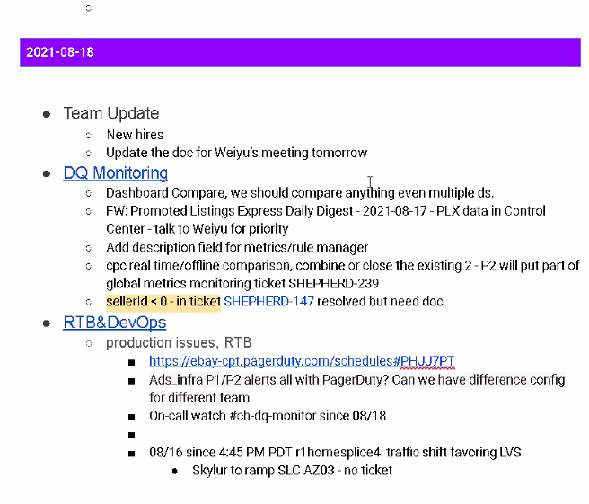

Need to setup PagerDuty

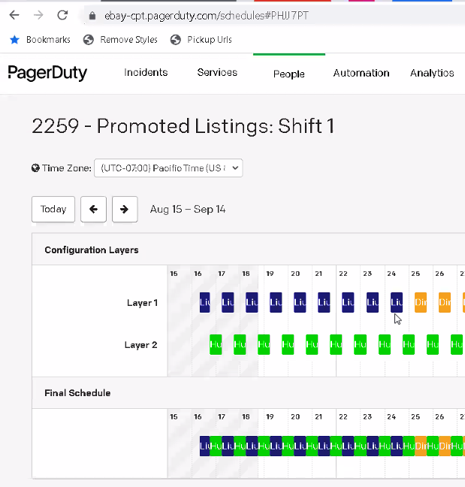

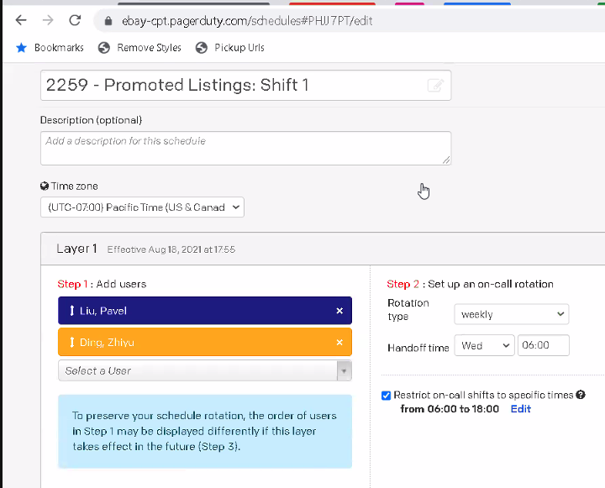

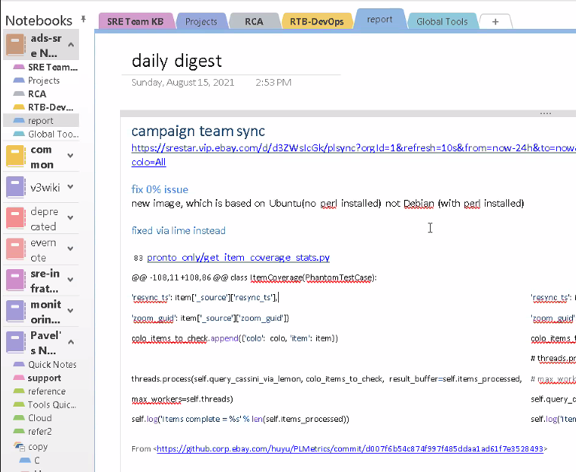

Important business alert to monitor

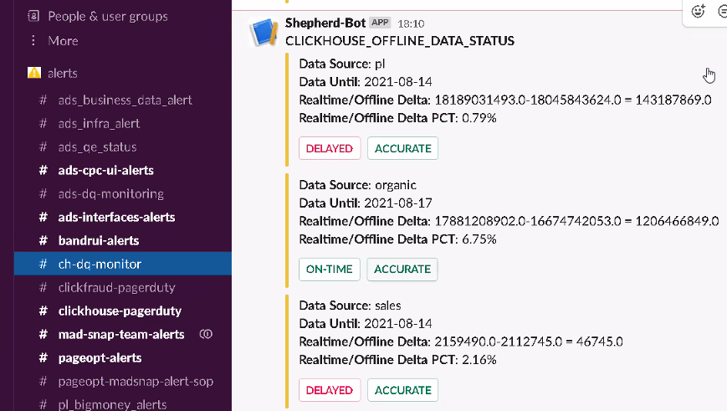

lvs has 3 ACs

Ask for Yixin Wang for Kibana QA

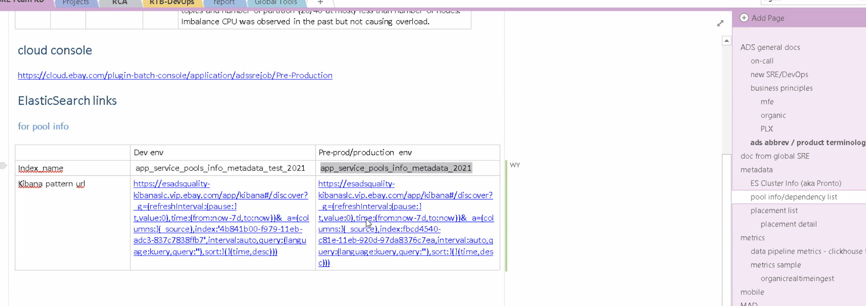

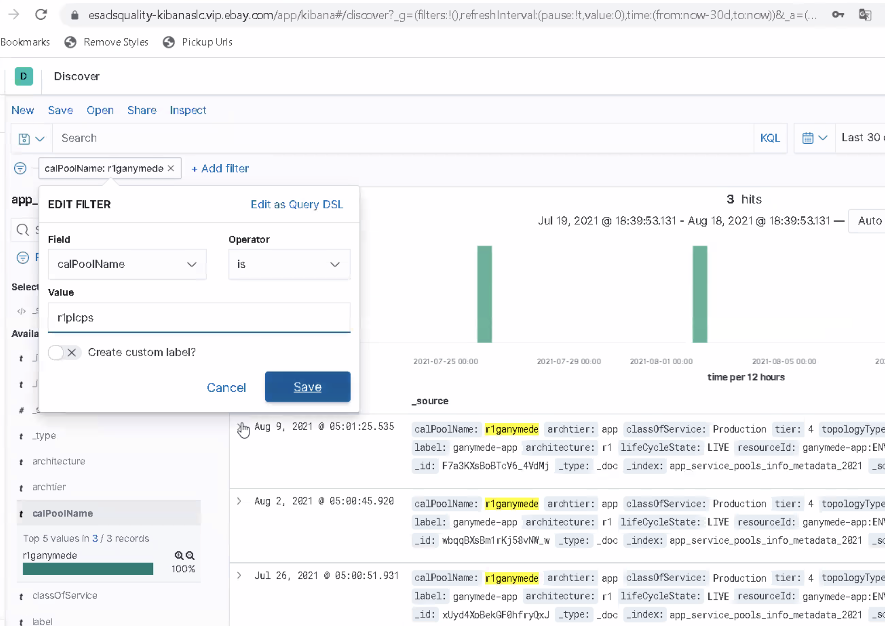

Velocity Demo Part II: Using Pact to Enforce Consumer Driven Contract Testing

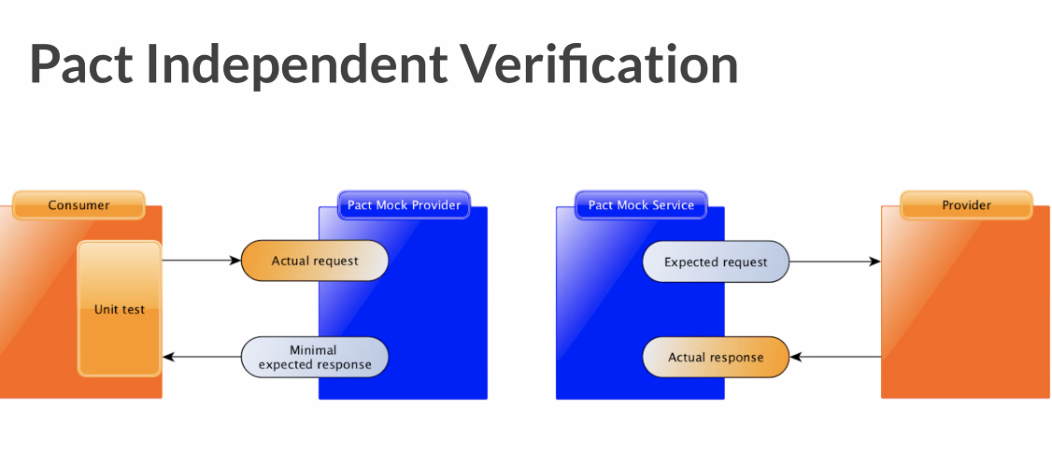

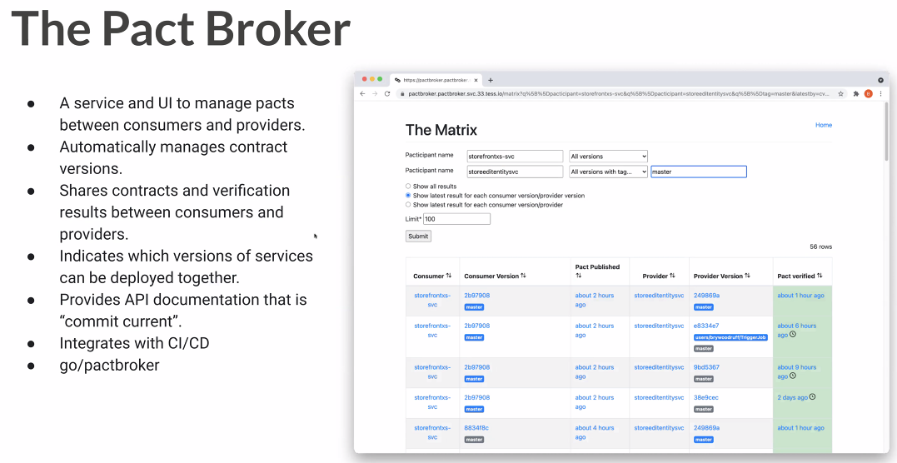

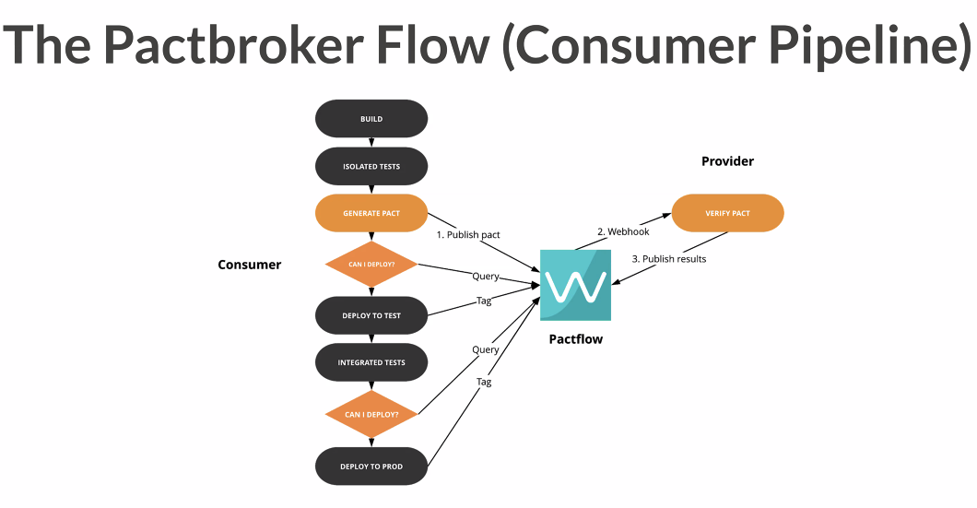

## 20210817 Day 7 GitHub Repo URL and EP Change

Task - 307 Add GitHub Repo URL to Pronto as a new field

* Added logic to add additional instance urls to iterate to with slug :8083/admin/v3console/ValidateInternals?component=Application%20Build%20Information&forceXml=true
* Added logic to extract GitHub URL for the additional endpoint

Need to debug and check output in dev

Task - 285 Sync EP snow ticket

* question to Huayi / UI - which fields do I need to capture from touchstone API
* question to Huayi/Pavel - which business units to capture aside from 1 - ads and 21 - merch

Meeting with Yichao

## 20210816 Day 6 Pool metrics, Clickhouse, and Tabix

**Pool metrics in ES**

Tim Makhmutov from Amsterdam

ES we can do some curl command

Previously in metadata page

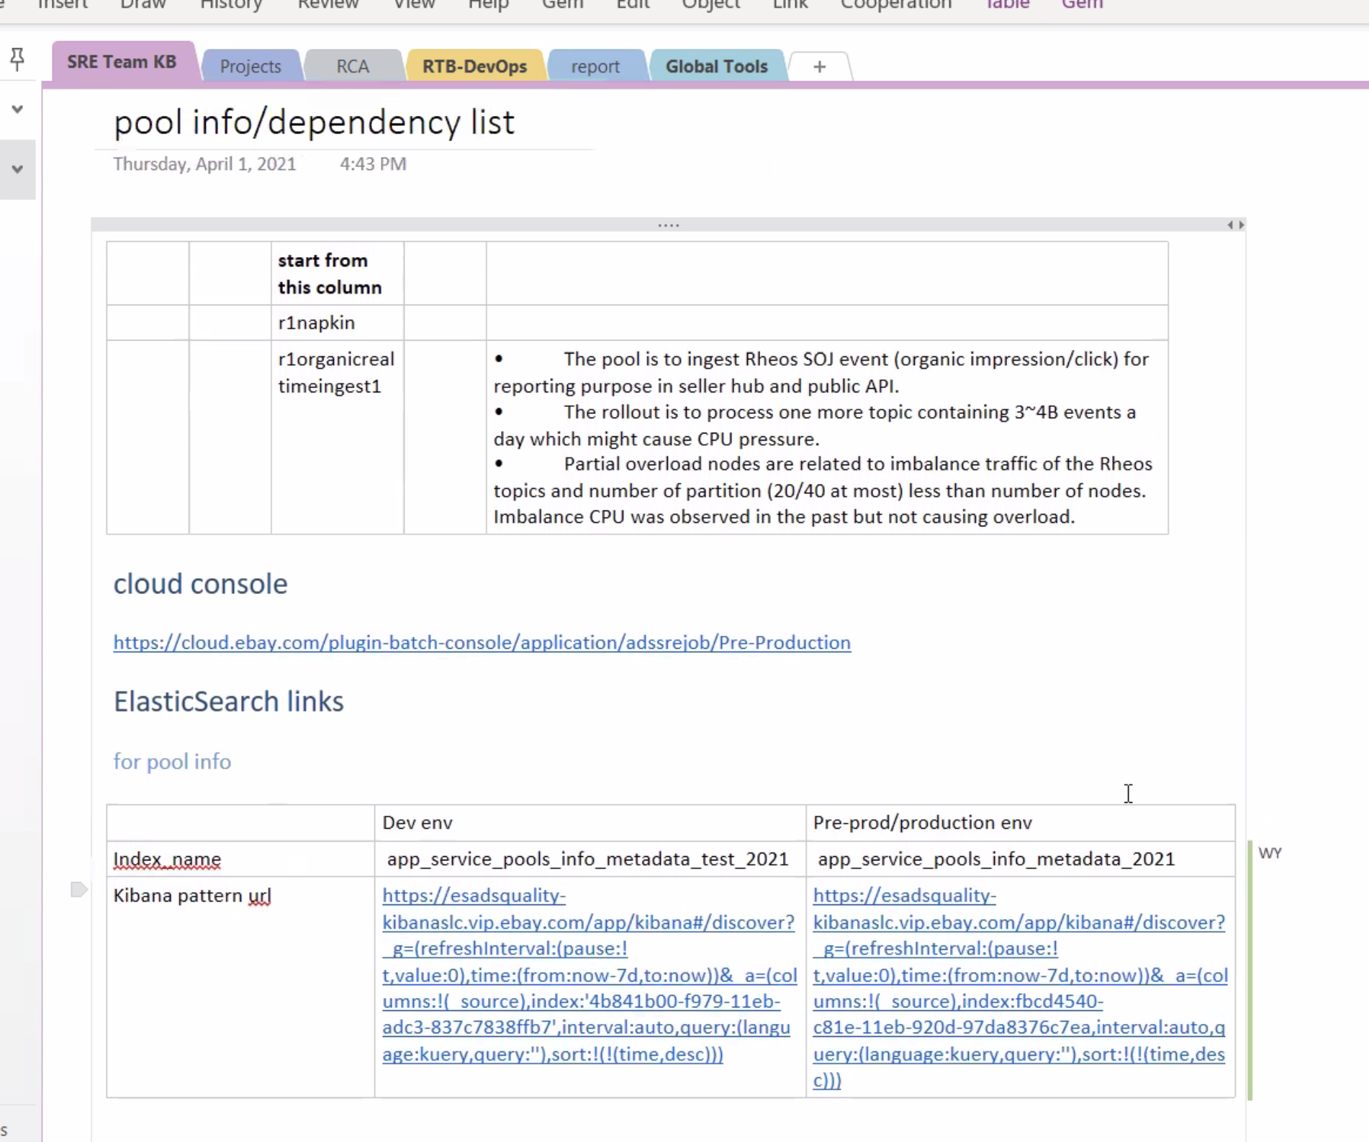

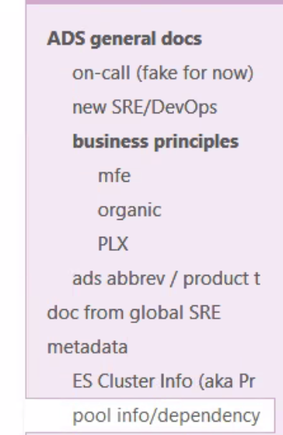

Add a column for PR monitoring that Timur can use.

Pool info and dependency info

We would ask ES for the PR.

Sync up with Huayi

Clark will add a column in RaptorBatch. Doesn’t make sense to add in Python anymore.

Timur want to see the PR to increase involvement.

2nd thing

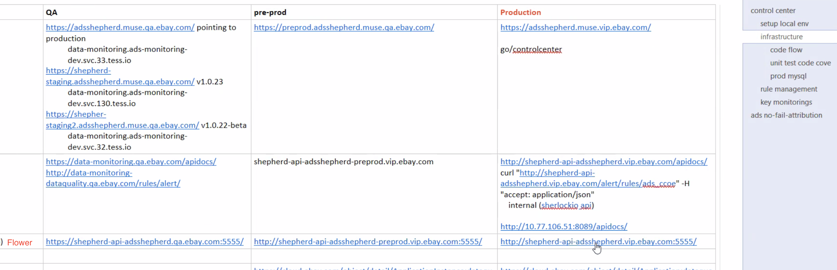

Get training from Huayi

RaptorBatch is eBay standard approach

We can do build here <https://cloud.ebay.com/app/detail/adssrejob/overview>

You will see a new manifest page in the new code.

**Weekly learn from Honghao**

2 events

* PL sales map
* Remove existing organic event

I’m a seller, I have an item with campaign. CPC click per cost. CPS click per sales.

Sold as organic. Not through ads.

Organic – not part of campaign, listed as common item.

PL enabled – enabled as promoted listing

Attribution rate – higher is better

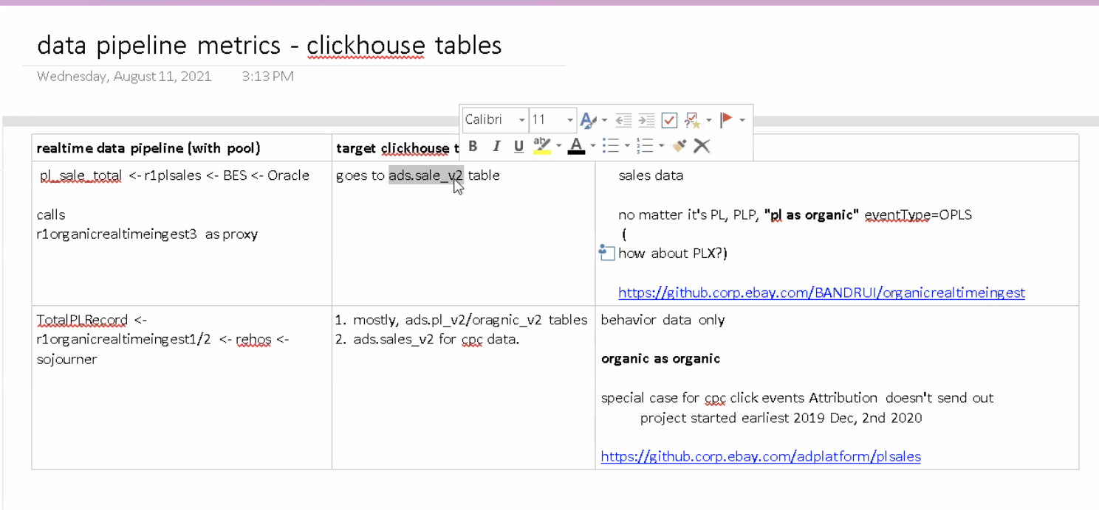

ClickCube

Query data in clickhouse and visualization

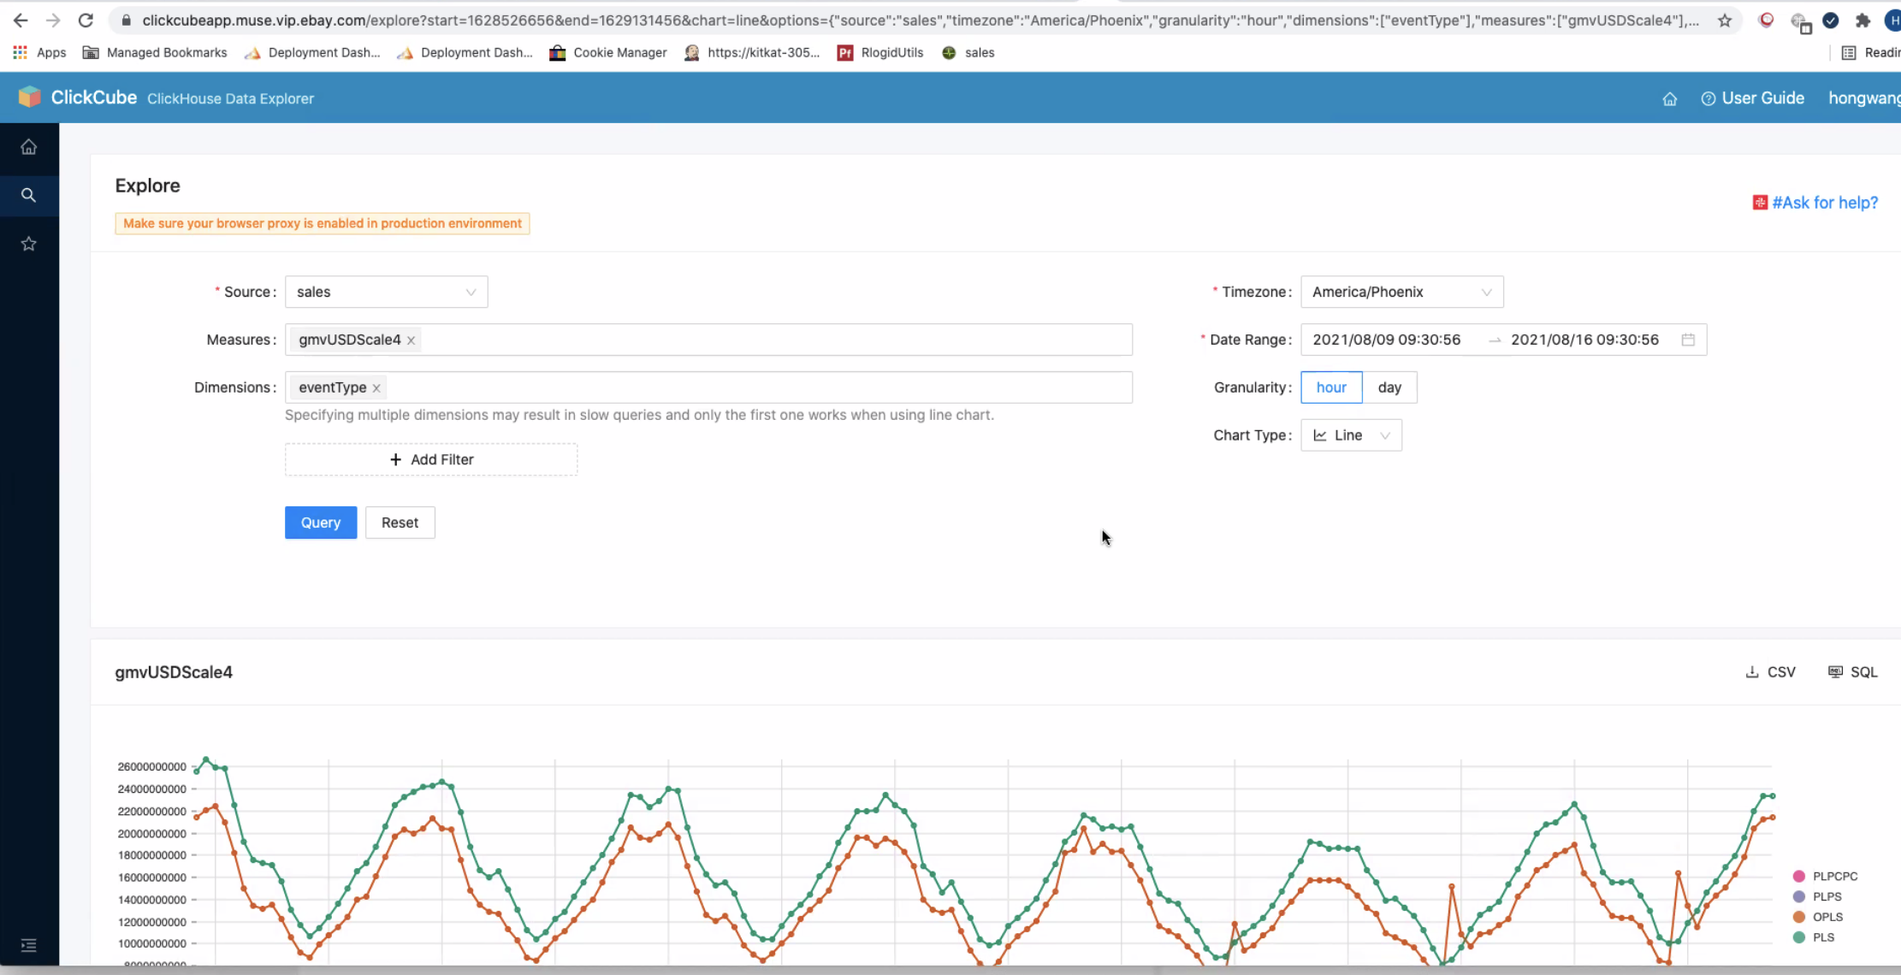

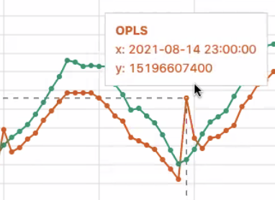

Investigated the spikes

Why we have a spike? It means there’s a lot of organic events in that hour (transaction time).

Attribution team uses the process time (not correct). Attribution fixed the bug. But there is still a spike. So there is still a problem.

It could mean that online process has bugs or issues. Spike removes when updated with offline data.

Happens at around midnight

PLS – Promoted Listing Sales

OPLS – Online Promoted Listing Sales

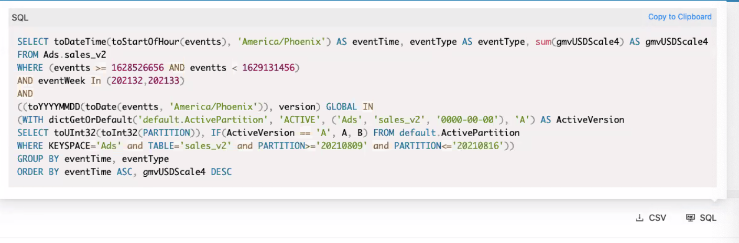

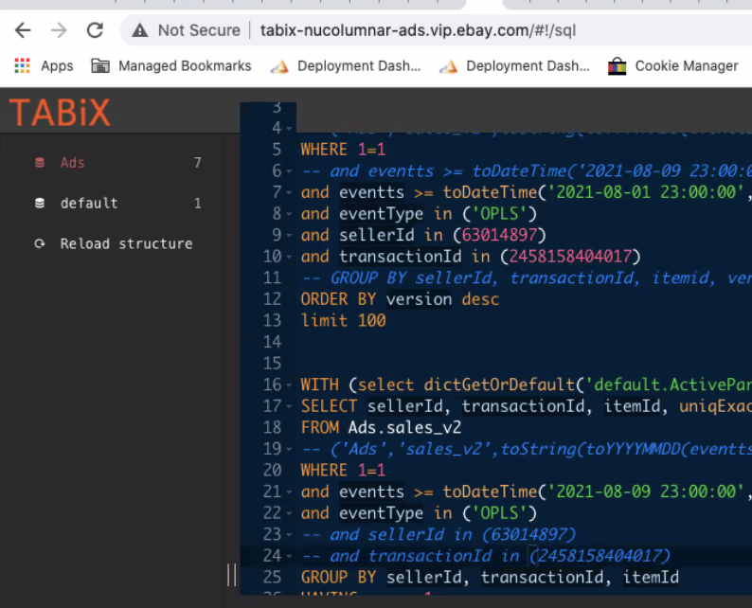

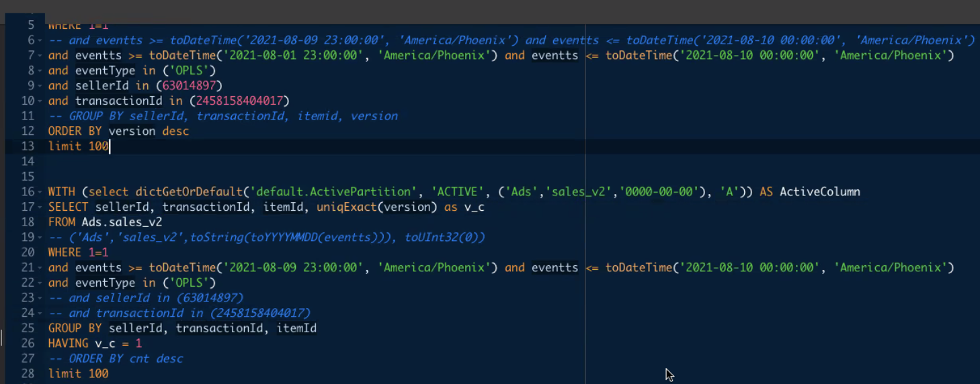

Clickhouse language – like SQL and clickhouse optimization

Clickhouse tables – version column

If online, version is 0.

If offline, version is > 0.

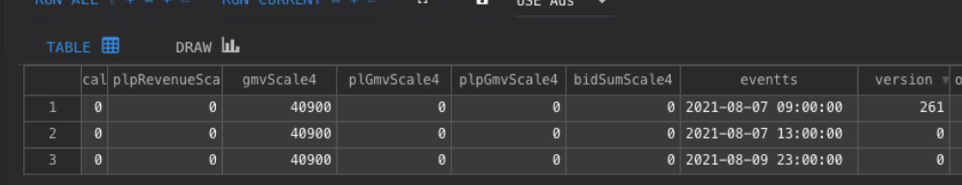

Why is transaction online and not in offline?

Goes to Oracle table first, then online, then offline.

S3P – GUI tool for production Oracle

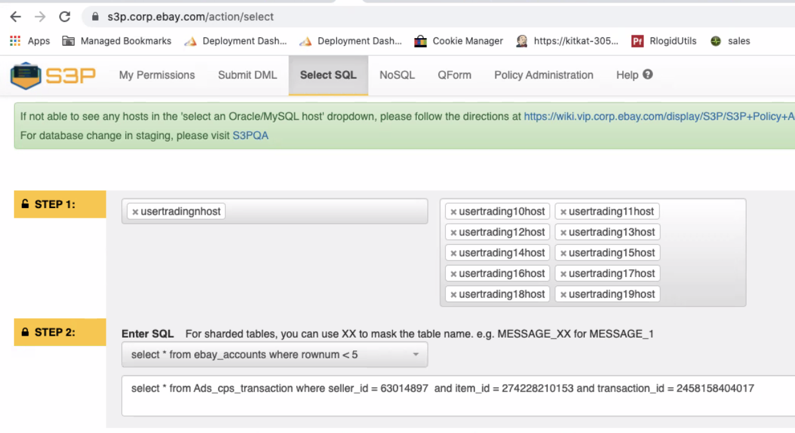

Went from organic to PL

XId – check if there is a click or not, if not, then its organic. If it can be associated with a click, then it’s a PL. it was a previously organic sales, it now becomes XID.

PL Sales is status with 2

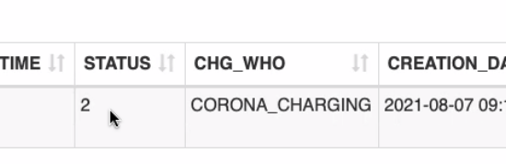

Remarket from organic to PL.

1 event make this transaction ID as PL. the other event, remove transaction ID from organic.

However, the remove organic event was inserted to clickhouse.

There are two online events (version with 0) with same transactionId

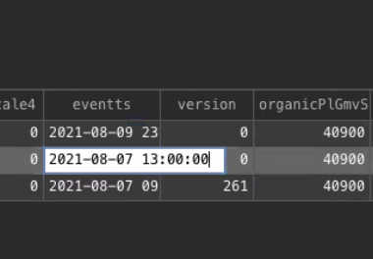

We can design a query with attribution team to have Oracle datasource in ES.

Clickhouse as online data and offline data. And we can see the discrepancy.

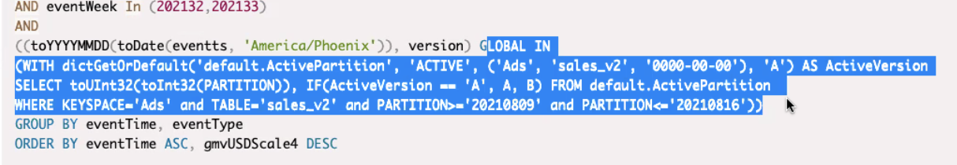

Last 3 days we use online data.

Flatter line is the correction/fix. It became stable.

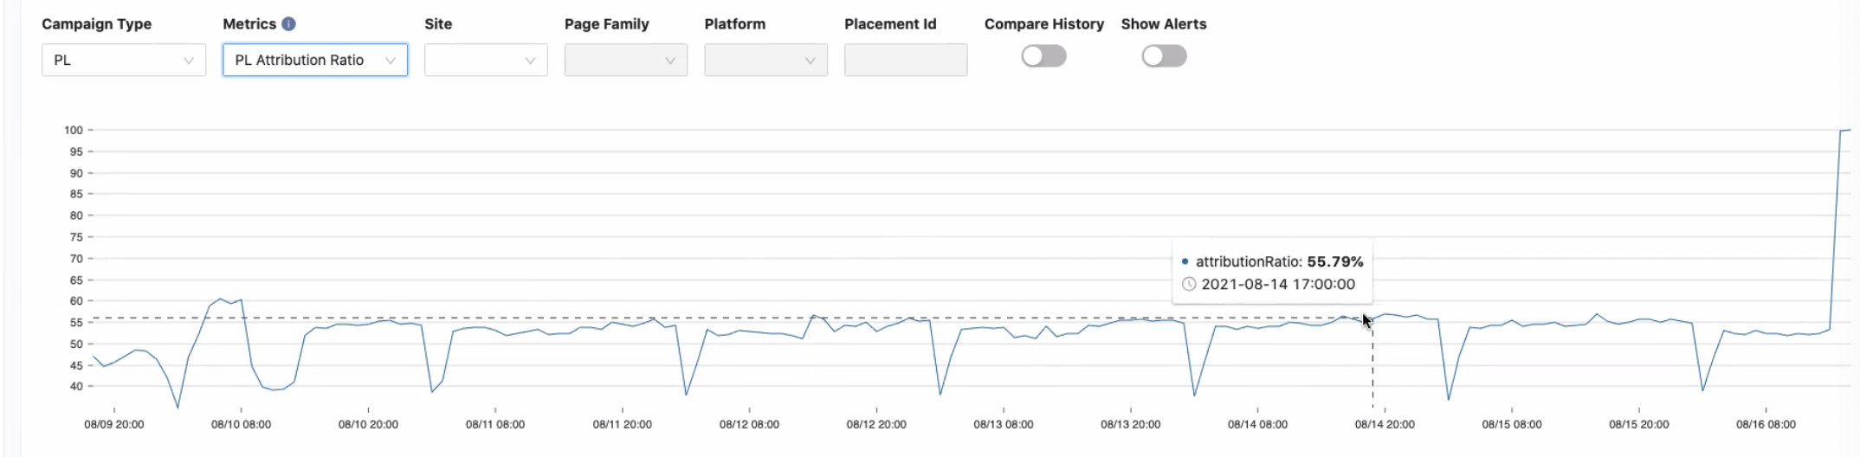

Need to fix deletion as insertion bug.

Attribution need to check if the event is delete. The other must check if the delete event is being done as insertion event.

## 20210813 Day 5 Adssrejob Control Center, Spring Batch

Read - https://wiki.vip.corp.ebay.com/display/PROMOTEDLISTINGS/Overview

* Promoted Listings > Seller Experience
* Campaign Manager > Seller Experience
* Spring Batch Architecture https://terasoluna-batch.github.io/guideline/5.0.0.RELEASE/en/Ch02_SpringBatchArchitecture.html#Ch02_SpringBatchArch_Detail

Reviewed/Explored

* adssrejob explanation video
* Control Center

Meeting with Pavel on Control Center

* We get pool list from ES. If there are new pools, we run a batch.
* We need the github repo in ES, PR
* Metrics is pulled from promethethos url
* We only need business metrics
* Need to add 1 more column “git repo”. To add more pool information.

Meeting with Yichao on adssrejob to confirm/recap

* Huayi maintains Control Center
* Experiment Change includes information other that SNOW
* Experiment should be filtered by ads (id:1) and merchandising (id: 21)
* Touchstone API doesn't require proxy like SNOW
* Implement new service layer touchstone get JSON return JSON
* use QA endpoint to test locally
* Read from API, write to ES

Code - adssrejob

* Reviewed the code base on existing Jobs
* Run the code - was able to run the existing job locally
* Implemented ExperimentChangeReader, ExperimentChangeProcessor, and ExperimentChangeEsWriter

ADS SRE Job (Raptor Batch)

Ticket: <https://jirap.corp.ebay.com/browse/SHEPHERD-285>

Docs: <https://docs.spring.io/spring-batch/docs/current/reference/html/job.html#configureJob>

Repo: <https://github.corp.ebay.com/login?return_to=https%3A%2F%2Fgithub.corp.ebay.com%2Fadssre%2Fadssrejob>

Jobs

* Scrub change
* Update existing change

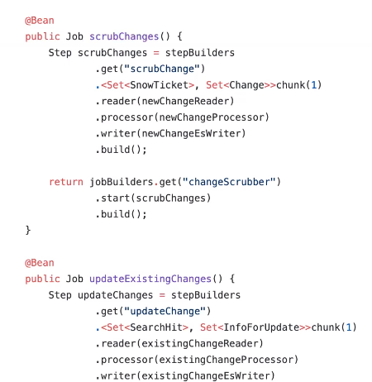

We only have pre-production deployment of jobs in eBay Cloud Platform

Job defined in the code.

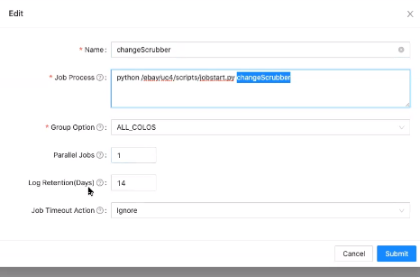

These are our dependencies. SNOW is Service Now

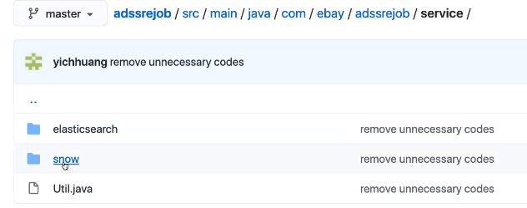

We need to sync every EP change from touchstone API and record in ES. We only care about Ad related EP change.

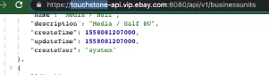

Question: how do we get the EP change list?

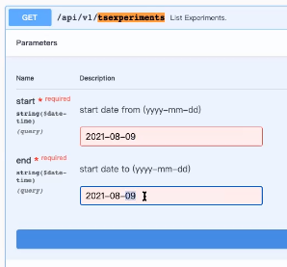

For the range, you need the head for the start of the change.

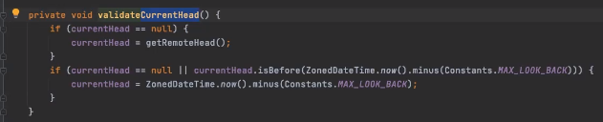

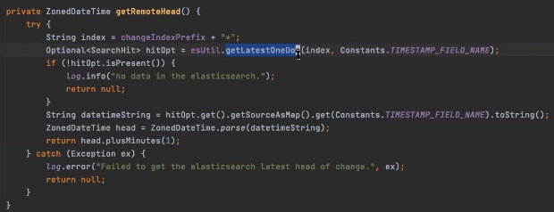

Timestamp (from touchstone) of the latest doc that has been recorded to service now. Then write to ES.

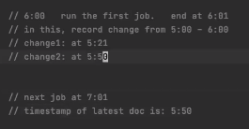

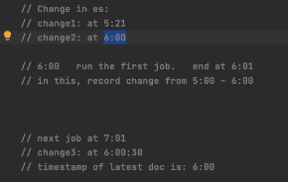

getRemoteHead() – get duplicate change and not remove new change.

ExistingChangeReader.java – change status. If the change is still running, missed items will be synced on the next job.

How can I only run EP change job and not all job?

How to run only 1 batch? Need to investigate.

2021-08-13 11:42:43.372 INFO 55370 --- [ main] c.e.a.j.pool.PoolInfoScrubberProcessor : returning {"errorMsg":"javax.ws.rs.NotFoundException: HTTP 404 Not Found","map":{}}

2021-08-13 11:42:43,372 [main] INFO com.ebay.adssrejob.job.pool.PoolInfoScrubberWriter:12 - Write companies:[{"errorMsg":"javax.ws.rs.NotFoundException: HTTP 404 Not Found","map":{}}]

2021-08-13 11:42:43.374 INFO 55370 --- [ main] c.e.r.b.k.listener.ChunkLoggingListener : After Chunk..

2021-08-13 11:42:43.374 INFO 55370 --- [ main] c.e.r.b.k.listener.ChunkLoggingListener : Before Chunk..

2021-08-13 11:42:43,374 [main] INFO com.ebay.adssrejob.job.pool.PoolInfoScrubberReader:25 - ===========================

Check parameter: null

2021-08-13 11:42:43,374 [main] INFO com.ebay.adssrejob.job.pool.PoolInfoScrubberReader:28 - ===========================

2021-08-13 11:42:43,374 [main] INFO com.ebay.adssrejob.job.pool.PoolInfoScrubberReader:39 - Nothing to read

2021-08-13 11:42:43.375 INFO 55370 --- [ main] c.e.r.b.k.listener.ChunkLoggingListener : After Chunk..

2021-08-13 11:42:43.375 INFO 55370 --- [ main] c.e.r.b.k.listener.StepLoggingListener : poolInfoScrubberStep finished ......

2021-08-13 11:42:43.376 INFO 55370 --- [ main] o.s.batch.core.step.AbstractStep : Step: [poolInfoScrubberStep] executed in 1s311ms

2021-08-13 11:42:43.378 INFO 55370 --- [ main] c.e.r.b.k.listener.JobSummaryListener : ---------------------------------------------------

2021-08-13 11:42:43.378 INFO 55370 --- [ main] c.e.r.b.k.listener.JobSummaryListener : Job Summary:

2021-08-13 11:42:43.378 INFO 55370 --- [ main] c.e.r.b.k.listener.JobSummaryListener : ---------------------------------------------------

2021-08-13 11:42:43.378 INFO 55370 --- [ main] c.e.r.b.k.listener.JobSummaryListener : ID: 2

2021-08-13 11:42:43.378 INFO 55370 --- [ main] c.e.r.b.k.listener.JobSummaryListener : Job Name : poolInfoScrubber

2021-08-13 11:42:43.378 INFO 55370 --- [ main] c.e.r.b.k.listener.JobSummaryListener : UC4 Job Name : null

2021-08-13 11:42:43.378 INFO 55370 --- [ main] c.e.r.b.k.listener.JobSummaryListener : Job Run ID : null

2021-08-13 11:42:43.378 INFO 55370 --- [ main] c.e.r.b.k.listener.JobSummaryListener : UC4 Restart Run ID : null

2021-08-13 11:42:43.378 INFO 55370 --- [ main] c.e.r.b.k.listener.JobSummaryListener : UC4 Job Parent Name : null

2021-08-13 11:42:43.378 INFO 55370 --- [ main] c.e.r.b.k.listener.JobSummaryListener : UC4 Job Top Parent Name : null

2021-08-13 11:42:43.379 INFO 55370 --- [ main] c.e.r.b.k.listener.JobSummaryListener : UC4 Job Parent Run ID : null

2021-08-13 11:42:43.379 INFO 55370 --- [ main] c.e.r.b.k.listener.JobSummaryListener : UC4 Job Top Parent Run ID : null

2021-08-13 11:42:43.379 INFO 55370 --- [ main] c.e.r.b.k.listener.JobSummaryListener : Job Parameters: {}

2021-08-13 11:42:43.379 INFO 55370 --- [ main] c.e.r.b.k.listener.JobSummaryListener : Start Date : Fri Aug 13 11:42:42 PDT 2021

2021-08-13 11:42:43.379 INFO 55370 --- [ main] c.e.r.b.k.listener.JobSummaryListener : End Date : Fri Aug 13 11:42:43 PDT 2021

2021-08-13 11:42:43.380 INFO 55370 --- [ main] c.e.r.b.k.listener.JobSummaryListener : Duration : 1s

2021-08-13 11:42:43.380 INFO 55370 --- [ main] c.e.r.b.k.listener.JobSummaryListener : Status : COMPLETED

2021-08-13 11:42:43.380 INFO 55370 --- [ main] c.e.r.b.k.listener.JobSummaryListener : Exit Code : COMPLETED

2021-08-13 11:42:43.380 INFO 55370 --- [ main] c.e.r.b.k.listener.JobSummaryListener : Exit Message :

2021-08-13 11:42:43.380 INFO 55370 --- [ main] c.e.r.b.k.listener.JobSummaryListener : ---------------------------------------------------

2021-08-13 11:42:43.381 INFO 55370 --- [ main] c.e.r.b.k.listener.JobSummaryListener : Details for Step Execution:

2021-08-13 11:42:43.381 INFO 55370 --- [ main] c.e.r.b.k.listener.JobSummaryListener : ---------------------------------------------------

2021-08-13 11:42:43.381 INFO 55370 --- [ main] c.e.r.b.k.listener.JobSummaryListener : Step : poolInfoScrubberStep

2021-08-13 11:42:43.381 INFO 55370 --- [ main] c.e.r.b.k.listener.JobSummaryListener : ID : 2

2021-08-13 11:42:43.382 INFO 55370 --- [ main] c.e.r.b.k.listener.JobSummaryListener : Start Date : Fri Aug 13 11:42:42 PDT 2021

2021-08-13 11:42:43.382 INFO 55370 --- [ main] c.e.r.b.k.listener.JobSummaryListener : End Date : Fri Aug 13 11:42:43 PDT 2021

2021-08-13 11:42:43.382 INFO 55370 --- [ main] c.e.r.b.k.listener.JobSummaryListener : Duration : 1s

2021-08-13 11:42:43.382 INFO 55370 --- [ main] c.e.r.b.k.listener.JobSummaryListener : Reads : 1

2021-08-13 11:42:43.382 INFO 55370 --- [ main] c.e.r.b.k.listener.JobSummaryListener : Writes : 1

2021-08-13 11:42:43.383 INFO 55370 --- [ main] c.e.r.b.k.listener.JobSummaryListener : Filters : 0

2021-08-13 11:42:43.383 INFO 55370 --- [ main] c.e.r.b.k.listener.JobSummaryListener : Read Skips : 0

2021-08-13 11:42:43.383 INFO 55370 --- [ main] c.e.r.b.k.listener.JobSummaryListener : Write Skip : 0

2021-08-13 11:42:43.383 INFO 55370 --- [ main] c.e.r.b.k.listener.JobSummaryListener : Process Skips : 0

2021-08-13 11:42:43.383 INFO 55370 --- [ main] c.e.r.b.k.listener.JobSummaryListener : Commits : 2

2021-08-13 11:42:43.384 INFO 55370 --- [ main] c.e.r.b.k.listener.JobSummaryListener : Rollbacks : 0

2021-08-13 11:42:43.384 INFO 55370 --- [ main] c.e.r.b.k.listener.JobSummaryListener : Status : COMPLETED

2021-08-13 11:42:43.384 INFO 55370 --- [ main] c.e.r.b.k.listener.JobSummaryListener : Exit Code : COMPLETED

2021-08-13 11:42:43.384 INFO 55370 --- [ main] c.e.r.b.k.listener.JobSummaryListener : Exit Message :

2021-08-13 11:42:43.384 INFO 55370 --- [ main] c.e.r.b.k.listener.JobSummaryListener : ---------------------------------------------------

2021-08-13 11:42:43.386 INFO 55370 --- [ main] c.e.r.b.k.listener.ChunkLoggingListener : poolInfoScrubber end.......

2021-08-13 11:42:43.387 INFO 55370 --- [ main] o.s.b.c.l.support.SimpleJobLauncher : Job: [SimpleJob: [name=poolInfoScrubber]] completed with the following parameters: [{}] and the following status: [COMPLETED] in 1s317ms

2021-08-13 11:42:43.390 INFO 55370 --- [ main] o.s.b.c.l.support.SimpleJobLauncher : Job: [SimpleJob: [name=sampleJob]] launched with the following parameters: [{}]

2021-08-13 11:42:43.391 INFO 55370 --- [ main] c.e.r.b.k.listener.ChunkLoggingListener : sampleJob start......

2021-08-13 11:42:43.394 INFO 55370 --- [ main] o.s.batch.core.job.SimpleStepHandler : Executing step: [step]

2021-08-13 11:42:43.394 INFO 55370 --- [ main] c.e.r.b.k.listener.StepLoggingListener : step begin ......

2021-08-13 11:42:43.395 INFO 55370 --- [ main] c.e.r.b.k.listener.ChunkLoggingListener : Before Chunk..

2021-08-13 11:42:43,395 [main] INFO com.ebay.adssrejob.job.sample.Reader:25 - ===========================

2021-08-13 11:42:43,395 [main] INFO com.ebay.adssrejob.job.sample.Reader:26 - Check parameter: null

2021-08-13 11:42:43,395 [main] INFO com.ebay.adssrejob.job.sample.Reader:27 - ===========================

2021-08-13 11:42:43,395 [main] INFO com.ebay.adssrejob.job.sample.Reader:41 - Read a company:eBay

2021-08-13 11:42:43,396 [main] INFO com.ebay.adssrejob.job.sample.Writer:12 - Write companies:[EBAY]

2021-08-13 11:42:43.397 INFO 55370 --- [ main] c.e.r.b.k.listener.ChunkLoggingListener : After Chunk..

2021-08-13 11:42:43.397 INFO 55370 --- [ main] c.e.r.b.k.listener.ChunkLoggingListener : Before Chunk..

2021-08-13 11:42:43,397 [main] INFO com.ebay.adssrejob.job.sample.Reader:25 - ===========================

2021-08-13 11:42:43,397 [main] INFO com.ebay.adssrejob.job.sample.Reader:26 - Check parameter: null

2021-08-13 11:42:43,397 [main] INFO com.ebay.adssrejob.job.sample.Reader:27 - ===========================

2021-08-13 11:42:43,398 [main] INFO com.ebay.adssrejob.job.sample.Reader:41 - Read a company:Amazon

2021-08-13 11:42:43,398 [main] INFO com.ebay.adssrejob.job.sample.Writer:12 - Write companies:[AMAZON]

2021-08-13 11:42:43.399 INFO 55370 --- [ main] c.e.r.b.k.listener.ChunkLoggingListener : After Chunk..

2021-08-13 11:42:43.399 INFO 55370 --- [ main] c.e.r.b.k.listener.ChunkLoggingListener : Before Chunk..

2021-08-13 11:42:43,399 [main] INFO com.ebay.adssrejob.job.sample.Reader:25 - ===========================

2021-08-13 11:42:43,400 [main] INFO com.ebay.adssrejob.job.sample.Reader:26 - Check parameter: null

2021-08-13 11:42:43,400 [main] INFO com.ebay.adssrejob.job.sample.Reader:27 - ===========================

2021-08-13 11:42:43,400 [main] INFO com.ebay.adssrejob.job.sample.Reader:41 - Read a company:Google

2021-08-13 11:42:43,400 [main] INFO com.ebay.adssrejob.job.sample.Writer:12 - Write companies:[GOOGLE]

2021-08-13 11:42:43.401 INFO 55370 --- [ main] c.e.r.b.k.listener.ChunkLoggingListener : After Chunk..

2021-08-13 11:42:43.401 INFO 55370 --- [ main] c.e.r.b.k.listener.ChunkLoggingListener : Before Chunk..

2021-08-13 11:42:43,401 [main] INFO com.ebay.adssrejob.job.sample.Reader:25 - ===========================

2021-08-13 11:42:43,402 [main] INFO com.ebay.adssrejob.job.sample.Reader:26 - Check parameter: null

2021-08-13 11:42:43,402 [main] INFO com.ebay.adssrejob.job.sample.Reader:27 - ===========================

2021-08-13 11:42:43,402 [main] INFO com.ebay.adssrejob.job.sample.Reader:41 - Read a company:Apple

2021-08-13 11:42:43,402 [main] INFO com.ebay.adssrejob.job.sample.Writer:12 - Write companies:[APPLE]

2021-08-13 11:42:43.403 INFO 55370 --- [ main] c.e.r.b.k.listener.ChunkLoggingListener : After Chunk..

2021-08-13 11:42:43.403 INFO 55370 --- [ main] c.e.r.b.k.listener.ChunkLoggingListener : Before Chunk..

2021-08-13 11:42:43,403 [main] INFO com.ebay.adssrejob.job.sample.Reader:25 - ===========================

2021-08-13 11:42:43,403 [main] INFO com.ebay.adssrejob.job.sample.Reader:26 - Check parameter: null

2021-08-13 11:42:43,403 [main] INFO com.ebay.adssrejob.job.sample.Reader:27 - ===========================

2021-08-13 11:42:43,403 [main] INFO com.ebay.adssrejob.job.sample.Reader:41 - Read a company:Microsoft

2021-08-13 11:42:43,404 [main] INFO com.ebay.adssrejob.job.sample.Writer:12 - Write companies:[MICROSOFT]

2021-08-13 11:42:43.405 INFO 55370 --- [ main] c.e.r.b.k.listener.ChunkLoggingListener : After Chunk..

2021-08-13 11:42:43.405 INFO 55370 --- [ main] c.e.r.b.k.listener.ChunkLoggingListener : Before Chunk..

2021-08-13 11:42:43,405 [main] INFO com.ebay.adssrejob.job.sample.Reader:25 - ===========================

2021-08-13 11:42:43,405 [main] INFO com.ebay.adssrejob.job.sample.Reader:26 - Check parameter: null

2021-08-13 11:42:43,405 [main] INFO com.ebay.adssrejob.job.sample.Reader:27 - ===========================

2021-08-13 11:42:43,405 [main] INFO com.ebay.adssrejob.job.sample.Reader:37 - Nothing to read

2021-08-13 11:42:43.406 INFO 55370 --- [ main] c.e.r.b.k.listener.ChunkLoggingListener : After Chunk..

2021-08-13 11:42:43.406 INFO 55370 --- [ main] c.e.r.b.k.listener.StepLoggingListener : step finished ......

2021-08-13 11:42:43.407 INFO 55370 --- [ main] o.s.batch.core.step.AbstractStep : Step: [step] executed in 13ms

2021-08-13 11:42:43.408 INFO 55370 --- [ main] c.e.r.b.k.listener.JobSummaryListener : ---------------------------------------------------

2021-08-13 11:42:43.408 INFO 55370 --- [ main] c.e.r.b.k.listener.JobSummaryListener : Job Summary:

2021-08-13 11:42:43.408 INFO 55370 --- [ main] c.e.r.b.k.listener.JobSummaryListener : ---------------------------------------------------

2021-08-13 11:42:43.408 INFO 55370 --- [ main] c.e.r.b.k.listener.JobSummaryListener : ID: 3

2021-08-13 11:42:43.408 INFO 55370 --- [ main] c.e.r.b.k.listener.JobSummaryListener : Job Name : sampleJob

2021-08-13 11:42:43.408 INFO 55370 --- [ main] c.e.r.b.k.listener.JobSummaryListener : UC4 Job Name : null

2021-08-13 11:42:43.408 INFO 55370 --- [ main] c.e.r.b.k.listener.JobSummaryListener : Job Run ID : null

2021-08-13 11:42:43.408 INFO 55370 --- [ main] c.e.r.b.k.listener.JobSummaryListener : UC4 Restart Run ID : null

2021-08-13 11:42:43.408 INFO 55370 --- [ main] c.e.r.b.k.listener.JobSummaryListener : UC4 Job Parent Name : null

2021-08-13 11:42:43.409 INFO 55370 --- [ main] c.e.r.b.k.listener.JobSummaryListener : UC4 Job Top Parent Name : null

2021-08-13 11:42:43.409 INFO 55370 --- [ main] c.e.r.b.k.listener.JobSummaryListener : UC4 Job Parent Run ID : null

2021-08-13 11:42:43.409 INFO 55370 --- [ main] c.e.r.b.k.listener.JobSummaryListener : UC4 Job Top Parent Run ID : null

2021-08-13 11:42:43.409 INFO 55370 --- [ main] c.e.r.b.k.listener.JobSummaryListener : Job Parameters: {}

2021-08-13 11:42:43.410 INFO 55370 --- [ main] c.e.r.b.k.listener.JobSummaryListener : Start Date : Fri Aug 13 11:42:43 PDT 2021

2021-08-13 11:42:43.410 INFO 55370 --- [ main] c.e.r.b.k.listener.JobSummaryListener : End Date : Fri Aug 13 11:42:43 PDT 2021

2021-08-13 11:42:43.410 INFO 55370 --- [ main] c.e.r.b.k.listener.JobSummaryListener : Duration : 0s

2021-08-13 11:42:43.410 INFO 55370 --- [ main] c.e.r.b.k.listener.JobSummaryListener : Status : COMPLETED

2021-08-13 11:42:43.410 INFO 55370 --- [ main] c.e.r.b.k.listener.JobSummaryListener : Exit Code : COMPLETED

2021-08-13 11:42:43.411 INFO 55370 --- [ main] c.e.r.b.k.listener.JobSummaryListener : Exit Message :

2021-08-13 11:42:43.411 INFO 55370 --- [ main] c.e.r.b.k.listener.JobSummaryListener : ---------------------------------------------------

2021-08-13 11:42:43.411 INFO 55370 --- [ main] c.e.r.b.k.listener.JobSummaryListener : Details for Step Execution:

2021-08-13 11:42:43.411 INFO 55370 --- [ main] c.e.r.b.k.listener.JobSummaryListener : ---------------------------------------------------

2021-08-13 11:42:43.411 INFO 55370 --- [ main] c.e.r.b.k.listener.JobSummaryListener : Step : step

2021-08-13 11:42:43.412 INFO 55370 --- [ main] c.e.r.b.k.listener.JobSummaryListener : ID : 3

2021-08-13 11:42:43.412 INFO 55370 --- [ main] c.e.r.b.k.listener.JobSummaryListener : Start Date : Fri Aug 13 11:42:43 PDT 2021

2021-08-13 11:42:43.412 INFO 55370 --- [ main] c.e.r.b.k.listener.JobSummaryListener : End Date : Fri Aug 13 11:42:43 PDT 2021

2021-08-13 11:42:43.412 INFO 55370 --- [ main] c.e.r.b.k.listener.JobSummaryListener : Duration : 0s

2021-08-13 11:42:43.412 INFO 55370 --- [ main] c.e.r.b.k.listener.JobSummaryListener : Reads : 5

2021-08-13 11:42:43.413 INFO 55370 --- [ main] c.e.r.b.k.listener.JobSummaryListener : Writes : 5

2021-08-13 11:42:43.413 INFO 55370 --- [ main] c.e.r.b.k.listener.JobSummaryListener : Filters : 0

2021-08-13 11:42:43.413 INFO 55370 --- [ main] c.e.r.b.k.listener.JobSummaryListener : Read Skips : 0

2021-08-13 11:42:43.413 INFO 55370 --- [ main] c.e.r.b.k.listener.JobSummaryListener : Write Skip : 0

2021-08-13 11:42:43.413 INFO 55370 --- [ main] c.e.r.b.k.listener.JobSummaryListener : Process Skips : 0

2021-08-13 11:42:43.414 INFO 55370 --- [ main] c.e.r.b.k.listener.JobSummaryListener : Commits : 6

2021-08-13 11:42:43.414 INFO 55370 --- [ main] c.e.r.b.k.listener.JobSummaryListener : Rollbacks : 0

2021-08-13 11:42:43.414 INFO 55370 --- [ main] c.e.r.b.k.listener.JobSummaryListener : Status : COMPLETED

2021-08-13 11:42:43.414 INFO 55370 --- [ main] c.e.r.b.k.listener.JobSummaryListener : Exit Code : COMPLETED

2021-08-13 11:42:43.414 INFO 55370 --- [ main] c.e.r.b.k.listener.JobSummaryListener : Exit Message :

2021-08-13 11:42:43.415 INFO 55370 --- [ main] c.e.r.b.k.listener.JobSummaryListener : ---------------------------------------------------

2021-08-13 11:42:43.416 INFO 55370 --- [ main] c.e.r.b.k.listener.ChunkLoggingListener : sampleJob end.......

2021-08-13 11:42:43.417 INFO 55370 --- [ main] o.s.b.c.l.support.SimpleJobLauncher : Job: [SimpleJob: [name=sampleJob]] completed with the following parameters: [{}] and the following status: [COMPLETED] in 18ms

2021-08-13 11:42:43.418 INFO 55370 --- [ main] c.e.r.init.InitializationManagerImpl : Initialization completed using 19312ms

2021-08-13 11:42:43.438 INFO 55370 --- [ main] c.e.r.c.h.a.HystrixAutoConfiguration : Aero Hystrix shuting down...

Knowledge Transfer - Control Center with Pavel Liu

Metrics

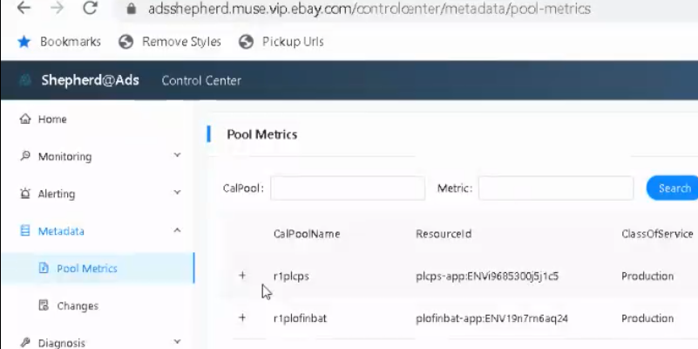

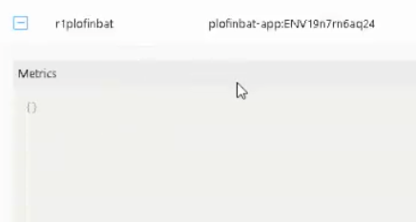

Repo: adssrejob

Data is pulled from

admin/prometheus

Web: Control Center

Basic idea: the 1st version of pool list is hard coded. Now, we get pool list from ES. If there are new pools, we run a batch.

Running jobs manually

Metrics is pulled from promethethos url

The columns are from different API

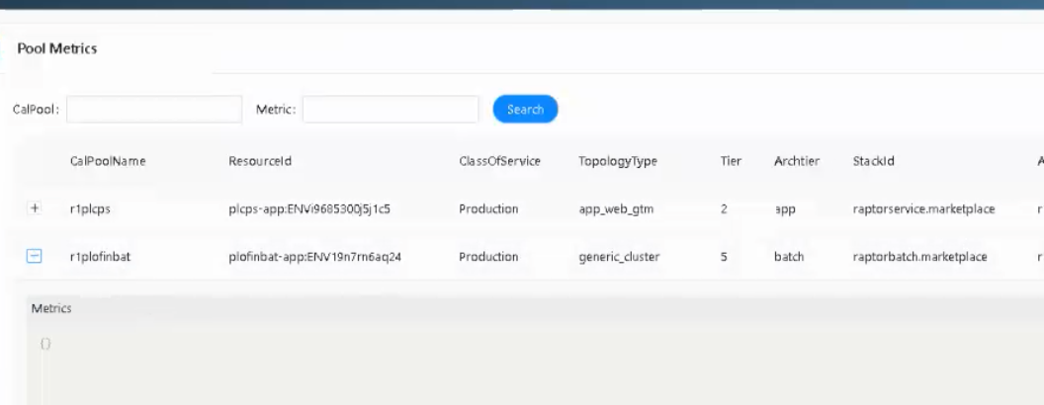

We only need business metrics

We need the github repo in ES, PR.

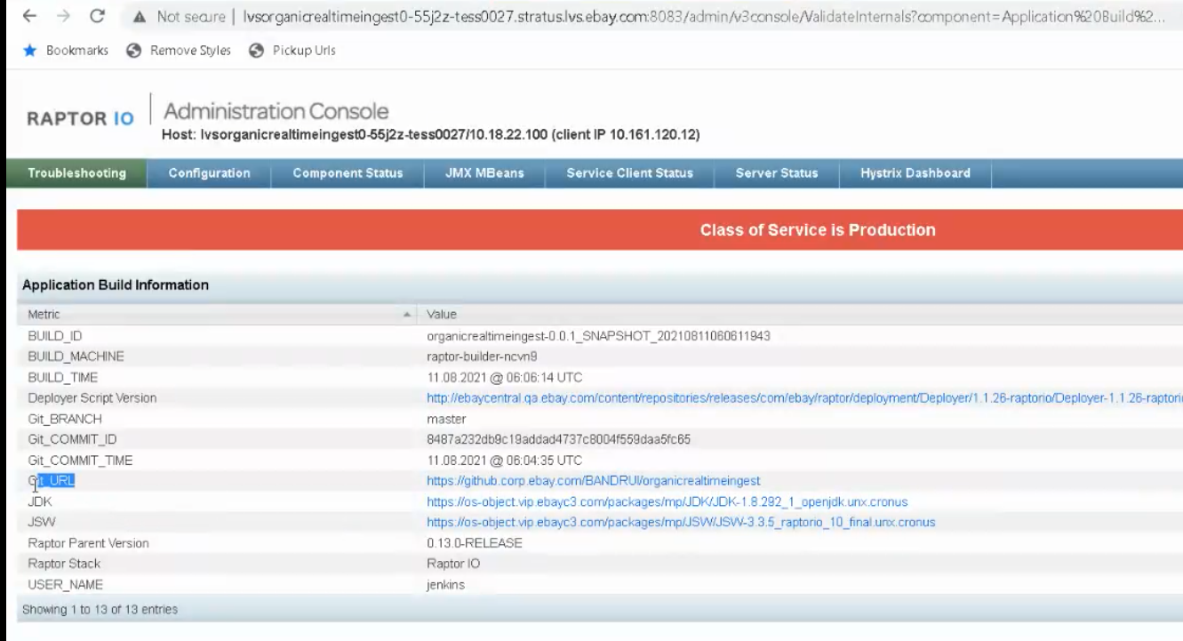

There is a velocity to quickly deploy to production and test it.

Manifest on how fast build and deploy and rollback metrics.

If PR can be merged in time or quickly.

Wait for the code to be integrated by next week.

This is called change metadata.

Need to add 1 more column “git repo”. To add more pool information.

Next time, how many “PR” still haven’t merge. – No need.

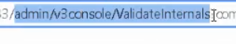

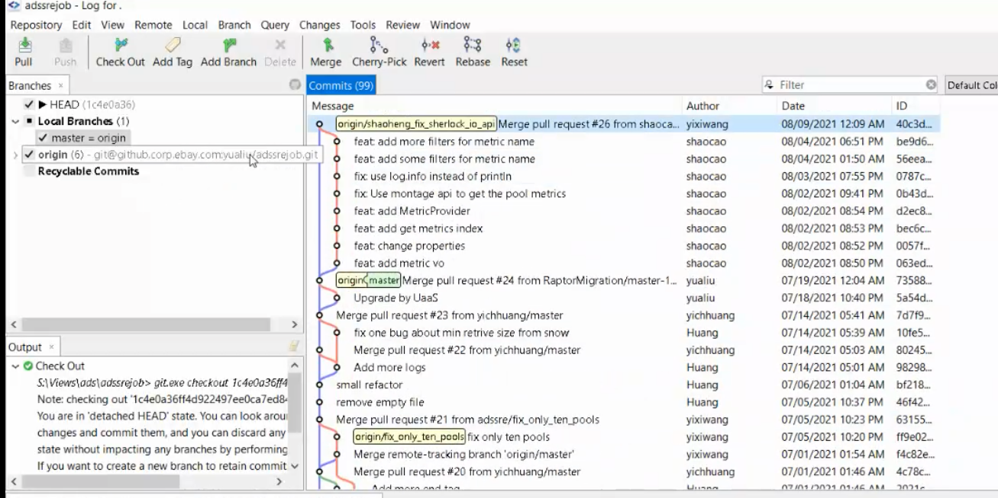

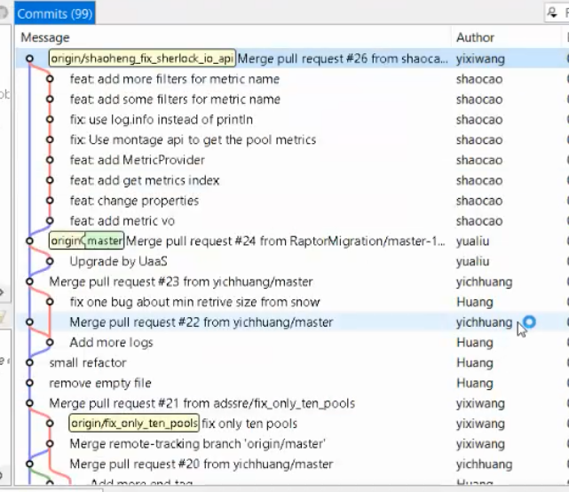

Fast-forward-merge

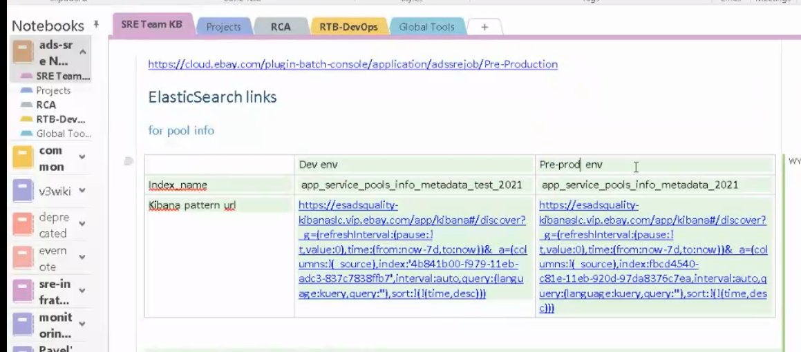

Check the index_name of pre-prod env in ES and put in 7 days.

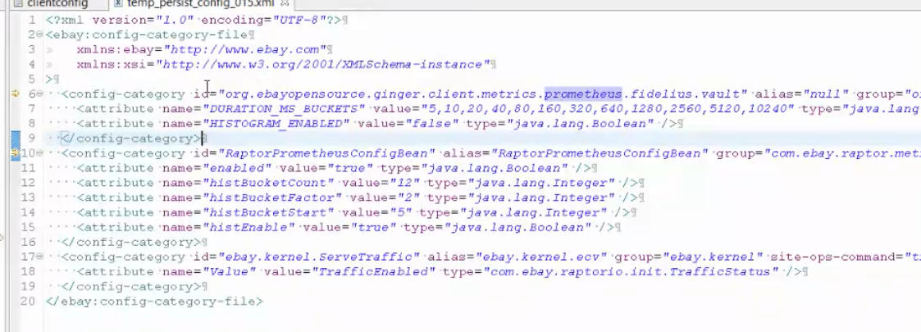

This pool can be any pool

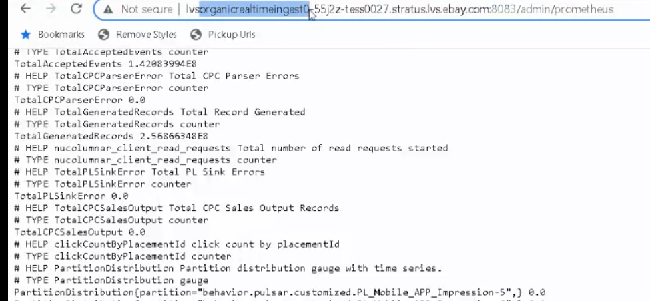

Pool page

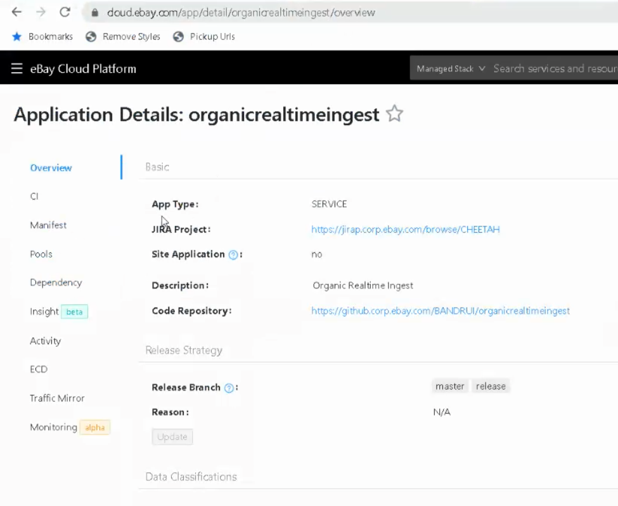

Pools – Feature, Staging

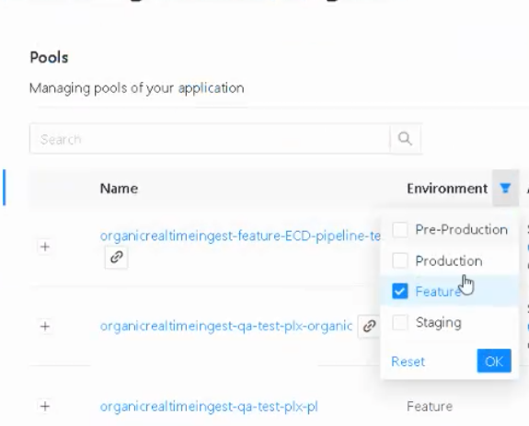

Staging pool > Manifests

Staging pool > Instances



Get the GitHub repo URL from Application Build Information:

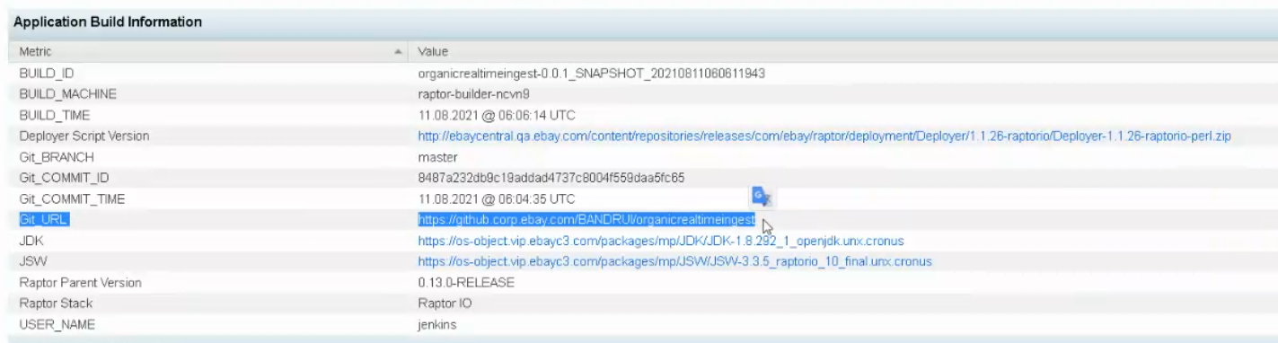

To get repo from “org”, there might be a lot of garbage repo. We will not take this in.

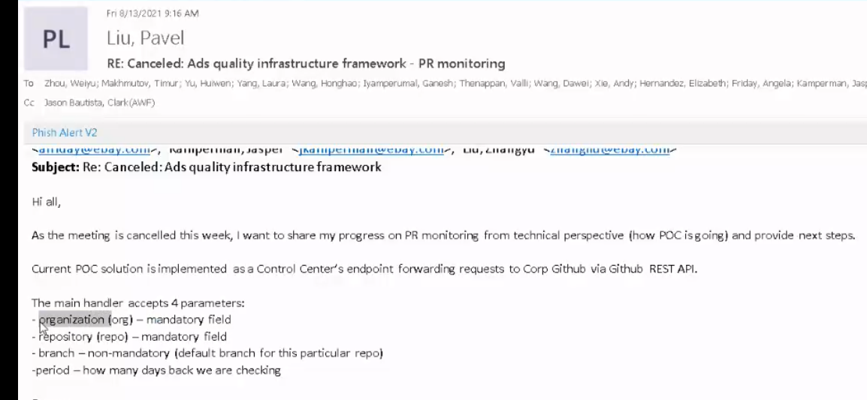

Meeting with Yichao

Do I use the same service snow? Or do I create a new service?

Where do I supply the parameters for the reader for touchstone API endpoint? How about the other jobs?

Do I need to create a DTO? Or should it directly be processed to ES?

How can I test to check If writes to ES works?

What does vo mean?

## 20210812 Day 4 Meetings, Setups, and Knowledge Transfer of RaptorBatch

Documentation

* Updated docs New Hire Onboarding to Ads Team. For requesting local admin rights via Self Service
* Read/Watch
* Spring Batch
* ADS SRE Job (Raptor Batch) - https://github.corp.ebay.com/adssre/adssrejob
* eBay Tech Stack - https://docs.google.com/presentation/d/1SAMO6AkgtmYurZslUu64se4foJUGxuAZM3_SRnY-yiw/edit#slide=id.g323c592f7f_2_1347

Setup

* Java
* Maven
* Tess
* IntelliJ Ultimate - Free Trial

Training/Knowledge Transfer

* ADS SRE Job (Raptor Batch) SHEPHERD-285 https://jirap.corp.ebay.com/browse/SHEPHERD-285 (https://ebay.zoom.us/rec/share/WFzr9cMMCGLhSttlMs30eb3M_N3MTm8ob_iiWSvECGeiFvV5MAix0drSgflrduk_.QZf-SutpMYqYXV2F Passcode: @02A@csE)

Meetings

* Earnings Learnings
* Global All-Hands
* Brainstorming Inventory Read-out Day 2
* Exploring adscmd
* Learn Troubleshooting from Honghao
* ADS SRE Job (Raptor Batch) sharing

**Earnings Learnings Meeting**

From Global Finance Teams

GMV

* gross market value of the transactions
* eBay takes 10% as revenue

Year-Over-Year

Q4 earnings are higher due to seasonal effects like Christmas holidays

Q1 earnings are lower

That’s why we use YoY to get a sense of how the company is doing.

What is lapping?

Lapping dynamics (YoY growth)

Earnings Per Share (EPS)

Takes net earnings and divide it by every share

As an owner of your company, what is your net score

Net Promoter Score (NPS)

Rating from the customer. Examples: Buyer NPS, Seller NPS. How many are promoter, neutral, detractor (never going to transact with eBay again)?

Happy or unhappy with our product

With this, we get address our pain points

Q&A

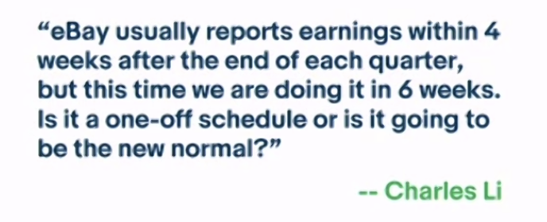

To sell our classified business and not including them. Regulatory requirement.

What is company standard NPS for buyer NPS and seller NPS?

Buyer NPS close to market range 70-75

Seller NPS not many industry standard as eBay is the standard 25-35 as it is still not smooth

NPS for sneakers and watches are over 90

What is GAAP and non-GAAP. Rules required to report under. i.e. amortizing intangible assets. We report GAAP externally and non-GAAP internally.

**Global All-Hands Meeting**

President and CEO Jamie Iannone

CEO Steve Priest

Stef Jay

Jamie and eLT (eBay Learnings Team)

Global Ethics Survey

Beliefs

* Empower our community
* Deliver with impact
* Be for everyone
* Act with integrity

Strong Execution

* Product Delivery
* Ads Revenue
* Payments Intermediation

**Brainstorming Inventory Read-out Day 2**

Goals

* ROAS – Return on Ad Spend
* Segmentation
* Velocity
* Automation

Campaign Management

* Simplified campaign creation
  + Make it easier for sellers to adopt ads products by simplifying campaign creation process
    - CM UI Redesign for PLS
    - CPC Campaign Manager Enhancements
    - Clone campaigns
    - Integrated seller education
    - Increase listing limits in campaigns
* Advertising based on seller goals (let’s meet where the seller is at)
  + Allow sellers to engage with ads in a way that aligns with their goals:
    - Align on customer value propositions and goals for each ads product
    - Provide a goal-based entry into campaign creation, aligning with goals, not just with our product structure
* Increase seller control for PLS automated campaigns
  + Give sellers the control they need to increase PLS adoption through automated campaigns
    - Depreciate bulk CSV flow to encourage greater AC usage
    - Exclude specific listings
    - Low-performing listings
    - Add filter by keyword, seasonality

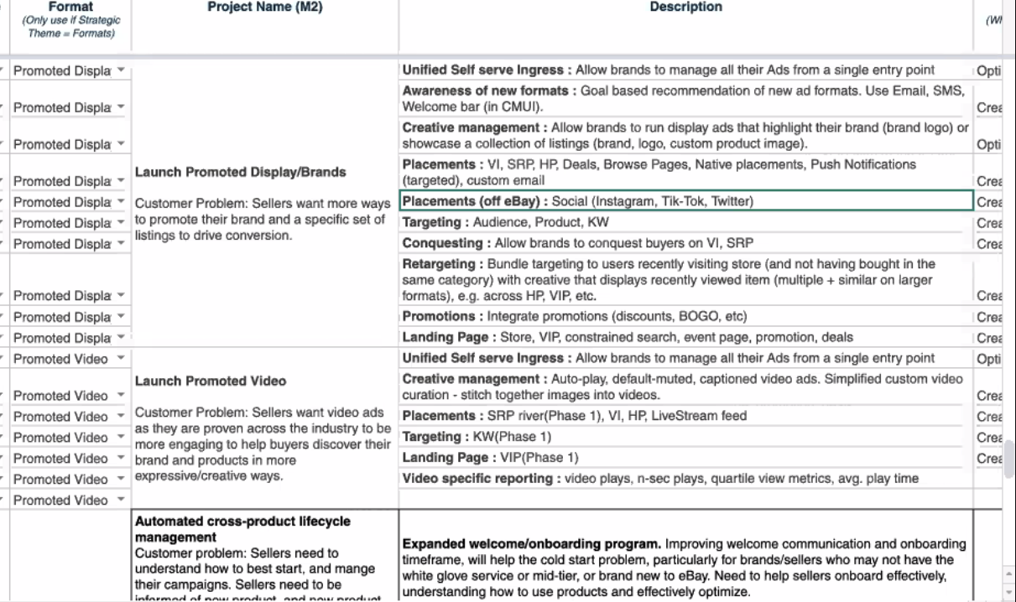

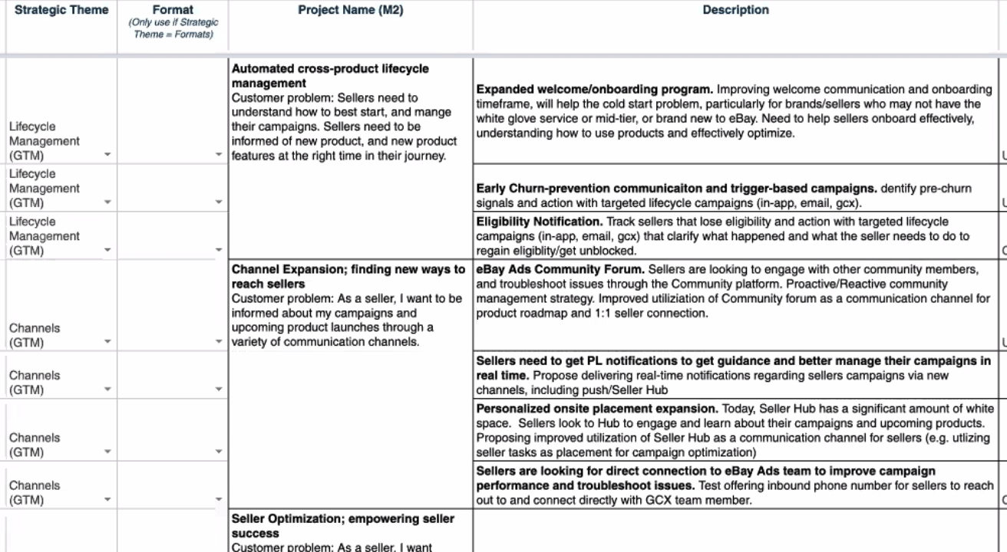

2022 Planning

Reinvent Feature Fees Read Out

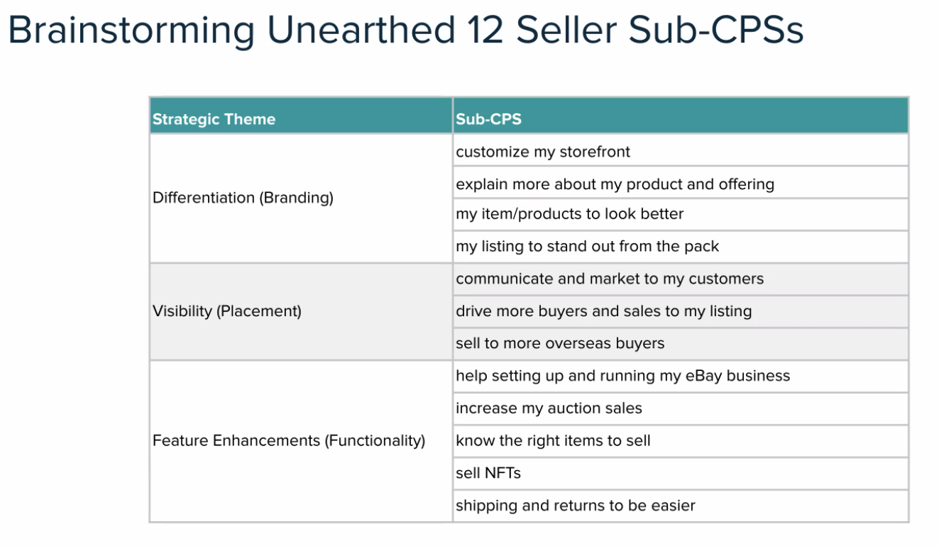

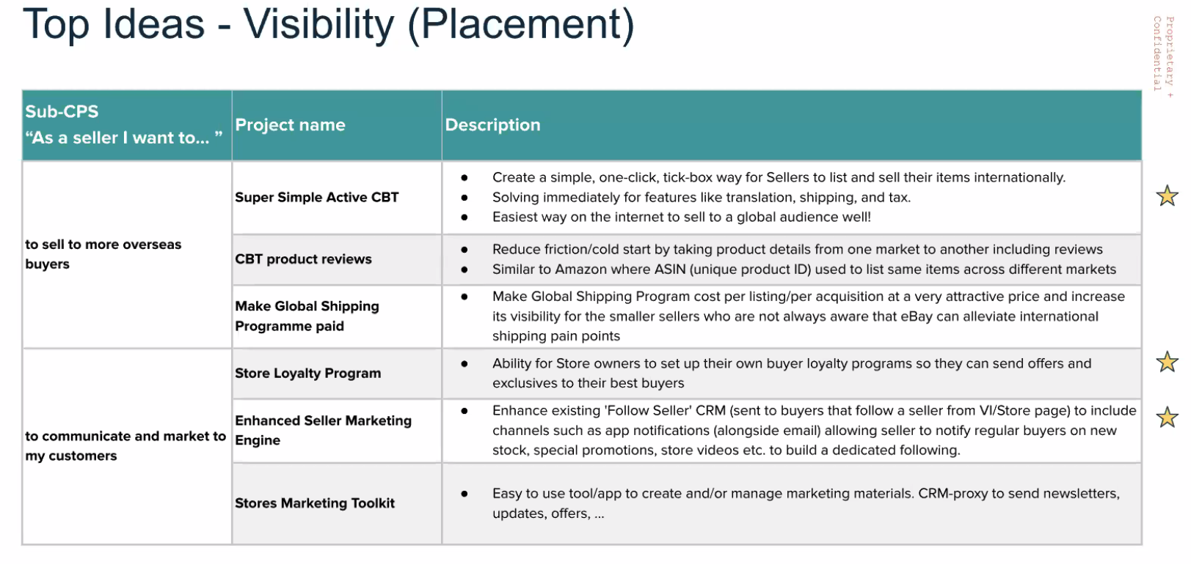

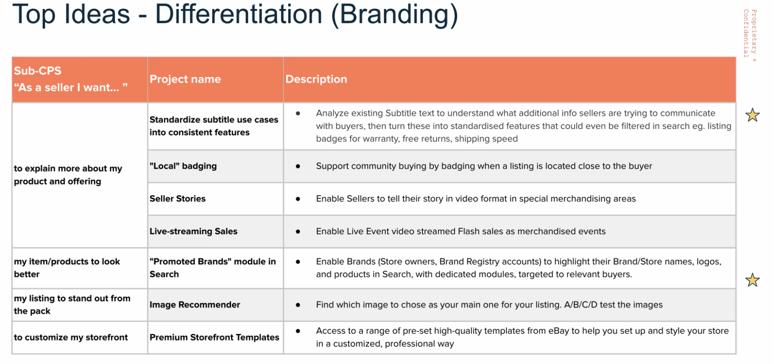

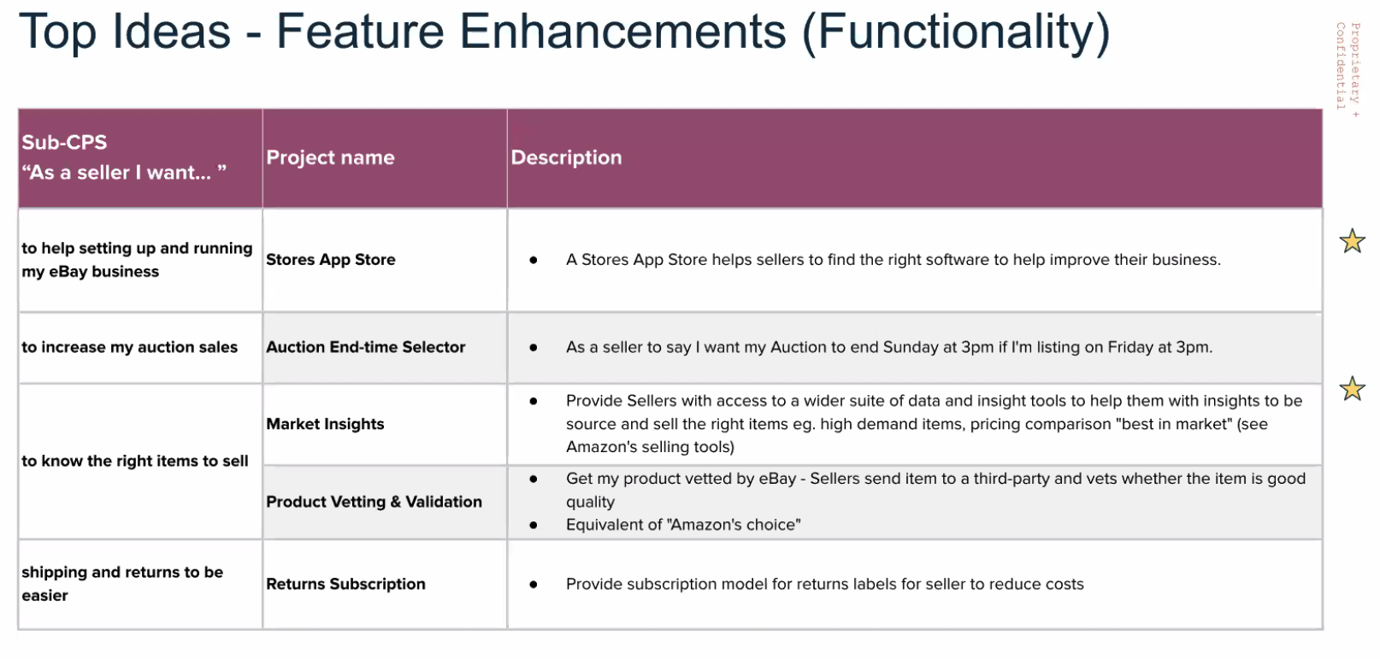

**Exploring adscmd**

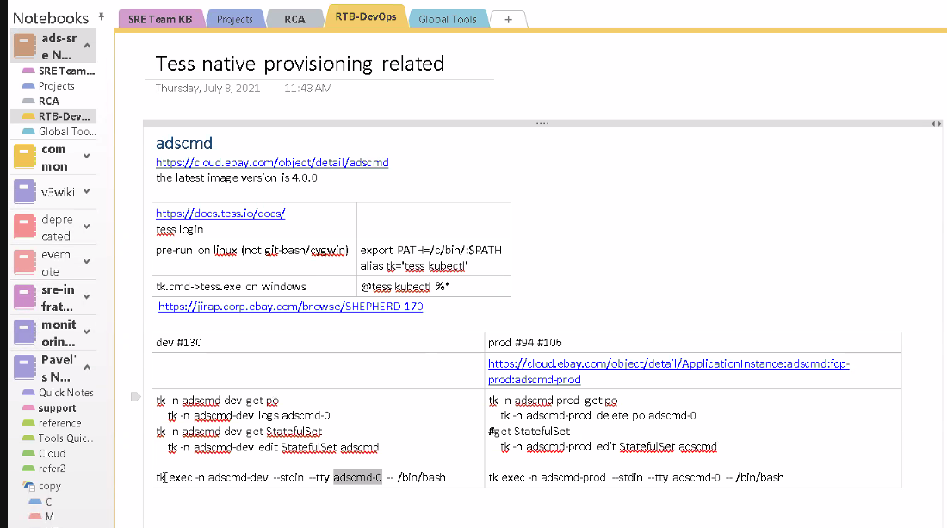

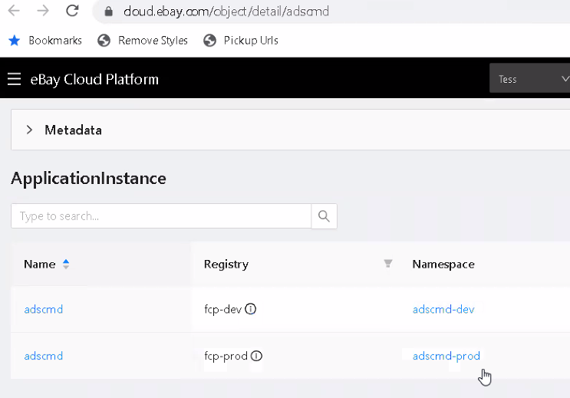

adscmd

* To run commands on dev and production like ssh, netstat, mysql, etc.
* If you have Kubernetes knowledge, you can use the same commands

Commands

* tess login
* cluster: 130

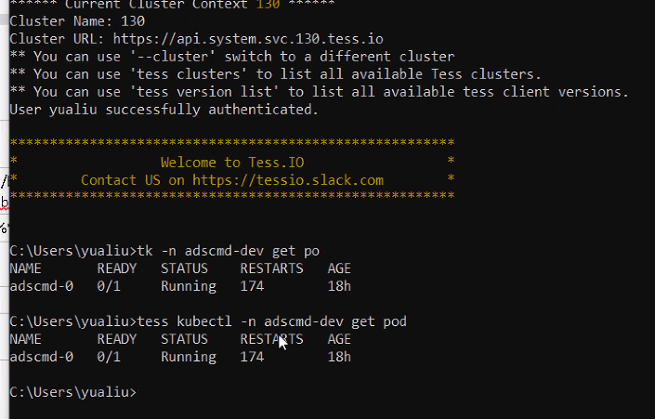

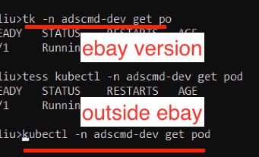

Tess is a wrapper for us internally for Kubernetes

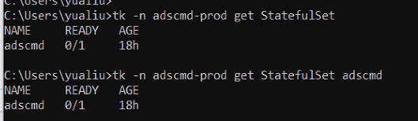

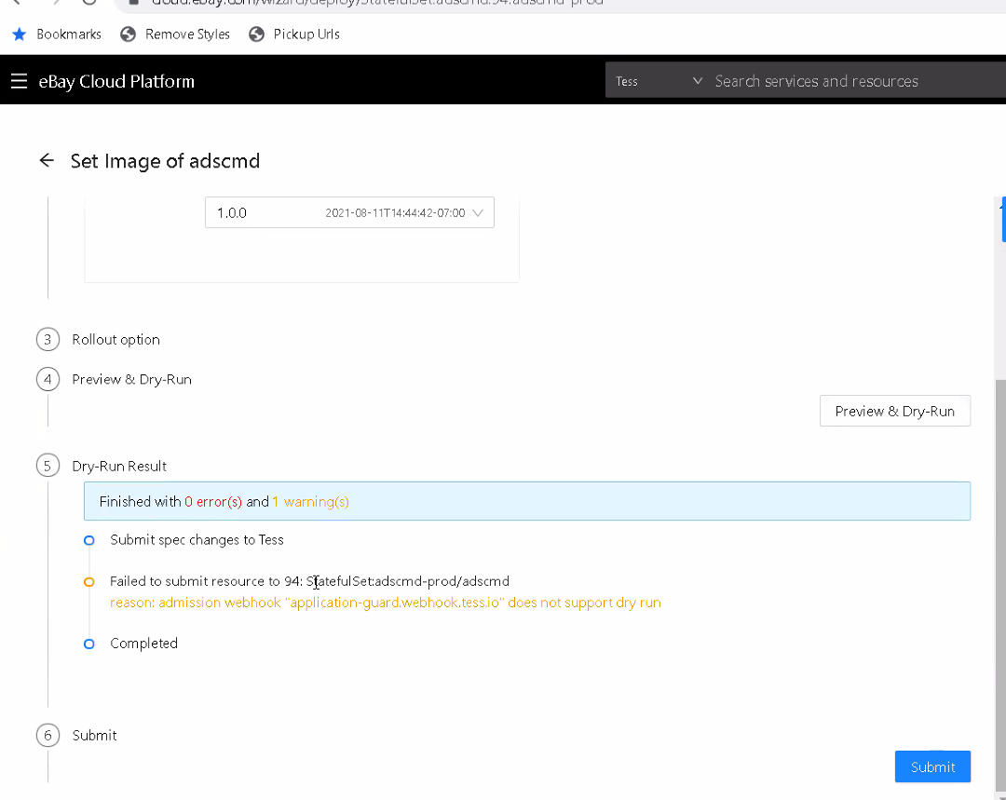

Summary

* adscmd - run commands on dev and prod pods
* we executed commands that manages lifecycle of pods
* we created/updated images in ebay cloud platform

**Learn trouble shooting from Honghao**

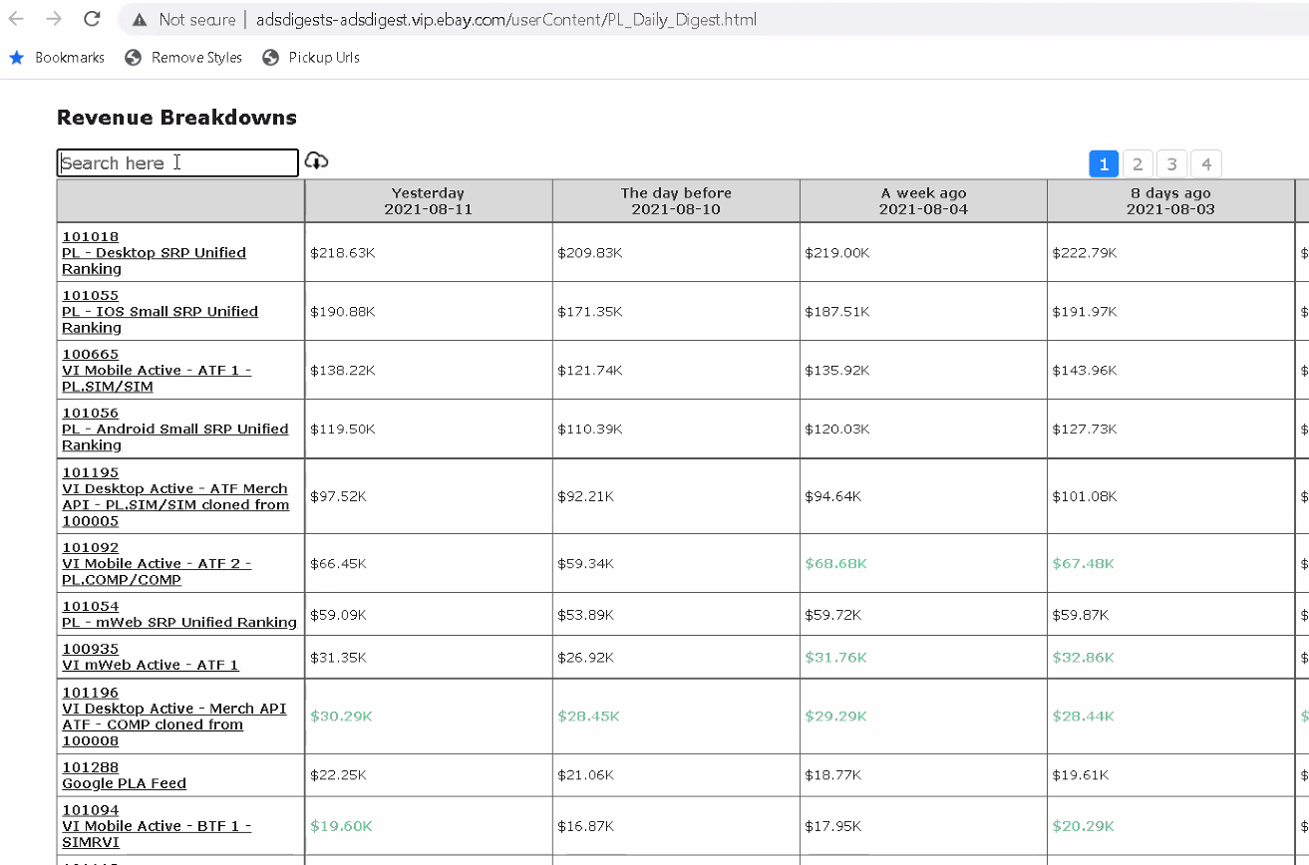

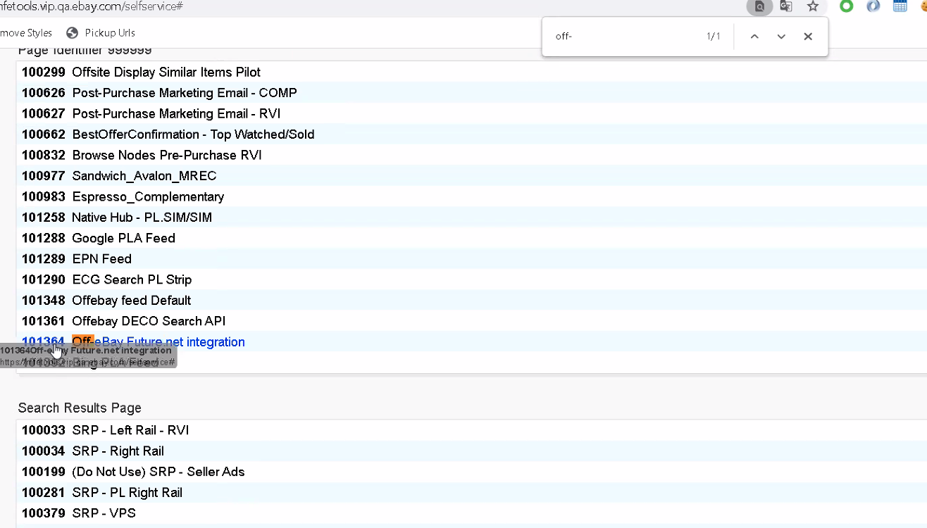

Business rules - every PL needs a placement

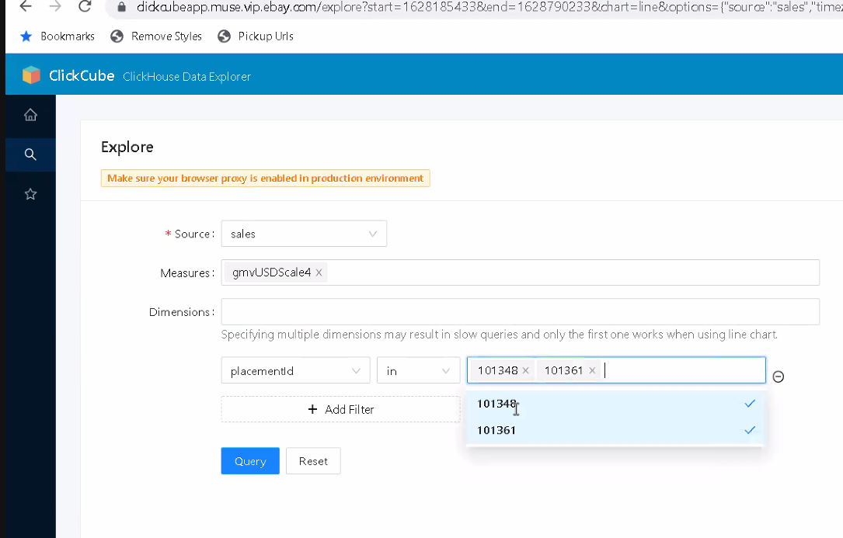

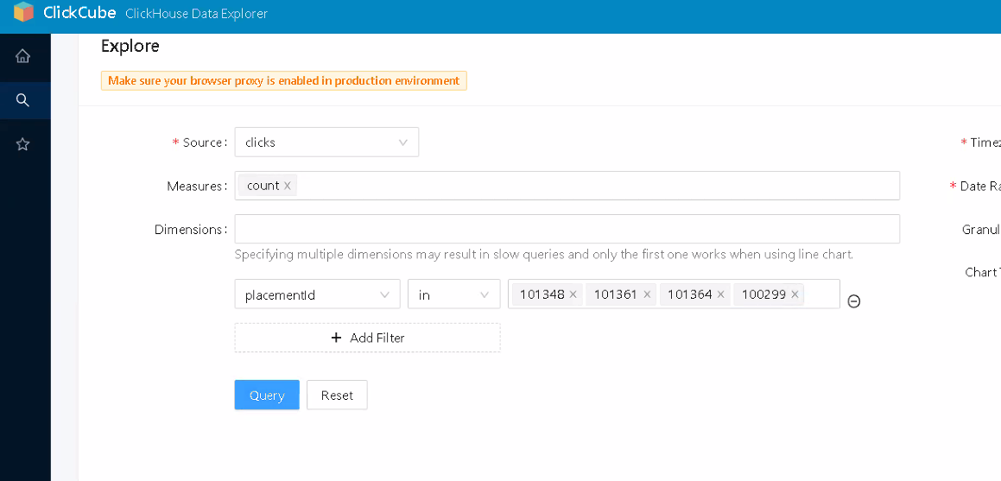

Off-ebay

External PL

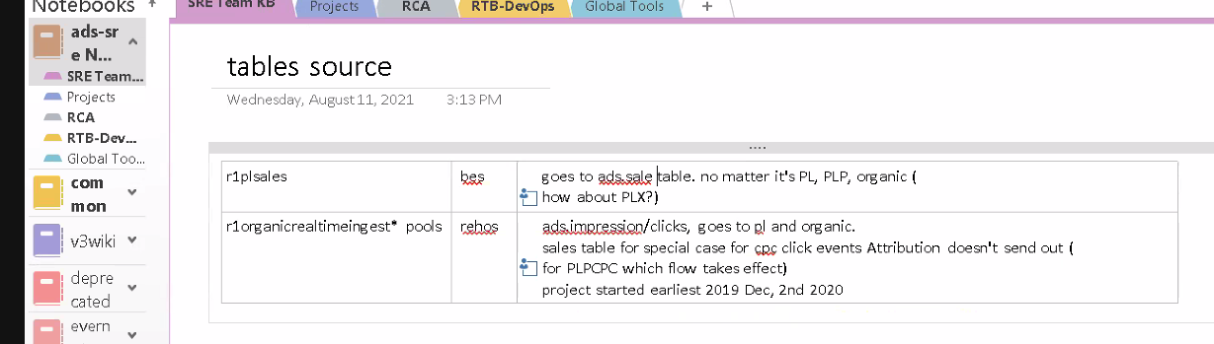

Organic as organic

PL as organic

Listing not included in campaign is organic

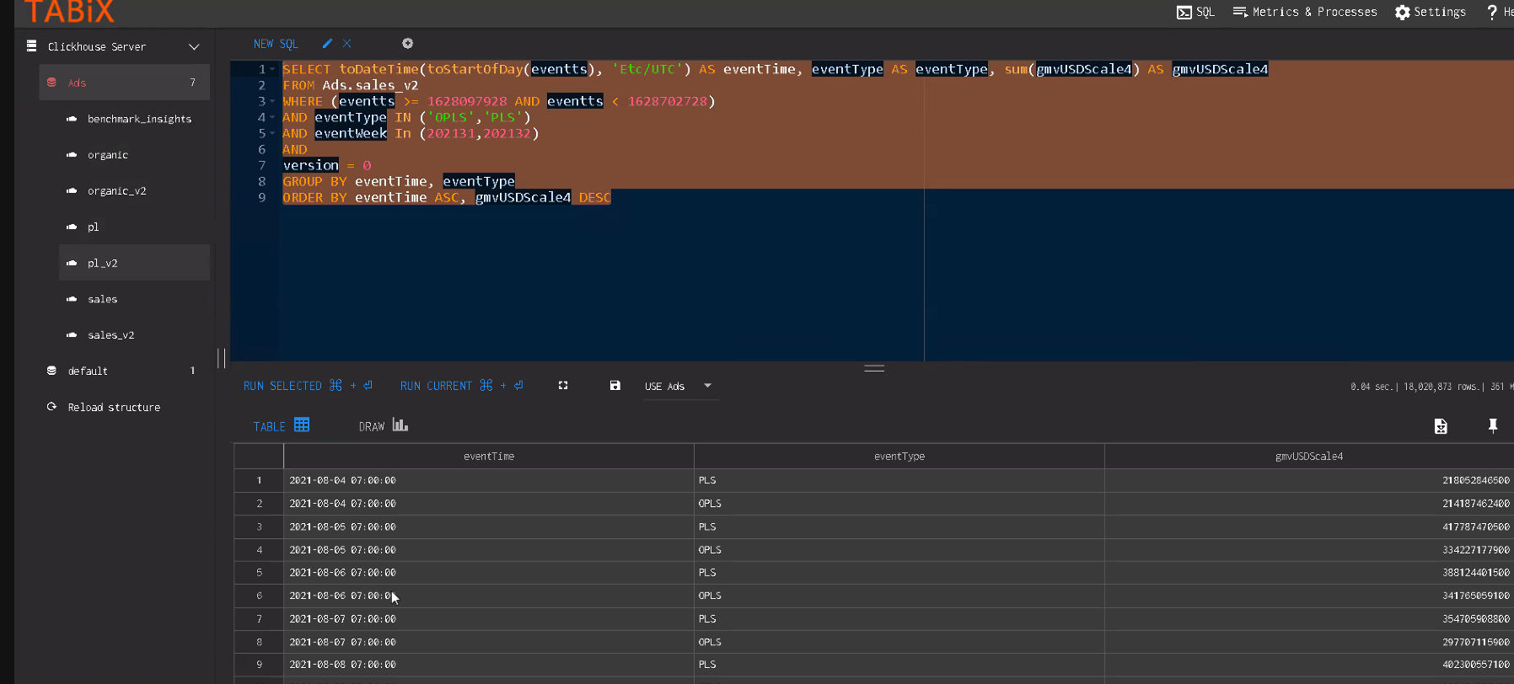

Issue organic went to zero

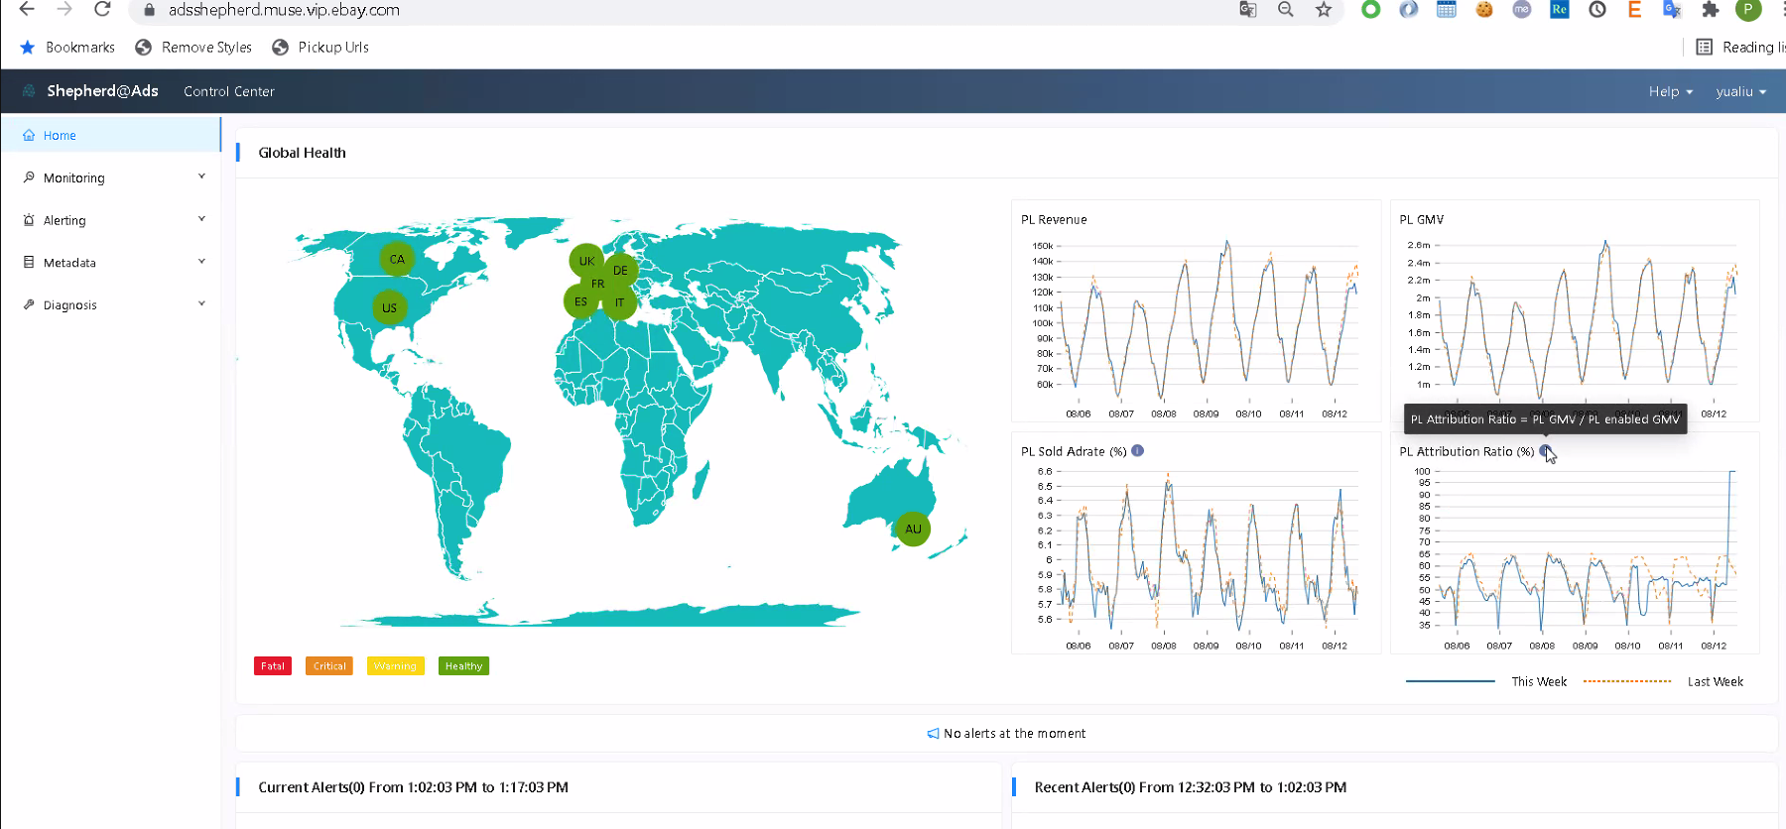

1. It does not have any data
2. Drop in 08/11

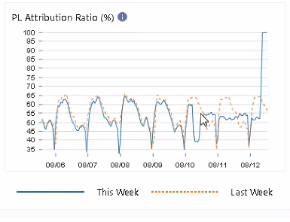

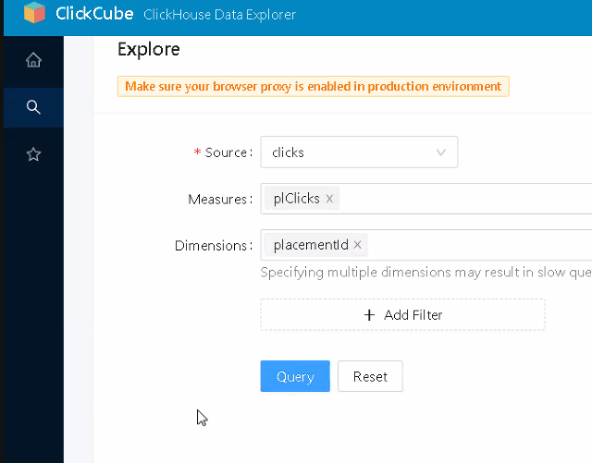

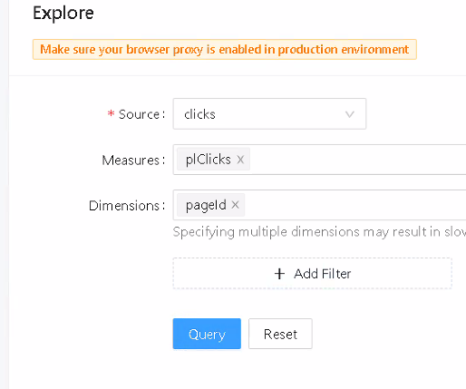

**Task**

<https://docs.google.com/document/d/15kAJwa9DIK_QIf7BVmDXsdlMCwLm6PBkTOezJJNA8ek/edit>

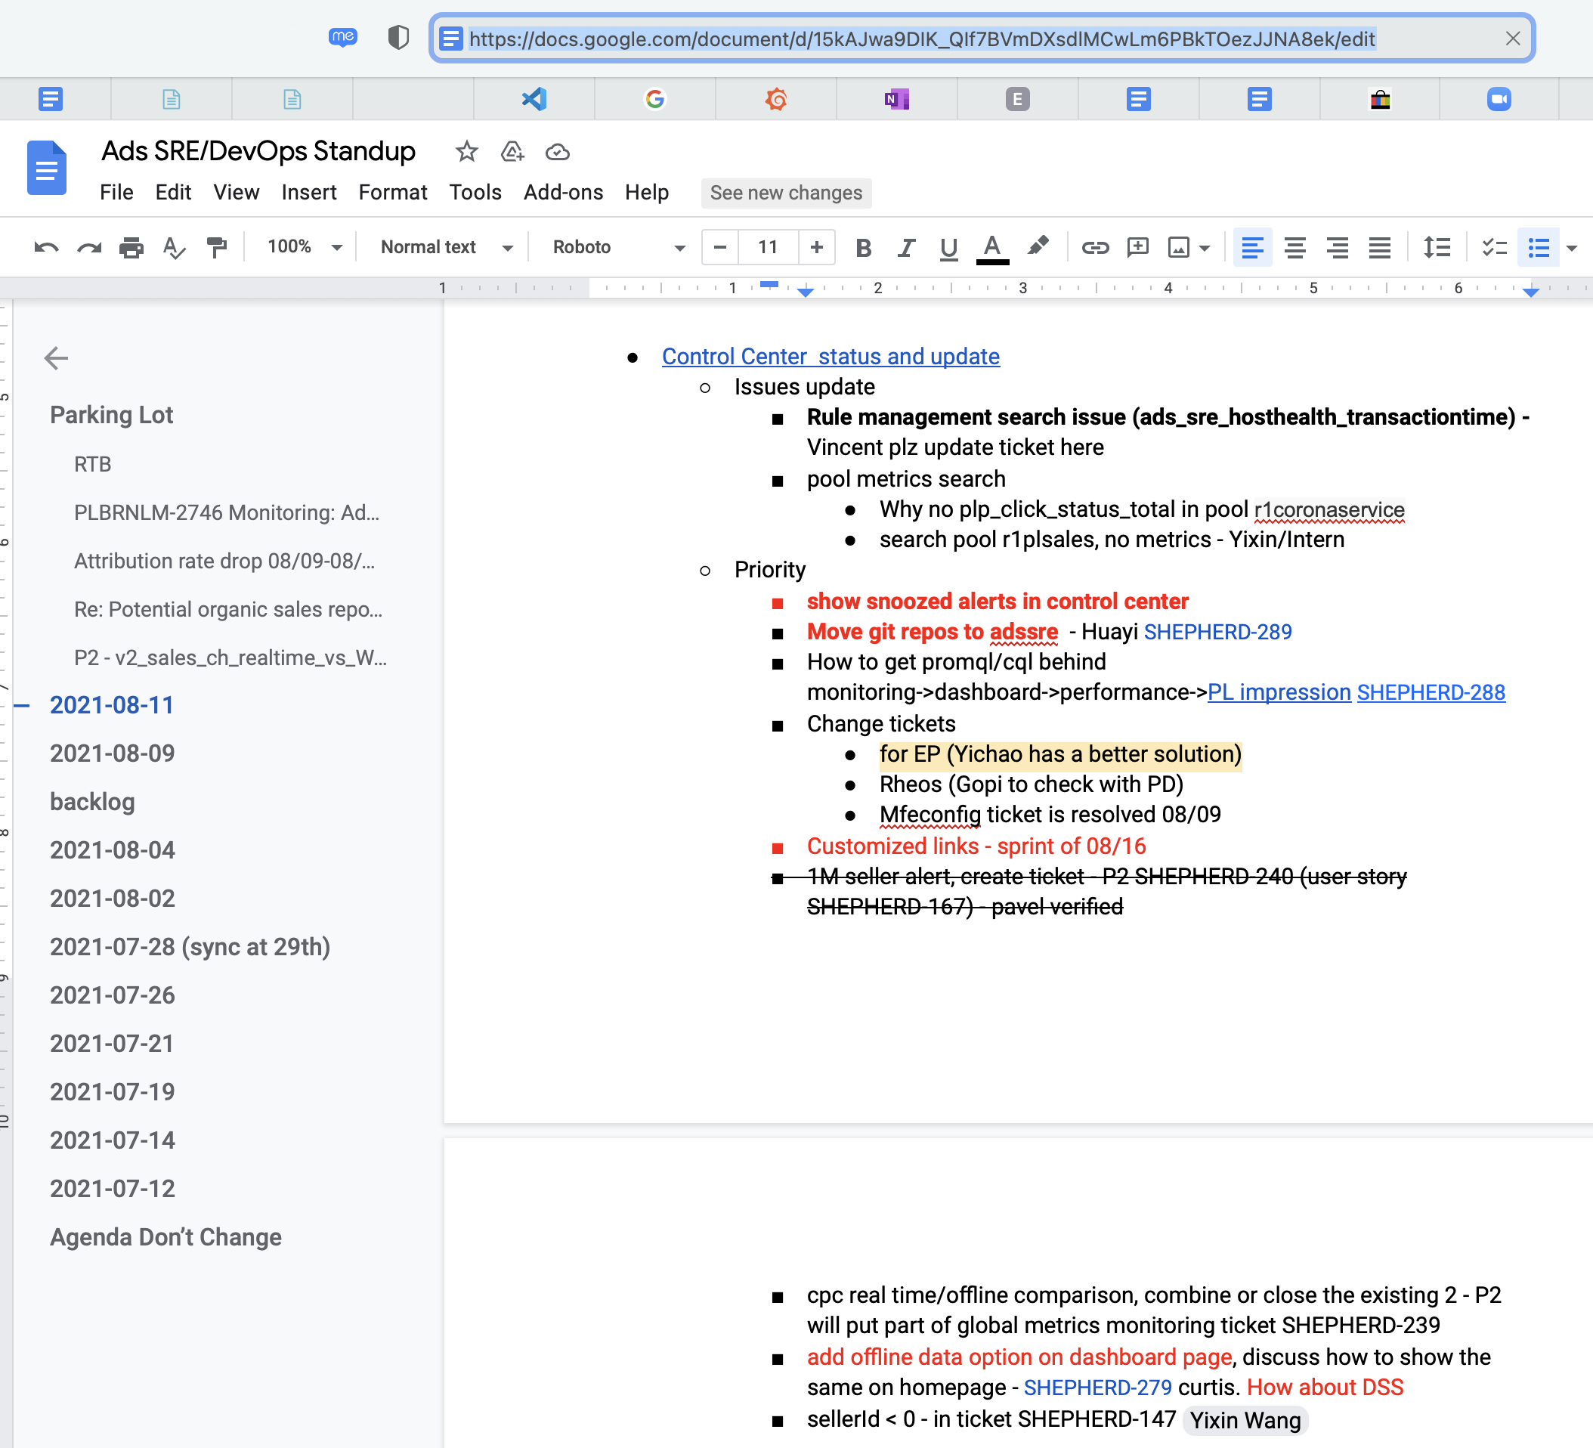

**Adrsrejob sharing**

Spring batch

Job package

## 20210811 Day 3 Documentation, More Setups and Access, Tess.io

Documentation

* Updated docs New Hire Onboarding to Ads Team. For proxy configuration in Mac.
* Updated docs Generating a valid GitHub Token https://wiki.vip.corp.ebay.com/display/CUS/Generating+a+valid+GitHub+token. New navigation and condensed the steps.
* Got access
* Shepherd - Agile Board - eBay Marketplaces JIRA https://jirap.corp.ebay.com/secure/RapidBoard.jspa?rapidView=23675&quickFilter=56724
* eBay Marketplaces Wiki - Confluence https://wiki.vip.corp.ebay.com/display/MERCHANDISING/2021-07-18+PLA+Sales+Drop+From+Jul+18th-Aug+1st
* eBay Cloud Platform https://cloud.ebay.com/app/detail/adssrejob/overview
* Ads Shepherd - Control Center https://adsshepherd.muse.vip.ebay.com/controlcenter/monitoring/metrics-explorer
* C3 (Connected Cloud Commerce) https://c3.corp.ebay.com/project/
* Grafana https://console.sherlock.io https://srestar.vip.ebay.com/d/sg8Pfh0mz/srestar-home-page?orgId=1
* Pronto Kibana https://esadsquality-kibanaslc.vip.ebay.com/login?next=%2F
* GitHub https://github.corp.ebay.com/

Setup

* GitHub token and SSH keys
* Installed Java 1.8.0_242 in /Users/cjasonbautista/Library/Java/JavaVirtualMachines

Training

* Tess.io with Srujan Tata and Jason Chan - ended early and will reconnect next week. Too much gap in knowledge that we couldn't come up with questions for now.

**Tess.io**

Stateful applications it will be in the machine directly. Need persistent volume

Most apps in ebay are stateful apps.

tessellate/tess-generic-app

When working on a new repo

base > templates

change “base” to name of project

Chart.yaml

Values.yaml

Follow README.md

* Go to eBay cloud platform

eBay Cloud Platform

* Template: Cloud Native Generic Application
* Dedicated Team: Ads Quality Initiatives
* Account: Use Existing
* Jira: Shepard
* OnCall Service: check values.yml oncall service

tess login

cluster 130

tess create -f .\application.yaml

dev environment : federation cluster : fcp-dev

cluster to deploy application, application instances

cluster 130 : statefulset

use as a template stat / adscmd-spec

* dev > application.yaml
* name: change this
* owner: change this

Jason suggestions:

Create a config file to avoid missing out fields if the file keeps changing.

In the Tess.IO docs, the HelloWorld might have some issues.

I personally,

To have better questions.

eBay Cloud Platform – Quota Management

the “tms” are load balancers

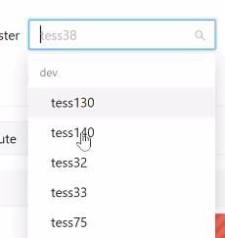

First stand-up

Hackathon

Skunk works

Huayi Tang – System Lead

Reno, Las Vegas

Yichuang

Organic Sales

PLS

OPLS is catching up. We found the root cause. There’s an email and evidence.

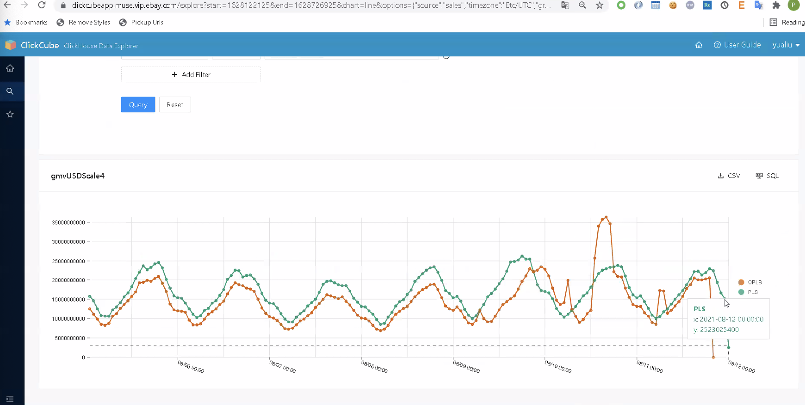

Spike in the attributionRatio

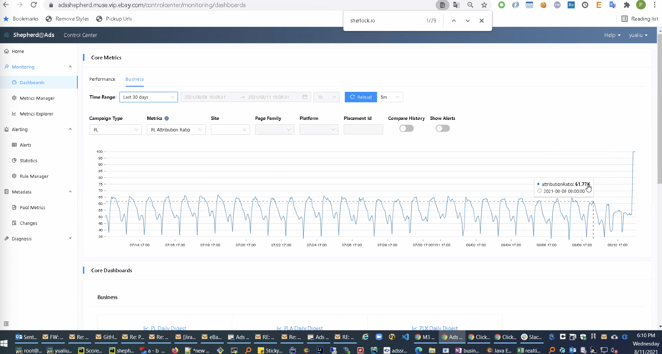

Are the increase on organic sales only on the US side?

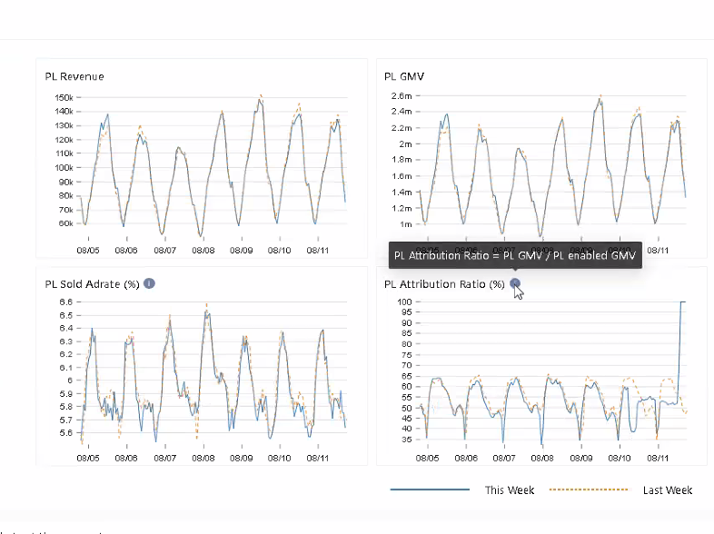

DQ Monitoring

After the DevOps, we go to RTB

JIRA: Huang, Yichao – add alert rules for collapse rate

In Control Center,

Filter by - Team: Ads Creator

Filter by – Team: Ads CCOE

DevOps:

JIRA: Shao, Bingcheng - monitor for our synchronous tasks

JIRA: adscmd – fix the “I have no name!” part when login, and support to ssh other hosts - Srujan deployed the fix on dev.

We need to add curl command.

Production issues, RTB

HS_ERROR_COUNT_AVG_HIGH_LVS

JIRA - Create an alert for SBEException

DevOps

* webhdfs client
* migration from infohub to corp AD

Clark and Jason will RaptorBatch

RTB-DevOps

* m3 Huiwen’s app

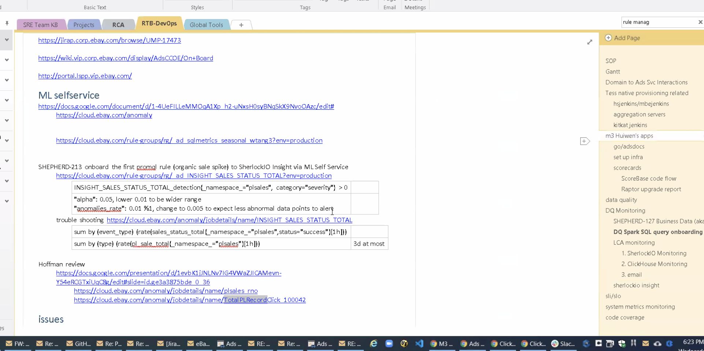

We cannot renew Ubuntu 18 by October

Control Center

SHEPHERD-289 move to next Sprint

SHEPHERD-254 deployed in prod. This is now resolved. In Control Center > Metrics Rule Manager, click preview icon. This enable us to copy-paste easier.

Pool metrics search

SHEPHERD-288 – not done

For clark, Control Center > Metadata > Changes

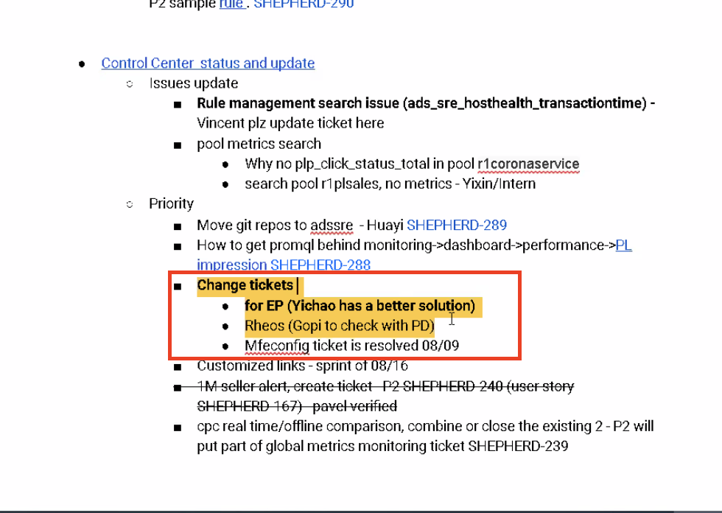

Need training to get access to deployment

ServiceNow – next generation of trace.

EP change. Impacts the monitoring cycle.

Ids start with CHG or CR

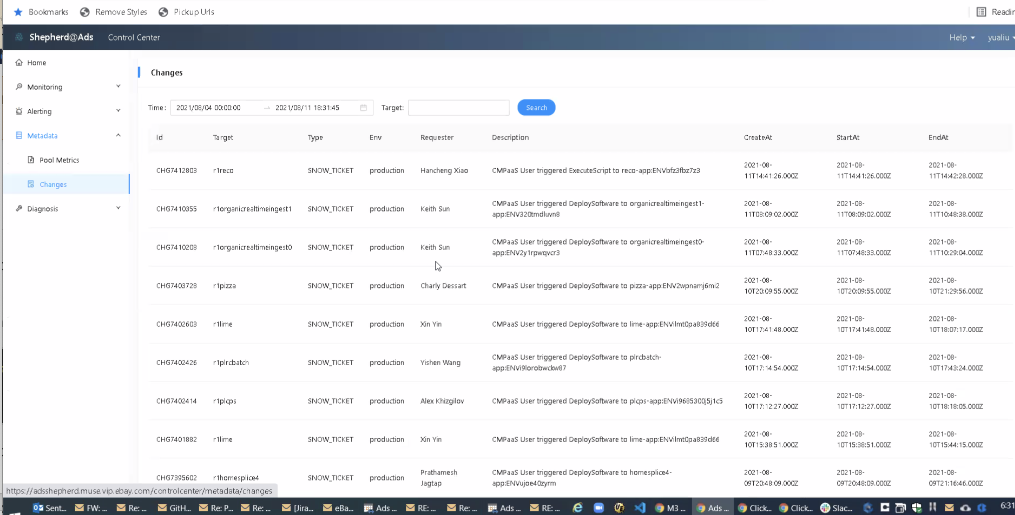

Is there any EP Change here?

Now there is ServiceNow integration.

EP is not related to Target (pool) column

Yichao knows the approach

When you click Search, it still calls the Elasticsearch API.

How to add more batch in RaptorBatch

Maybe add 1 more type in Type column

SNOW_TICKET

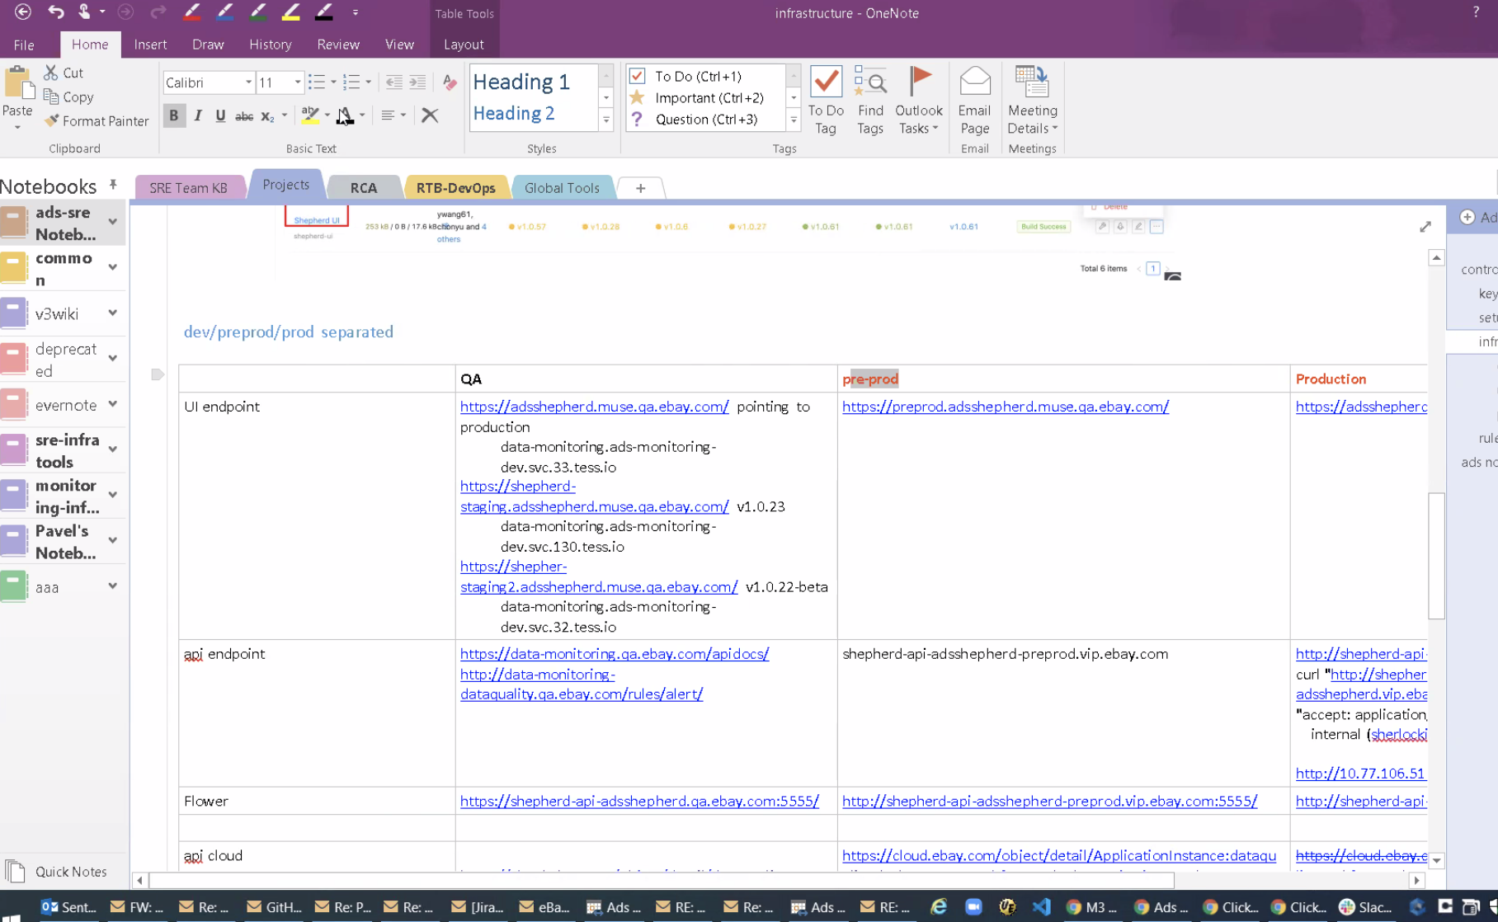

Maybe the issue

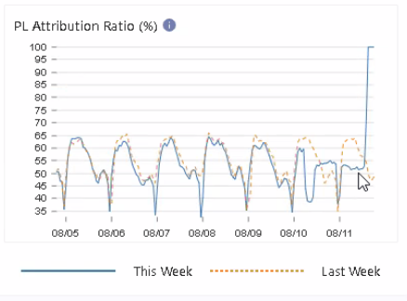

OneNote > ads-sre > Projects

Flower (batch, scheduler, job)

eBay Cloud Platform

StatefulSet means kind of deployment

PersistentVolumeChain

## 20210810 Day 2 Online Trainings, New Hire Docs

Installed

* Slack on Phone
* Outlook on Phone

Completed Trainings

* New Hire Compliance Training (3 items)
* eBay Think Twice
* eBay Information Security Awareness
* Knowledge Base Training

Documentation

* Updated New Hire Docs to resolve issue on automatic installation failure

## 20210809 Day 1 Start Date, Welcome, and Laptop

9:00 am – 12:00 noon

Had problems with accessing the laptop in the morning. I called IT twice. The manager needs to approve but the request wasn’t going through. It was the same with the other new hire.

1:00 pm

Intro Call with Pavel Liu (eBay Manager)

* Includes Brillio Team
* The introduction was only for formalities. Me and Pavel has been messaging already before the Intro Call.

1:30 pm

Contacted IT again. eBay new hire team member gave me a direct email for IT support that deals with badge ID. Turns out I wasn’t issued a badge number.

2:30 pm

I had access to the laptop, but I was missing a lot of applications

3:00 pm

I contacted IT support with remote desktop connection. IT support said that the automated installation fails from time to time due to various reasons. IT helped me run the automated installation.

4:30 - 5:00 pm

Done with installation. Updated my manager and updated the new-hire docs if they encounter the same issue.

Tasks:

* Enhance new hire guide
* Check “New Hire Onboarding to Ads Team”
  + I need up to Java for my environment
  + No need to install Scala

Resource Persons:

* Srujan Tata
  + Basic Stuff
* Zhiyu Tim Ding & Pavel
  + Java stuff
* Huayi Tang
  + Python stuff
* Honghao Wang
  + Reports to Weiyi
  + Helps us with Root Cause Analysis

Meetings

* Tuesday is no meeting day. Don’t make very long meeting and avoid it
* Thursday shorter meeting for the New York team. Usually, Pavel is the only one who attends.